Key Vocabulary
Battery | A portable device that stores electrical energy.
Bulb | Part of a circuit that gives out light.
Mains | The electricity that comes from a socket in the wall and through wires.
Rechargeable | A battery that we can put ‘electricity’ back into.
Circuit | A pathway hat electricity can flow around. It includes wires and a power supply and may include bulbs and switches.
Components | The items that make up a circuit.
Terminal | The ends of the battery. One is negative and one is positive.
Wires | Used to connect components together.
Switch | A component that turns a circuit on and off.
Conductor | A material that transmits electricity.
Insulator | A material through which electricity cannot flow.
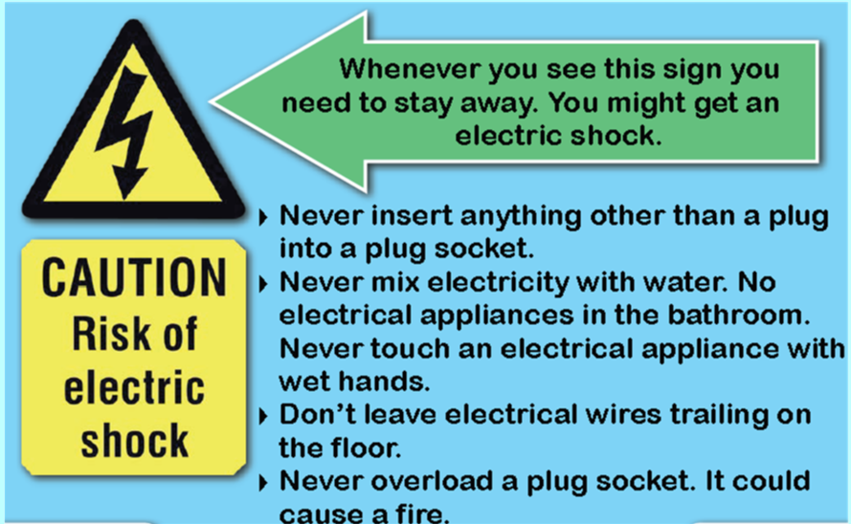
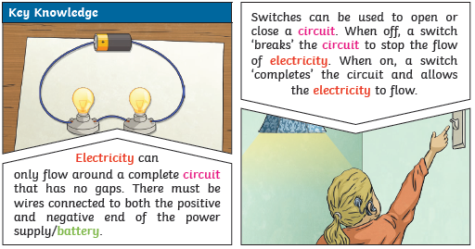
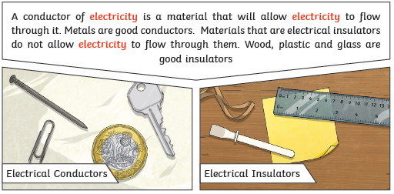
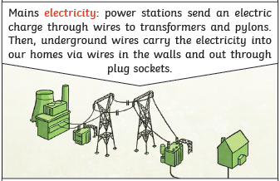 | 