Key Vocabulary
Roots | These anchor the plant into the ground and absorb water and nutrients from the soil.
Stem | This holds the plant up and carries water and nutrients from the soil to the leave.
Leaves | The leaves make food for the plant using sunlight and carbon dioxide from the air.
Flower | These make seeds to grow into new plants. Their petals attract pollinators to the plant.
Petal | The brightly coloured part of the flower that attracts insects to pollinate the planet.
Nutrients | These are needed by all living things to survive. Plants get their nutrients from the soil.
Pollination | When pollen from a flowering plant is moved from the male anther of a flower to the female stigma.
Fertilisation | When the male and female parts of the flower have mixed in order to make seeds for new plants.
Germination | When a seed starts to grow.
Seed dispersal | When seeds are moved away from the parent plant so that the seeds have the best chance of survival
Stamen | The male parts of the flower which is made up of the anther and the filament.
Carpel | The female part of the flower which is made up of the stigma, style and ovary.
Sepal | Leaf-like structure that protects the flower and petals before they open out.
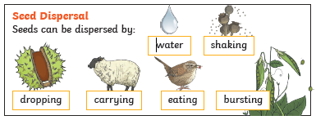
Useful diagrams
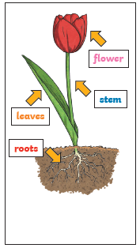 | 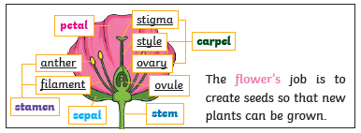
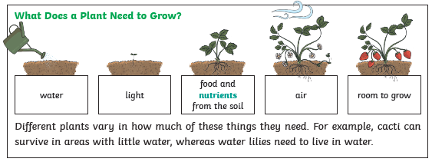
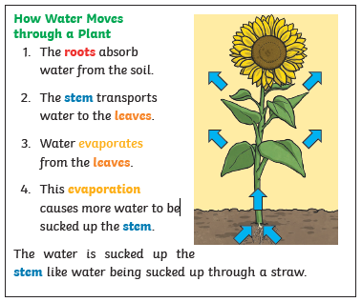 | 