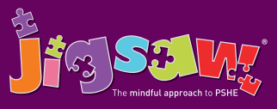
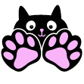
EYFS Puzzle 5 Relationships
Knowledge | Social and Emotional skills
• Know what a family is  • Know that different people in a family have different responsibilities (jobs)  • Know some of the characteristics of healthy and safe friendship  • Know that friends sometimes fall out  • Know some ways to mend a friendship  • Know that unkind words can never be taken back and they can hurt  • Know how to use Jigsaw’s Calm Me to help when feeling angry  • Know some reasons why others get angry | • Can identify what jobs they do in their family and those carried out by parents/carers and siblings  • Can suggest ways to make a friend or help someone who is lonely  • Can use different ways to mend a friendship  • Can recognise what being angry feels like • Can use Calm Me when angry or upset
Children are introduced to the key relationships in their lives. They learn about families and the different roles people can have in a family. They explore the friendships they have and what makes a good friend. They are introduced to simple strategies they can use to mend friendships. The children also learn about Jigsaw’s Calm Me and how they can use this when feeling upset or angry
Key Vocabulary:
Family, Jobs, Relationship, Friend, Lonely, Argue, Fall-out, Words, Feelings, Angry, Upset, Calm me, Breathing

