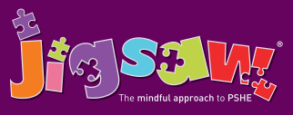
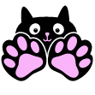
Year 5 Puzzle 4 Healthy Me
Knowledge | Social and Emotional skills
- Know the health risks of smoking  • Know how smoking tobacco affects the lungs, liver and heart  • Know some of the risks linked to misusing alcohol, including antisocial behaviour  • Know basic emergency procedures including the recovery position  • Know how to get help in emergency situations  • Know that the media, social media and celebrity culture promotes certain body types  • Know the different roles food can play in people’s lives and know that people can develop eating problems / disorders related to body image pressure  • Know what makes a healthy lifestyle | - Can make informed decisions about whether or not youchoose to smoke when you are older  • Can make informed decisions about whether You choose to drink alcohol when you are older  • Recognise strategies for resisting pressure  • Can identify ways to keep yourselves calm in an emergency  • Can reflect on your own body image and know how important it is that this is positive  • Accept and respect yourselves for who you are  • Respect and value your own bodies  • Be motivated to keep yourselves healthy and happy
In this Puzzle the class look at the risks linked to smoking and how this affects the lungs, liver and heart. They do the same with the risks associated with alcohol misuse. They are taught a range of basic emergency procedures (including the recovery position) and learn how to contact the emergency services when needed. The children look at how body types are portrayed in the media, social media and celebrity culture. They also talk about eating disorders and people’s relationships with food and how this can be linked to negative body image pressures.
Key Vocabulary:
Choices, Healthy behaviour, Unhealthy behaviour, Informed decision, Pressure, Media, Influence, Emergency, Procedure, Recovery position, Calm, Level headed, Body image, Media, Social media, Celebrity, Altered, Self-respect, Comparison, Eating problem, Eating disorder, Respect, Debate, Opinion, Fact, Motivation.

