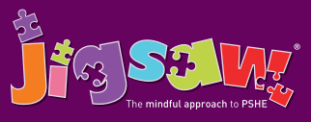
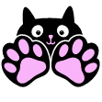
EYFS Puzzle 4 Healthy Me
Knowledge | Social and Emotional skills
- Know the names for some parts of my body  • Know what the word ‘healthy’ means  • Know some things that I need to do to keep healthy  • Know that I need to exercise to keep healthy  • Know how to help myself go to sleep and that sleep is good for me  • Know when and how to wash my hands properly  • Know what to do if I get lost  • Know how to say No to strangers | - Recognise how exercise makes me feel  • Recognise how different foods can make me feel  • Can explain what I need to do to stay healthy  • Can give examples of healthy food  • Can explain how I might feel if I don’t get enough sleep  • Can explain what to do if a stranger approaches me
In this Puzzle children learn about their bodies; the names of some key parts as well as how to stay healthy. They talk about food and that some foods are healthier than others. They discuss the importance of sleep and what they can do to help themselves get to sleep. They talk about hand washing and why it is important. The class also discuss stranger danger and what they should do if approached by someone they don’t know.
Key Vocabulary:
Healthy, Exercise, Head, Shoulders, Knees, Toes, Sleep, Wash, Clean, Stranger, Scared, Trust.

