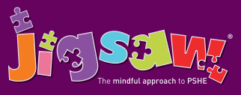
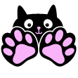
Year 6 Puzzle 1 Being Me in My World
Knowledge | Social and Emotional skills
- Know how to set goals for the year ahead  - Understand what fears and worries are  - Know about children’s universal rights (United Nations Convention on the Rights of the Child)  - Know about the lives of children in other parts of the world  - Know that personal choices can affect others locally and globally  - Understand that their own choices result in different consequences and rewards  - Understand how democracy and having a voice benefits the school community  - Understand how to contribute towards the democratic process | - Be able to make others feel welcomed and valued  - Know own wants and needs  - Be able to compare their life with the lives of those less fortunate  - Demonstrate empathy and understanding towards others  - Can demonstrate attributes of a positive role-model  - Can take positive action to help others  - Be able to contribute towards a group task  - Know what effective group work is  - Know how to regulate my emotions
In this Puzzle (unit) the children discuss their year ahead, they learnt to set goals and discuss their fears and worries about the future. The class learn about the United Nations Convention on the Rights of the Child and that these are not met for all children worldwide. They talk about their choices and actions and how these can have far-reaching effects, locally and globally. The children talk about their own behaviour and how their choices can result in rewards and consequences and how these feel. They talk about how an individual’s behaviour and the impact it can have on a group. They also talk about democracy, how it benefits the school and how they can contribute towards it. They establish the Jigsaw Charter and set up their Jigsaw Journals.

Vocabulary:
Challenge, Goal, Attitude, Actions, Rights and Responsibilities, United Nations Convention on The Rights of the Child, Citizen, Choices, Consequences, Views, Opinion, Collaboration, Collective Decision, Democracy.

