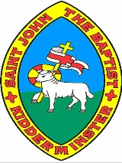
I’m an Evacuee Get Me out of Here Knowledge Organiser
Key Events
1939 | 1st September | German troops invade Poland
 | 3rd September | Britain and France declare war on Germany.
1940 | 10th May | The Battle of France begins.
 | 26th May | Allied forces are evacuated from Dunkirk in France
 | 10th July | The Battle of Britain begins.
 | 7th September | The Blitz begins
1941 | 22nd June | German invades the USSR (Soviet Union)
 | 7th December | Japan bombs Pearl Harbor in US
1943 | 16th and 17th May | The Dambusters bombing raid is carried out.
1944 | 6th June | The D-Day landings
1945 | 7th May | Germany surrenders to the Allies
 | 6th and 9th August | The US drops atomic bombs on two cities in Japan.
 | 2nd September | Japan finally surrenders, ending the war.
Key Vocabulary
Allies | The United Kingdom, France and Poland, later joined by other countries, including the USSR (Soviet Union), the United States of America and China.
Nazi Party | A German political party with racist and anti-Jewish ideas, led by Adolf Hitler.
Atomic bomb | A very high-energy bomb made of radioactive material.
Propaganda | Information designed to promote a political idea or opinion.
Active Service | Taking part in a military operation as part of the armed forces.
Rationing | Only allowing people to have a certain amount of something.
Evacuation | Taking people from a dangerous place to a safer one.
Holocaust | The killing of millions of Jews by the Nazis
Annex | The forceful takeover of land/territory.

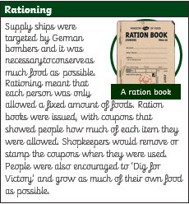
Evacuation
