**Viking Raiders and Invaders Knowledge Organiser**

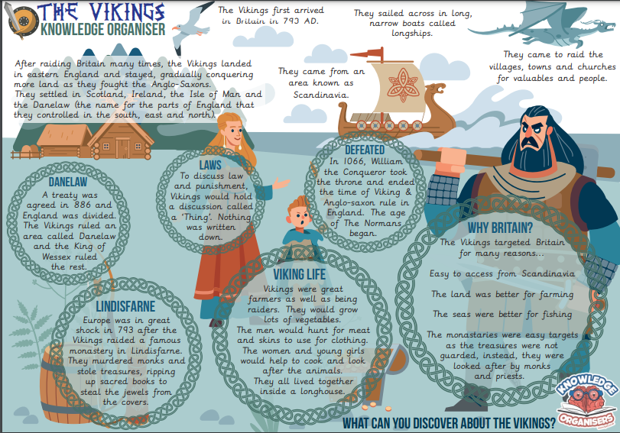

**Viking Raiders and Invaders Knowledge Organiser**

