**Year 5 – Saxon Settlers and Viking Raiders**

|  |  |  |  |  |  |  |  |  |  |  |  |
| --- | --- | --- | --- | --- | --- | --- | --- | --- | --- | --- | --- |
| **Pre-History** | **Iron Age** | **Romans**  **Anglo-Saxons** | **Medieval** | | | |  | **Georgians**  **Stuarts**  **Tudors** | **Victorians** | **Modern** |  |
|  | **Vikings**  **Normans** | **late Medieval** |  |

1603 CE 1714 CE 1837 CE 1901 CE

700 BCE

43 CE

450 CE

790 CE 1066 CE 1300 CE 1485 CE

# 

**The Anglo-Saxon Heptarchy**

**What do we know about the Anglo-Saxons?**

The fall of the Roman Empire in 410 CE left England in an unprotected state which led to the **Angles, Saxons and Jutes** invading from Germany, Denmark and the Netherlands. These invaders settled in England and we know them as the **Anglo-Saxons**.

Not much is known about the fall of the Roman Empire leading into the early Anglo-Saxon period, as not many people wrote about it. However, most of the written information from this period comes from two monks, **Gildas** who wrote in the 6th century and **Bede**, who wrote in the 8th century.

The Anglo-Saxons were mostly farmers who **lived in wooden huts**. Children here would generally not go to school. Girls would help around the home and boys learned the skills of their fathers.

From the 5th century up until 927 CE, England was not a united country like today and instead it was **separated into many kingdoms**. Historians refer to the **seven largest kingdoms** as the **'heptarchy'**.

Each kingdom had its **own king** and they would often fight between each other. Sometimes the people

who lived in the kingdom would rebel against the king’s power.

So, being in complete control of an Anglo-Saxon kingdom required power, influence, and lots of money!

Anglo-Saxon kings had so much power and control over their people that they even worked to change their religion to their own beliefs!

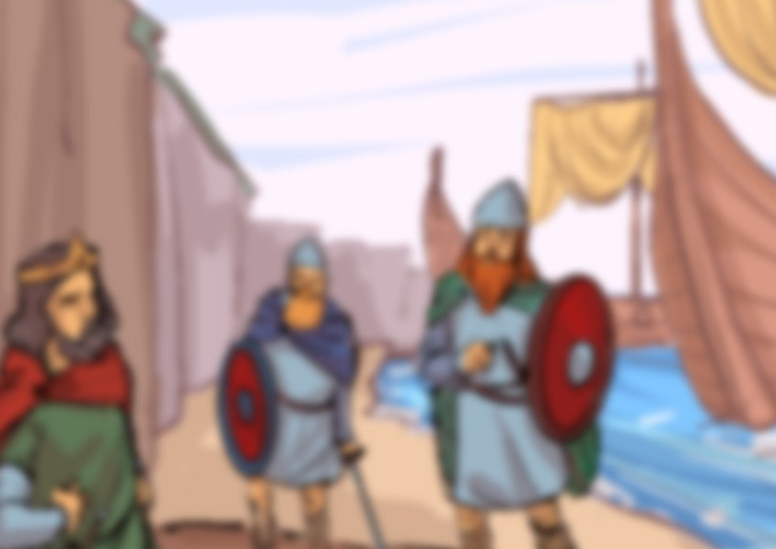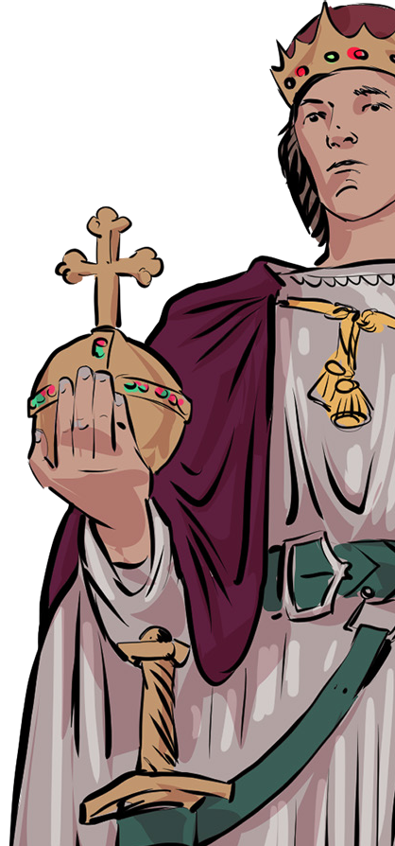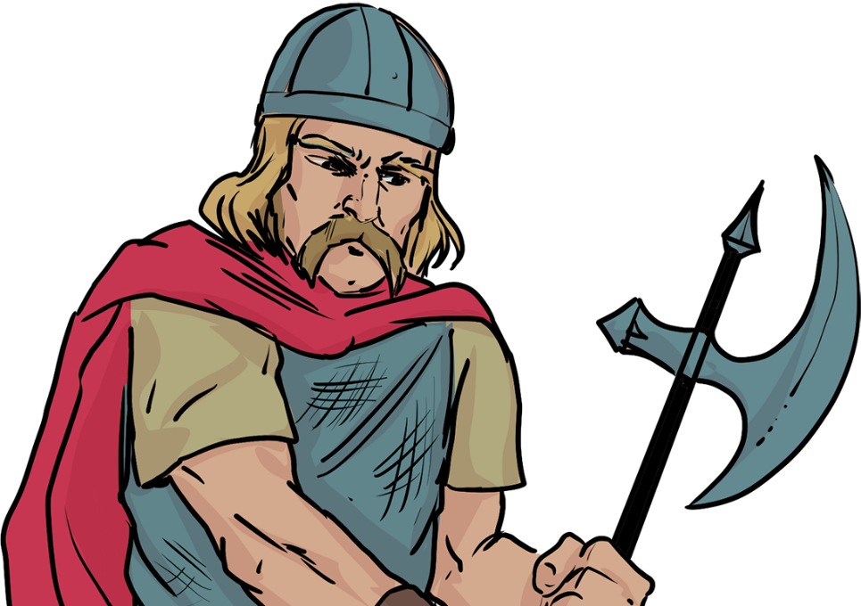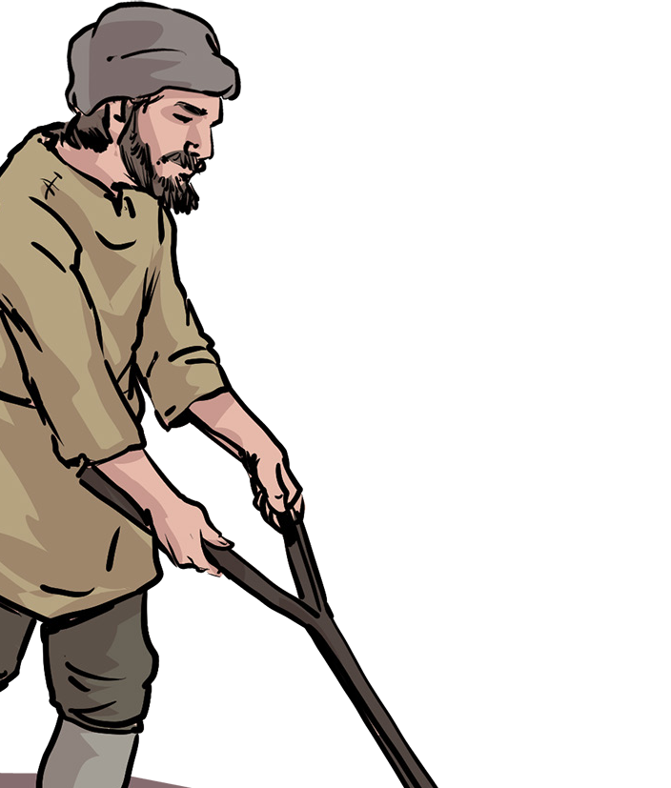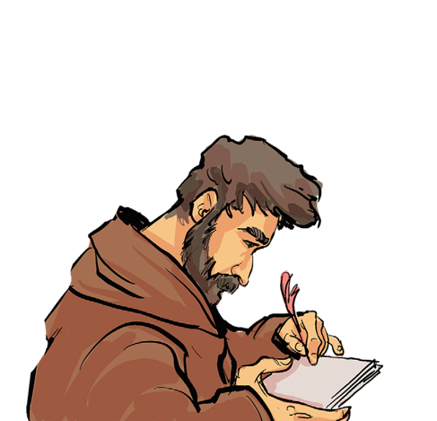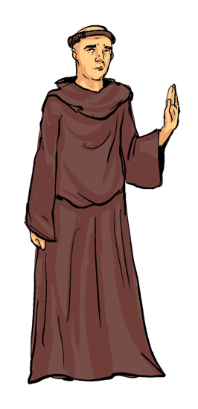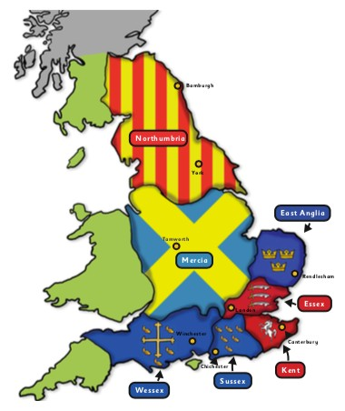

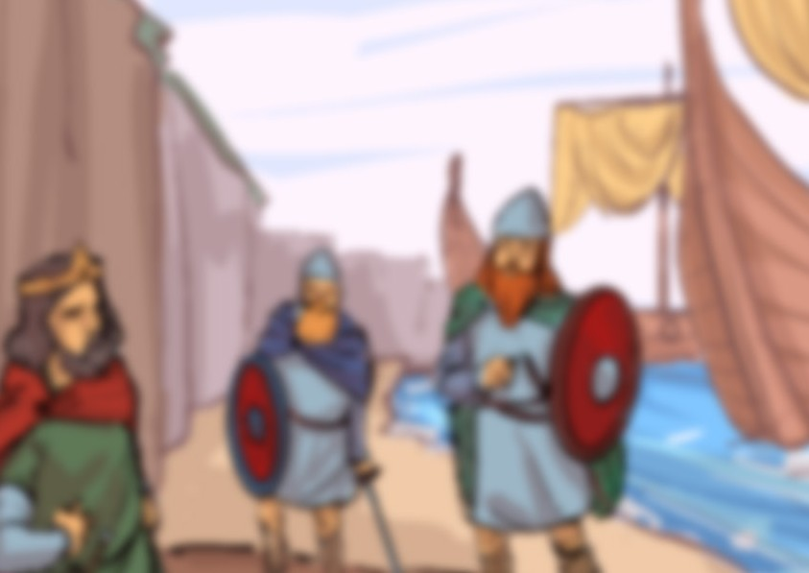

**Lindisfarne Priory**

In **793 CE**, a small island (known as Holy Island) off the coast of **Northumbria** was home to **Lindisfarne priory** – a **Christian settlement of monks**. The priory held many great treasures like **gold goblets**, **silver crosses** and **jewel-encrusted bibles**.  
It became the target of a **Viking raid** (possibly originating from Norway) because it was protected by solders as only monks and villagers lived there.  
Even if the monks had been able   
to defend themselves, they were   
no match for the strength of the   
Viking invaders – the Vikings   
were skilled in battle – using   
**shields, swords, spears,   
battle axes** and **arrows.**

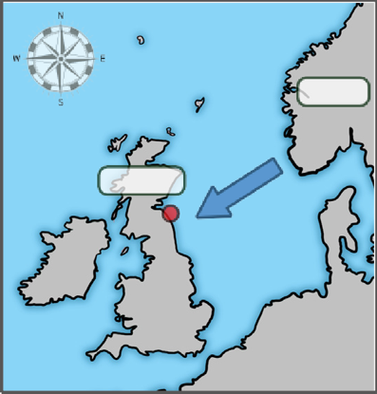

**Anglo-Saxons**

**Norway**

**Lindisfarne**

The **Vikings** were famous for being ruthless warriors and astute traders. They set sail in **longboats** from their homes in **Norway, Sweden and Denmark**, and raided and traded across Europe. Their raids were sudden and daring, often using surprise to overcome their victims. For Viking warriors, honour and glory in battle lasted forever. Warriors who died bravely were believed to go to **Valhalla**, the **Viking heaven**. This belief made them extremely tough, fearless opponents.

**Viking raids** on the coastline of Britain were **very common in the 700s** and it would have been common for the people who lived near the coast to be worried about impending attacks from **Vikings from Scandinavia**.

There were many theories (ideas) as to why these men left Scandinavia to raid and eventually settle in England.

**What do we know about the Vikings?**

In **793 CE**, a small island (known as Holy Island) off the coast of **Northumbria** was home to **Lindisfarne priory** – a **Christian settlement of monks**. The priory held many great treasures like **gold goblets**, **silver crosses** and **jewel- encrusted bibles**.

It became the target of a **Viking raid** (possibly originating from Norway) because it was not protected by soldiers,

as only monks and villagers lived

there. Even if the monks had   
been able to defend themselves,

they were no match for the   
strength of the Viking invaders –   
the Vikings were skilled in battle –

using **shields**, **swords**, **spears**,

**battle** **axes** and **arrows.**

**Lindisfarne Priory**

**Did the Anglo-Saxons and Vikings live peacefully together?**

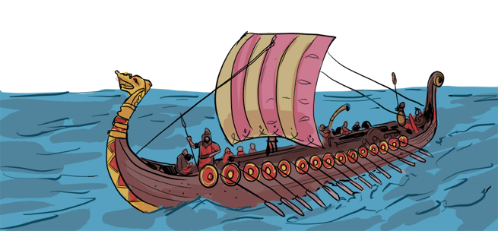

**Georgians**

**Victorians**

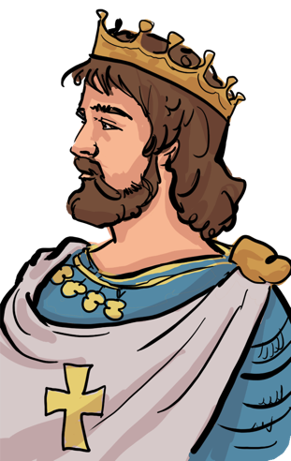

# 

The Vikings’ overwhelming strength and power controlled most of Britain by the **end of the 9th century**, even though kings like **Alfred the Great** tried to defeat them.

The land they controlled was named the **Danelaw** because the rules of these lands came from the **Danish** (Danes) and **Norse** overlords who had settled from **Scandinavia**. Living as an Anglo-Saxon under the Danelaw was very di cult because the lives of Anglo-Saxons were considered less than that of the Dane/Norse people. This all changed after King Alfred the Great made a treaty with invaders saying that the lives of both the Anglo-Saxon and Scandinavians would be treated as equal. It also clearly marked out the territories of **Wessex and the Danelaw**.

**The first king of England**

Over the next hundred years, the Anglo-Saxons in Wessex and Mercia fought together to drive back the Danelaw regions and by **927 CE**, **King Aethelstan** had conquered the city of **York** and all of **Northumbria**, finally uniting all of England. This makes Aethelstan the **first king of England**.

