Ancient Greece Knowledge Organiser

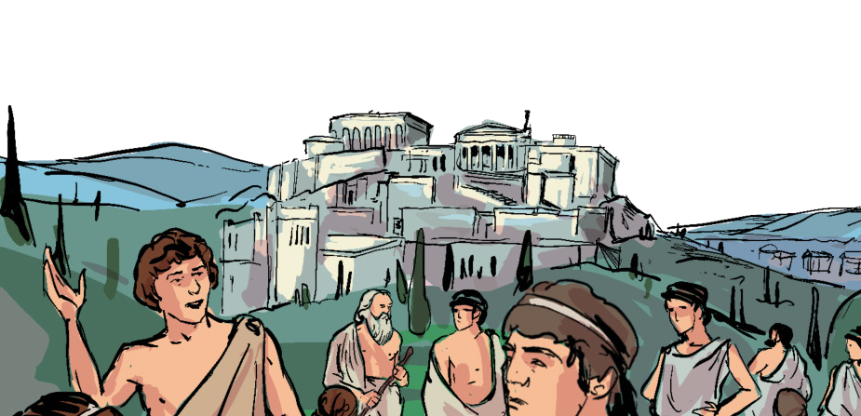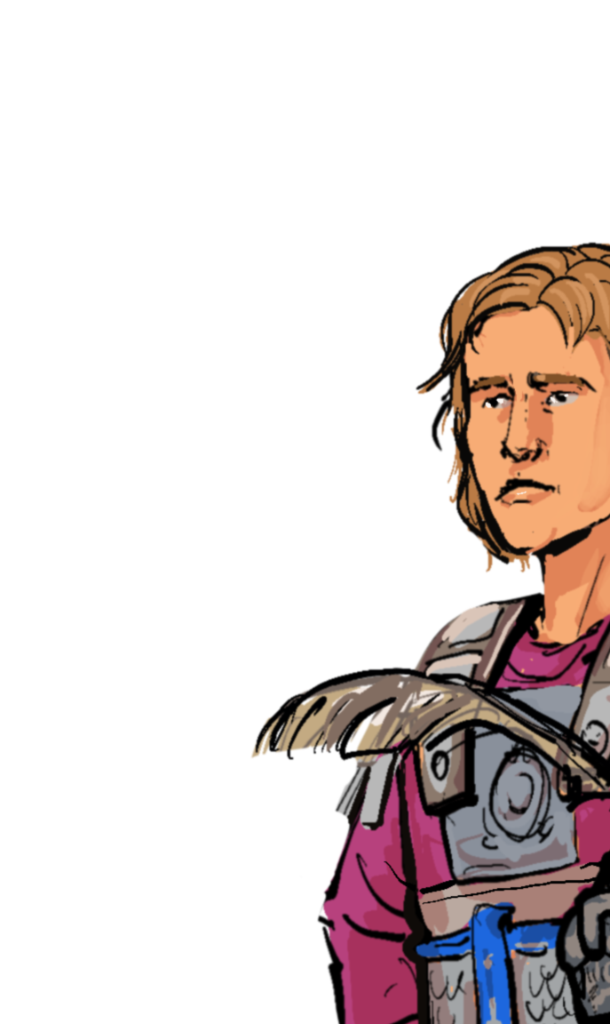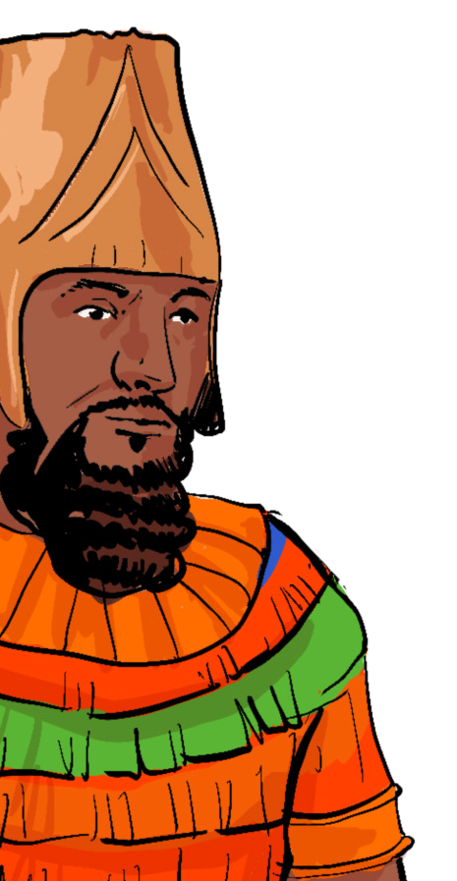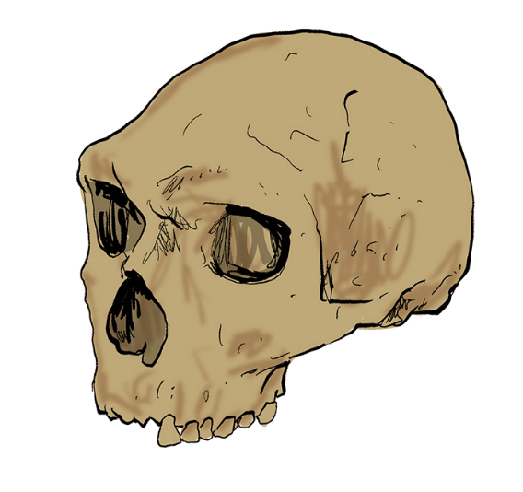

**776 BCE**

First Olympic Games Introduced

**600 BCE**

First coins

**432 BCE**

Parthenon built

Ancient Greece

**Archaic Period Hellenistic Period**

**Iron Age**

**Classical Period**

**Paleolithic**

**Mesolithic**

**Neolithic**

**Bronze Age**

**Romans**

**30,000 BCE**

**8300 BCE 6000 BCE**

**2900 BCE**

**1500 BCE**

**1100 BCE 800 BCE**

**146 BCE**

**324 CE**

**1453 CE**

**It’s All Greek To Me.**

Unit Question – What were the greatest achievements of Ancient Greece?

**Byzantine Greece**

# How do we know about the Ancient Greeks?

**Archaeological studies** suggest that people have lived in the Hellenic (Greek) region for hundreds of thousands of years. There is evidence of **Palaeolithic life** found in a cave **near Thessaloniki** – Petralona. Hundreds of thousands of years later, one of the earliest and most advanced civilisations of the time flourished from **3000 BCE – 1450 BCE**, **the Minoans** on the Greek island of Crete. These fascinating people have been considered essential to the **foundation of European civilisations** for centuries. Historians believe that the Minoans were the first advanced European civilisation. They built **huge buildings**, created **beautiful paintings** (frescoes), crafted **impressive tools**, invented **writing systems** and built a vast **trade network**. The Minoans lived on the **isle of Crete**. Across this large island, they built magnificent palaces linked to towns and villages across the island by roads. We know about the Minoans because, in the early 1900s, an archaeologist called **Sir Arthur Evans** discovered the ruins of a large complex on the island of Crete. In c.1450 BCE, the Minoan civilisation came to an end. Archaeologists and historians are unsure about what happened to them, which remains a mystery.

## Artist’s impression of the early hominid skull discovered in Petralona cave.

Greek city-states

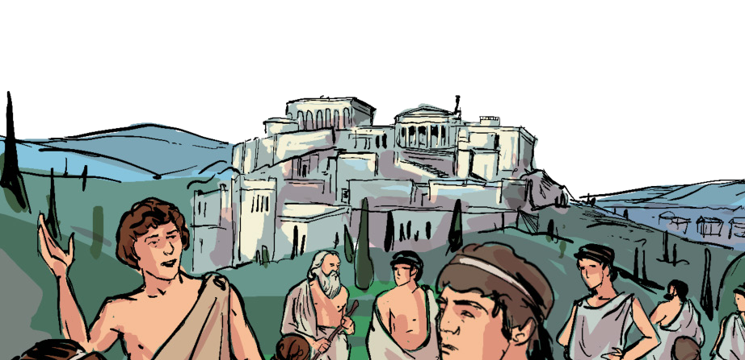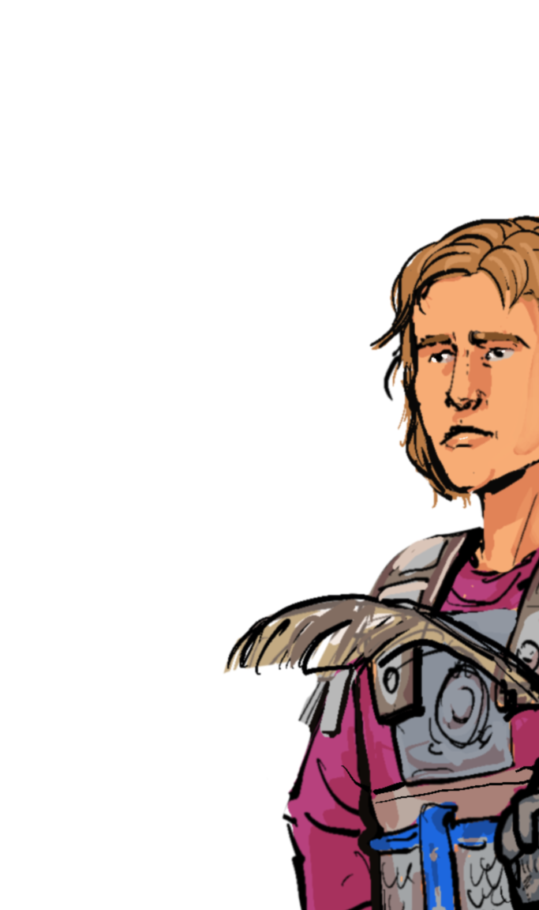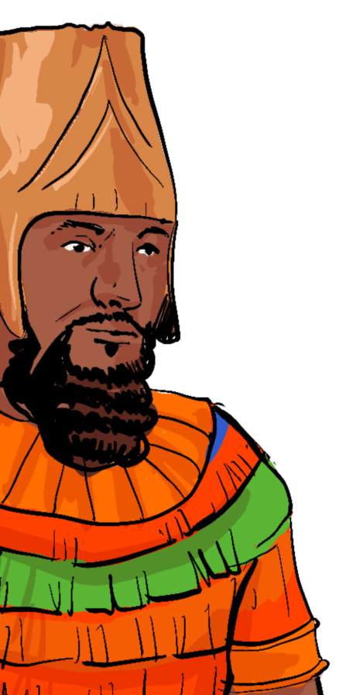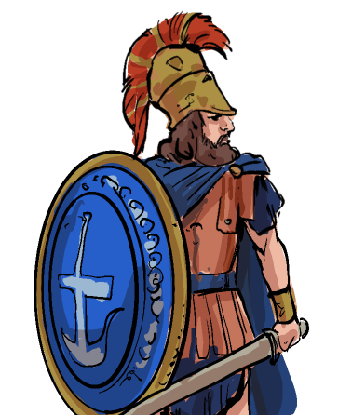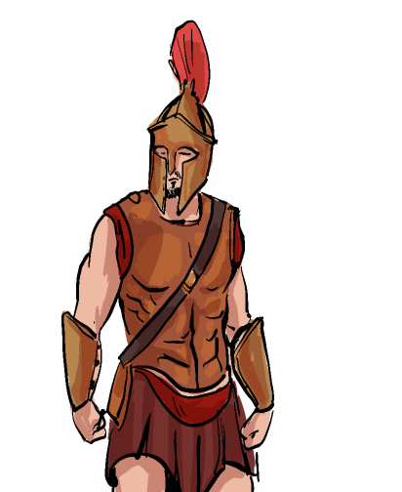

## Spartan Soldier

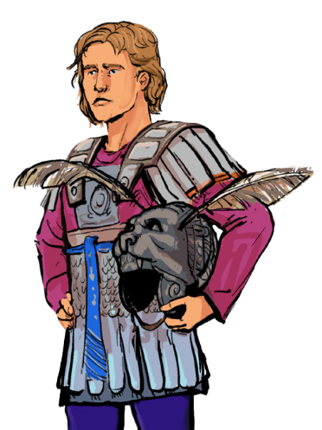

**From the 8th Century BCE**, Greek city-states (called poleis) began to form. A city-state is like an **independent country**. It is made up of a city and its surrounding land. It is independent because it creates its own laws and governs itself. The most powerful city-states were **Athens, Sparta, Corinth, Argos and Thebes**. Although the city-states had a similar culture and language, they were not united and fought for dominance over the Hellenic region.

## Athens vs Sparta!

Athens was a unique place as it housed a form of **democracy** where citizens could vote for decisions to be made, rather than a king or group of elders making the decision, which was more common at the time. Although there were similarities, Sparta was ruled differently from Athens. It had an **oligarchy** – a group of men ruled and made the laws for the city-state. Sparta believed greatly in war and battle and trained their children from a young age to become warriors. They gave women and girls more rights than other city -states and educated them.

## Athenian Soldier

# Who ruled Ancient Greece? Greek influence on the western world

Greece wasn’t a single country in ancient times like today. It was made up of lots of smaller city-states. These states fought each other and often went to war.

## The Battle of Marathon

Under the rule of **Darius I**, in 490 BCE, the **Persian army** outnumbered the Athenians at the Battle of Marathon, yet the A**thenians managed to achieve a dramatic victory**.

The Greeks surprised their enemies by running downhill straight at the Persians.

## The Peloponnesian War

Sparta and Athens fought a long war, called the Peloponnesian War, from **431 to 404BCE**. Only the threat of invasion by outsiders made the Greeks forget their differences and fight on the same side. **Alexander the Great**

Their biggest enemy was the Persians, who tried to conquer Greece a few times, but the Greeks managed to fight them off. Ultimately, the **Greeks**, led by Alexander the Great, **defeated the Persian Empire in the 330s BCE**.

After thousands of years, our modern society has many things to be thankful to the Ancient Greeks for.

* The Ancient Greeks developed many of the **letters** we use today in reading and writing.
* Athenian **democracy** was a system of government designed to give adult men the right to vote on how the city-state would make rules and laws. Today, **we have a similar democracy** where we vote for politicians to represent us in government.
* The **Olympic Games** originated in Olympia, an ancient Greek city-state.
* The Ancient Greeks introduced the world to the **theatre**. **Comedies** and **tragedies** are still genres of theatre and entertainment that we enjoy today.