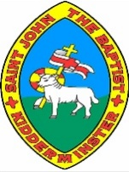
Rome Wasn’t Built in a Day Knowledge Organiser
Key Vocabulary
Caledonia | The name used in Roman times for Scotland.
Celt | Group of people living in Britain who fought against the Romans.
Centurion | An officer that was in charge of 100 soldiers in a legion.
Chariot | A two wheeled cart that was pulled by horses and used in war and for sport.
Conquer | To gain by force – to win
Empire | A group of countries that have the same ruler.
Emperor | The ruler of an empire.
Invade | To enter a place that you do not own in order to occupy.
Iceni | A tribe of Celts who lived in the East of Britain, led by Boudicca.
Gladiator | A man trained to fight against other men or animals for sport
Latin | The language spoken by the Roman’s and within the Empire.
Legion | A large section of the Roman army, made up of 5000 soldiers.
Picts | Tribes from Caledonia.
Roman Empire | The name used for the land that was controlled by the Romans, including parts of Europe, Middle East and North Africa.
Slums | Overcrowded, poor area of housing in a town or city.
Stronghold | A building that is well defended from attackers.
 | Key People
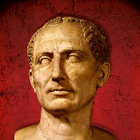 | Julius  Caesar | Politician and general that lead the Roman republic.
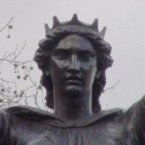 | Boudicca | Leader of the Celtic tribe who lead the revolt against the Romans in 60 AD.
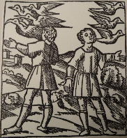 | Romulus and  Remus | Mythical Twins who founded Rome. Romulus killed Remus.
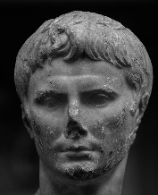 | Augustus | First emperor of the Roman Empire. Great nephew and heir of Caesar.
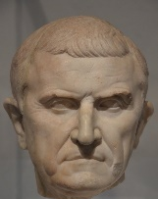 | Spartacus | Gladiator and leader of the slave rebellion in 71BC
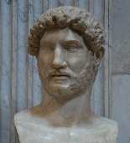 | Hadrian | Roman emperor from 117 to 138 who ordered building a wall guarding the north frontier

Rome Wasn’t Built in a Day Knowledge Organiser
AD1
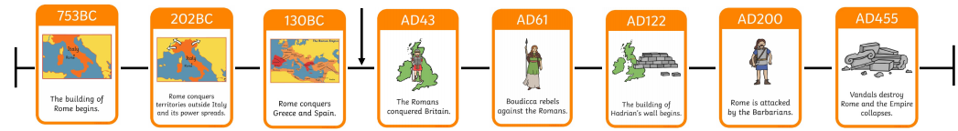

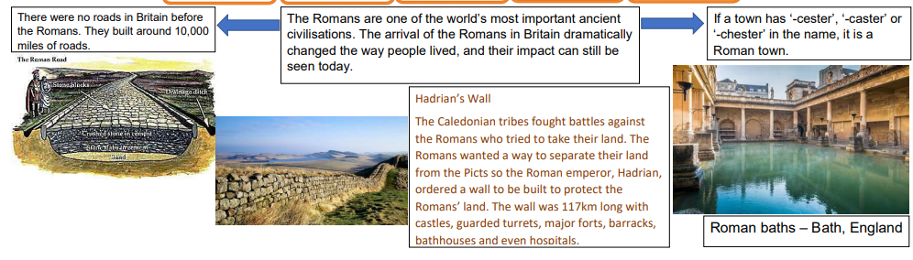
Why did they invade Britain? The Romans came looking for riches, lands and metals such as iron, copper and gold.
What made the Romans so powerful? The Romans had a very well organised army which allowed them to conquer other countries. The Roman army was one of the most successful armies in history and far more advanced than any other army at the time.
What did the Romans invent? They invented lots of things we still use today, including concrete, newspapers, books, calendars and central heating! The Romans built roads in the UK, 55,000 miles of roads in fact!

