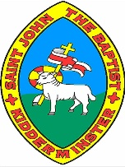
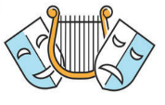
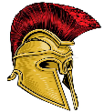
It’s All Greek to Me Knowledge Organiser

Map of Ancient Greece |  | Places, People, and Daily Life in Ancient Greece
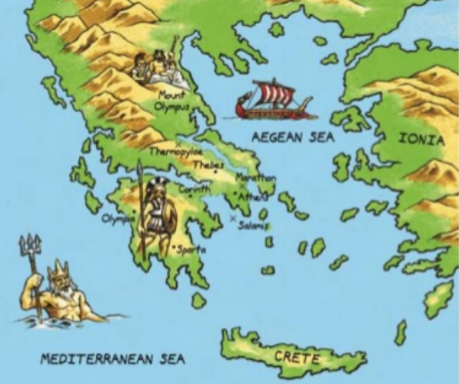  Greece’s position next to the sea (there are over 1400 islands) meant Ancient Greeks were a seafaring people. Trade between the islands led to the creation of ‘city-states’ (polis). Each city-state was ruled by a powerful city, led by a ruler or (later) government. Greece is a warm country, but winds from the Mediterranean, and rains from the north, kept temperatures livable and created fertile farming conditions. |  | The Acropolis | 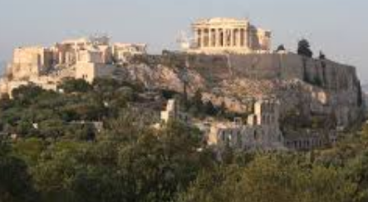 | The Acropolis of Athens is the best known acropolis in Greece – an acropolis is a settlement built on high ground. It was built during the rules of Pericles, a golden age for Athens, as a monument to the city’s greatness. | Where?  Athens | Key Fact:  The Acropolis is on a flat-topped rock that rises 150m above sea level
 |  | The Parthenon | 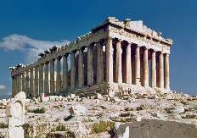 | The Parthenon is a temple in the middle of the Acropolis in Athens. It was a temple to Athena, the goddess of wisdom, and originally had a statue to her. It has now stood for nearly 2,500 years, a superb architectural achievement! | Where?  Athens | Key Fact:  The building used 22,000 tonnes of marble!
 |  | Mount Olympus | 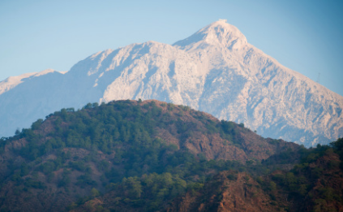 | Mount Olympus is the highest mountain in Greece. It was believed in Ancient Greek times that when things needed to be decided in the mystical world, the 12 main Gods would gather at Mount Olympus, and that many lived there. | Where?  50 miles southwest of Thessaloniki | Key Fact:  Mount Olympus rises to 2,918m
 |  | Knossos Palace | 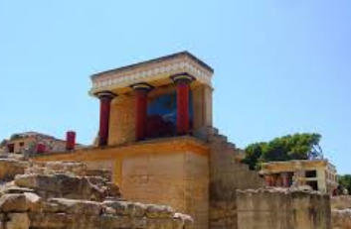 | Knossos Palace is positioned in what was the capital of Minoan Crete. It is the site of a beautiful and expansive palace, which is supposed to be the same location as the fabled labyrinth in which the minotaur dwells! | Where?  Northern Crete | Key Fact:  The Knossos Palace was rumoured to originally hold 5000 rooms!
 |  | Alexander the Great | 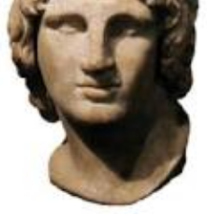 | Alexander the Great gained a strong and united Greece when he became King. He used his military genius to then win battle after battle, conquering eastern Europe and Egypt. | When?  356-323BC | Key Fact:  He died aged only 32. He accomplished a lot in his short life!
Key Vocabulary
Athens - The birthplace of democracy and the heart of the Ancient Greek civilisation
Athenians - People who live in Athens.
Spartans - The people of Sparta. They believed that strict discipline and a tough upbringing made the best soldiers
Democracy - Greek word meaning ‘rule by the people’. It is a form of government allowing people to have their say by allowing them to vote.
Olympics - Originated in Ancient Greece as a festival or celebration of and for Zeus the Olympics Games still take place every 4 years
Truce - When two fighting sides declare peace or a break in a war
Philosophy – Greek philosophers started a new type of thinking. Rather than believing in myths and stories, they began searching for the truth of the world by using their rational thinking.
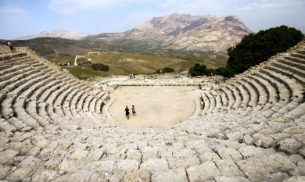
Theatre – The theatre-loving Ancient Greeks flocked to the hillside theatres during their leisure time to see the latest plays. Comedies and tragedies were performed by men only and they wore different masks, wigs and costumes to portray their different characters. All of today’s plays, TV programmes and films have their origins in Greek theatre.
 |  | Greek Homes | 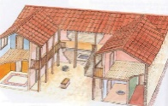 | Ancient Greek homes were built around a courtyard, which was the centre of activity. Around the courtyard were the rooms of the house, including work rooms and bedrooms. | How?  Homes were made of sun-dried bricks. | Key Fact:  Most houses had an ‘andron’ – a room just for men.
 |  | Childhood | 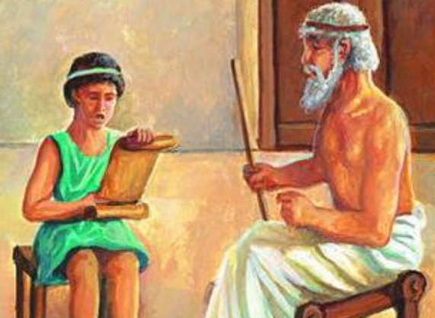 | When a child was born, a father could decide whether to keep or abandon the child. At age seven, the child could start school, learning maths, reading, and writing. | How?  Sometimes, children also studied music. | Key Fact:  Children were considered adults at only 13!
 |  | Food | 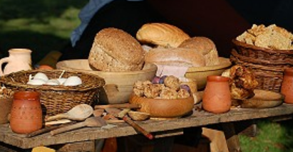 | The Ancient Greeks mostly ate bread dipped in wine, cheeses, fish, olives, and vegetables. Meat was eaten on rare occasions, such as festivals. Watered down wine was the main drink. | How?  Foods/wines were traded between cities. | Key Fact:  Many food festivals were for men only!
 |  | Clothes | 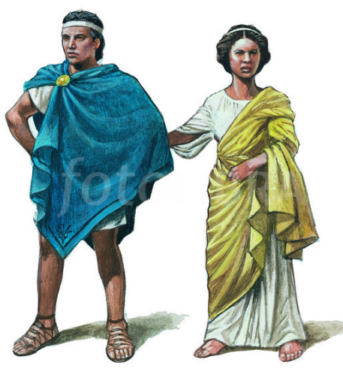 | The Ancient Greeks wore a tunic called a ‘chitin’ – worn by both men and women. These were fastened together at different places, and a belt was also normally worn at the waist. Chitins came in many sizes and colours. | How?  Chitins were generally made out of a thin wool material | Key Fact:  The rich could afford linen and silk chitins.
146 BC – Rome conquers Greece, making it a part of the Roman Empire.
432 BC – The Parthenon, the most famous building in Athens, is completed
336 BC– Alexander the Great is King and completes many conquests
400-300 BC – Socrates, Plato and Aristotle live, advancing learning
508 BC– Democracy begins in Athens, giving greater power to the people
570 BC – Pythagoras is born. He made major breakthroughs in science and maths
600 BC – The first Greek coins are used to buy and sell goods
776 BC – The first Olympic games take place in honour of Greece

