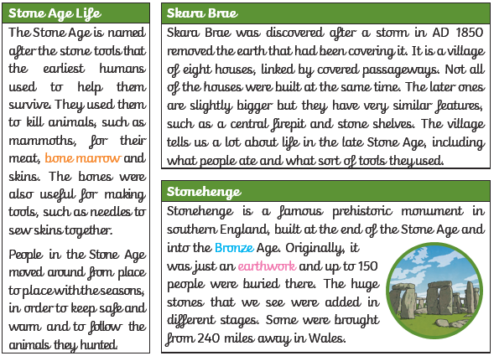
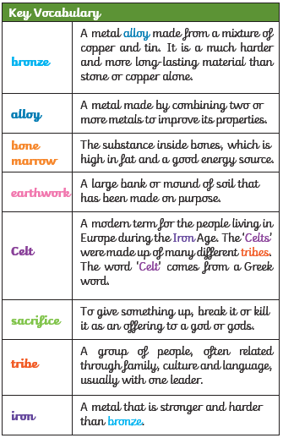
Stones and Bones Knowledge Organiser
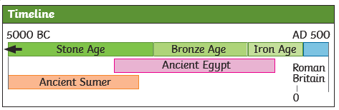

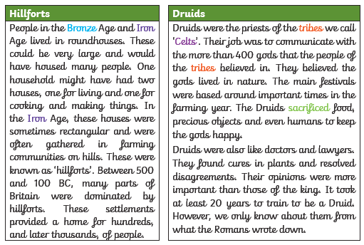
Stones and Bones Knowledge Organiser
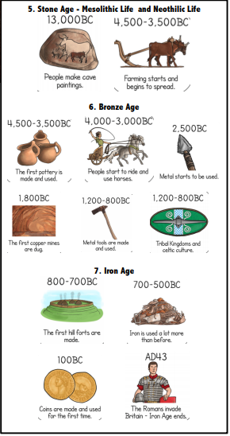

BC and AD | Important Time Periods
B.C. means Before Christ. A date such as 3000BC means 3000 years before the year 1 AD (there was no year zero) A.D. – means Anno Domini in Latin which stands for ‘in the year of our Lord’. A date such as 2021 AD means 2021 years after Jesus is believed to have been born. | Stone Age – When the first humans began to live in Europe. They used stones as tools.  Bronze Age - In this era, metals were used to make hunting tools. Humans also began to farm land.  Iron Age - Humans now used iron to make tools, and farmed land instead of hunting. They lived in communities.

