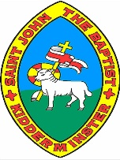
Walk like an Egyptian Knowledge Organiser
Key information
The Ancient Egyptians ruled over 5000 years ago and lasted for 3000 years. Pharaohs ruled Egyptians and one of the most famous was a boy called Tutankhamun. Ancient Egypt depended on the waters of the River Nile, which flows through harsh and arid desert. Only the land on the banks of the Nile could be cultivated to support life and farm on. The rest of Egypt was, and is, desert. The Ancient Egyptians made paper from reeds called papyrus and that is where we get the word ‘paper’. They wrote in pictures called hieroglyphics. The Egyptians were famous for creating magnificent buildings called Pyramids. The Egyptians built over 100 pyramids and some of them were almost 150 meters tall. Ancient Egyptians believed in several gods and mummified the bodies of wealthy and famous people to send them to the afterlife safely.
Key Vocabulary
Hieroglyphics | A system of writing that used pictures and symbols (hieroglyphs) instead of letters.
Pharaoh | The supreme ruler of Ancient Egypt
Mummification | Mummification is a process in which the skin and flesh of a dead body can be preserved in preparation for the afterlife. The Egyptians wrapped bandages around the corpse to protect the body from rotting
Canopic jars | Special jars that held the organs of a mummy including the lungs, intestines, liver and stomach
Pyramids | Giant tombs built for dead pharaohs
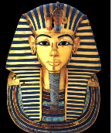  Tutankhamun | He became pharaoh at the tender age of nine in 1337 BC and reigned during the 18th Dynasty. A team of British archaeologists discovered his tomb in 1922, nearly 3000 years after his death.

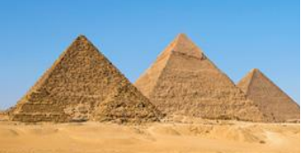
Pyramids in Egypt An example of Hyrogliphics
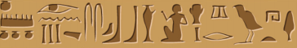
An example of Hyrogliphics
An example of Hyrogliphics

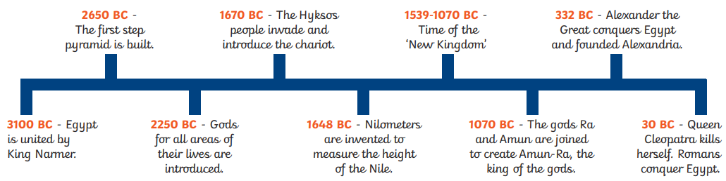
Ancient Egypt Timeline

