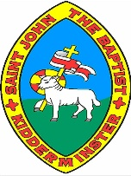
Amazing Grace Knowledge Organiser
Grace Darling | A young girl who rescued people from a shipwreck in a terrible storm.
Lighthouse | A tall tower that has a powerful light at the top to warn ships or boats about nearby rocks or land.
Longstone Lighthouse | The lighthouse where Grace lived with her family.
Coble Boat | A small, wooden boat with no engine or roof.
Oars | A long piece of wood with a flat bit at the end. You row with them to make a boat with no engine move.
The Forfarshire | The name of the ship that crashed into Harcar Rock.
Rescue | Saving a person or people from something dangerous.
Survivors | People who are still alive after something dangerous has happened to them e.g. their ship has sunk.
RNLI – Royal National Lifeboat Institution | The charity that is in charge of lifeboats. They use special boats to rescue people when they are in danger at sea or in big rivers.
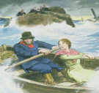
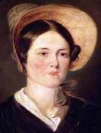

Why did Grace become famous? In the middle of a storm Grace and her father William used a small, wooden boat with no engine to rescue people from a shipwreck.
How did Grace Darling change the RNLI? Grace was the first woman to get a medal from the RNLI. Queen Victoria wrote a letter and gave a reward to Grace Darling, so Grace Darling became famous. After hearing about Grace Darling, Victorian people started to realise how important lifeboats are for rescuing people in danger at sea.
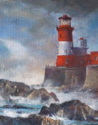
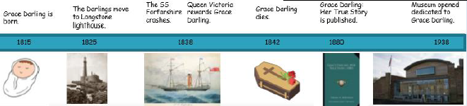
How did Grace help to improve women’s lives in Victorian times? Victorian people thought women couldn’t do heroic things (like rescuing people from dangerous situations). People thought women should have children, cook, sew and clean. Grace Darling’s strength and bravery helped to change this. People started to learn that women could be strong and brave just like men could.

