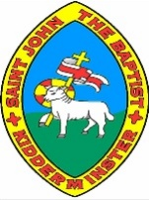
Knowledge Organiser – Victorian Times and Designs
Key Facts
How long have toys existed? | Toys have existed for thousands of years. They were made of the materials that were available at the time. Even stones and string have been made into toys.
What were toys made of during the Victorian era? | Toys were mainly made of wood, paper and metal during the Victorian era.
What toys did Victorian children play with? | Rich Victorian children played with toys such as clockwork trains, rocking horses, tea sets and dolls. Poorer children played with homemade toys such as peg dolls, wooden boats and rags stuffed with sawdust to make balls or toy animals.
What are modern toys made of? | Modern toys are mainly made of plastic. This is because it is usually safer and easier to make things with.
How are modern toys different? | Many modern toys use electricity to work. Computers and consoles were made in the 20th Century
Key Vocabulary
Victorian | The time of Queen Victoria’s reign. 1837-1901.
20th Century | The 20th Century was 1900-1999.
21st Century | We are in the 21st Century. It started in the year 2000 and will end in 2099.
wooden toys | Lots of toys were made of wood. Boats, train sets and cup and ball were all made of wood. Some toys are still made of wood.
paper toys | Some toys, like paper windmills, were made out of paper.
metal toys | Toy soldiers and some spinning tops were made out of metal.
plastic toys | Most modern toys are made of plastic. Toy soldiers, dolls and ride-on cars are usually made of plastic.

Knowledge Organiser – Victorian Times and Designs
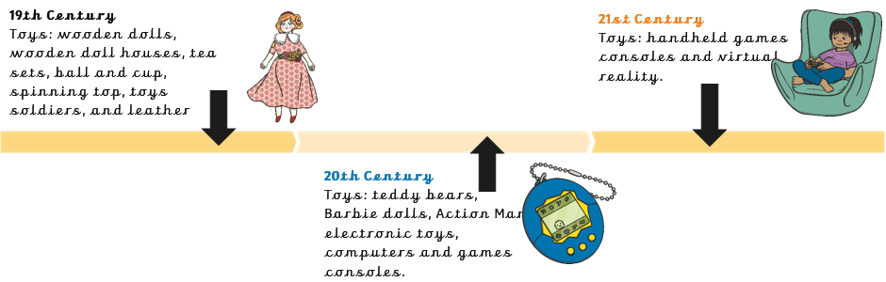
A Toy Timeline
Victorian School Life
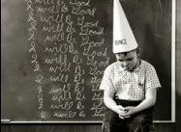
For many years, only children of rich families went to school or were taught at home by a teacher called a governess. Poor children couldn’t go to school as they had to work to earn money. In 1893, the law changed to allow all children to go to school for free.
Victorian school was strict with lots of rules. Naughty children had harsh punishments, such as writing lines or wearing a dunces’ cap. Sometimes, children would be beaten with a stick called a cane.
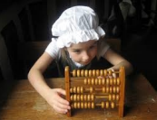
Teachers used a blackboard with chalk. Young children would write on mini blackboards called slate. Older children used ink and paper.
For Maths, children would use an abacus.

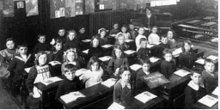
Classrooms were tightly packed with lots of children, Sometimes, there would be over 100 children in the same room! Children had to be silent all the time and were not allowed to ask questions.

