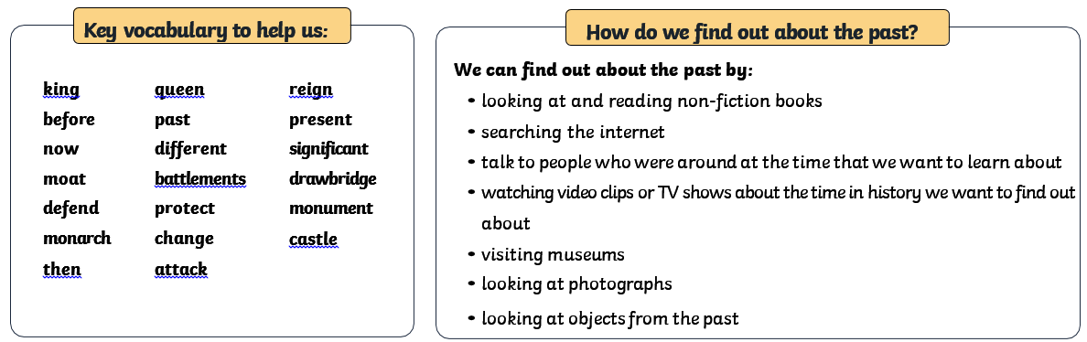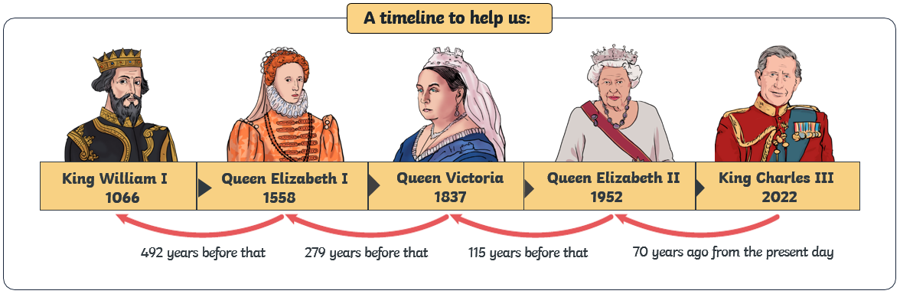

**Rule Britannia Knowledge Organiser**

**Where did kings and queens live through time?**

