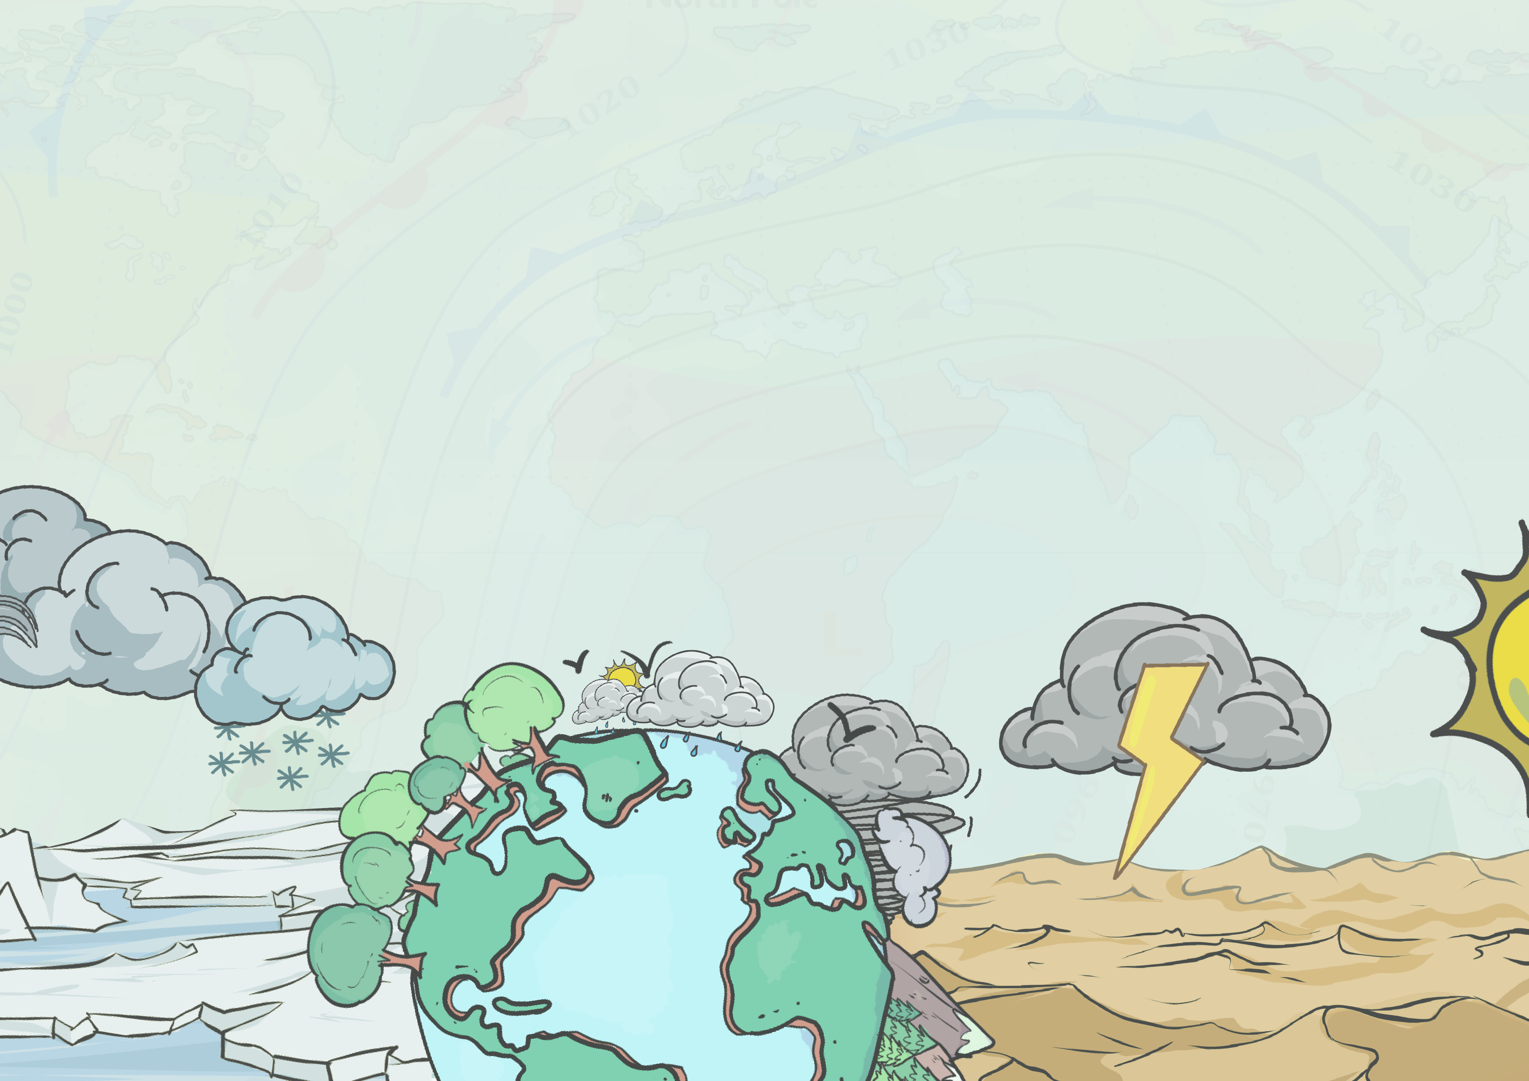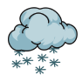

**Weather and Climate** 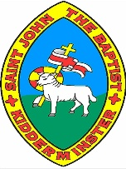

**Year 2**

**Knowledge Organiser**

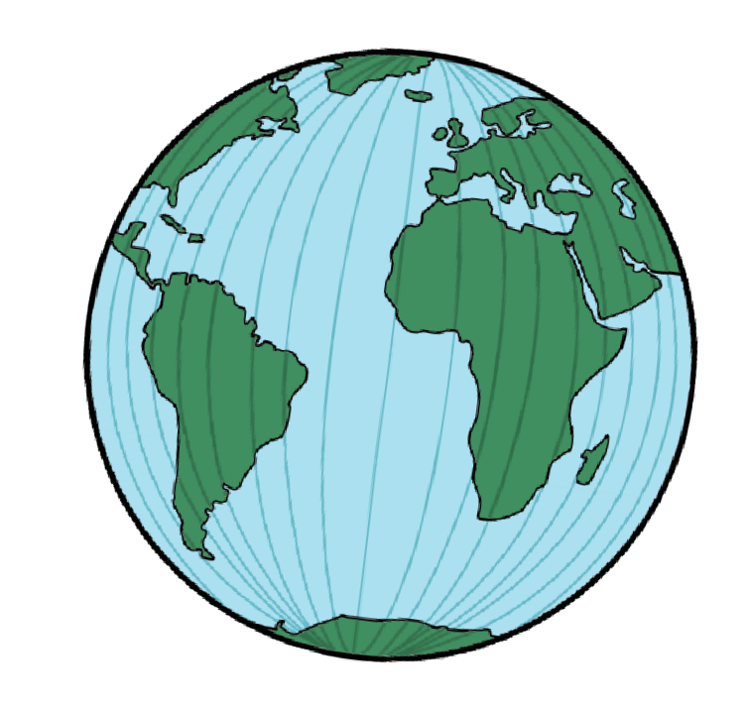

**S U N**

**rays from the Sun**

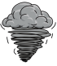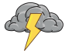

**o**

**S**

**equator**

**N**

**o**

**r**

**t**

**h**

**P**

**o**

**l**

**e**

**e**

**l**

**o**

**P**

**h**

**t**

**u**

**Climate zones**

**Why are there different climate zones?**

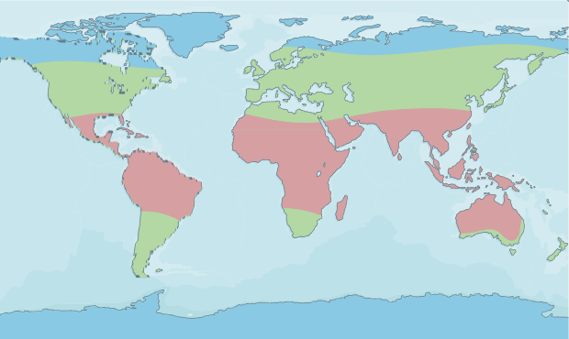

**Climate key:**

**hot temperate**

**cold**

**South Pole**

This map shows the **different climate zones** around the world.

The Earth is round and **tilted at an angle**, so the Sun’s rays **don’t fall evenly on the land and oceans**. Places on the equator are the **hottest places** on Earth. They are the **closest to the Sun** and get the most **direct sunshine.**

The Sun shines less directly on the **North and South Poles** because they are f**urther from the Sun**, so they are the **coldest places on Earth.**

Places in the **northern and southern hemispheres** can have a **similar climate** if they are the **same distance** from the **equator**.

**The United Kingdom**

The **UK** has a **temperate climate.**

**Weather words**

**How does climate affect weather?**

**Clouds**

**Rain**

|  |
| --- |
|  |
| **Hot** |
| Hot weather can mean there is **little or no rain all year**. These hot, dry places are called **deserts**.  Hot weather can also be **damp**. Another word for this type of weather is **humid**.  It can **rain a lot** in some hot places. These places are called **tropical**, and **rainforests** are often in these areas.  Places near the **equator** tend to have the  **same or similar weather all year round**. |

|  |
| --- |
|  |
| **Temperate** |
| These areas lie **between the equator and the poles**.  Places in temperate areas do not tend to have ‘**extreme**’ climates.  The temperatures in these areas are described as **mild**. They are not extremely hot or extremely cold.  They have a **moderate amount of rainfall** all year round.  Places in temperate areas have **four seasons**. |

|  |
| --- |
|  |
| **Cold** |
| These areas are **close to the poles**.  The **closer** a place is to a **pole**, the  **colder it is**.  The poles have **extremely low temperatures** – less than freezing for most of the year, so there is a lot of **ice and snow**.  Places near the **poles** tend to have the **same or similar weather all year round**. |

|  |  |  |
| --- | --- | --- |
|  | **Snow** | **Temperature** |
| drizzle | hail | hot  warm  cool  cold  freezing |
| showers | sleet |
| rain | snow |
| downpour | snowflake |
|  | **Wind** | **Other vocabulary** |
| cloudy | breeze blustery windy gale | forecast |
| gloomy | drought |
| foggy | lightning |
| overcast | thunder |
| clear | rainbow |



www.grammarsaurus.co.uk



**Measuring the weather**

**Forecasting the weather**

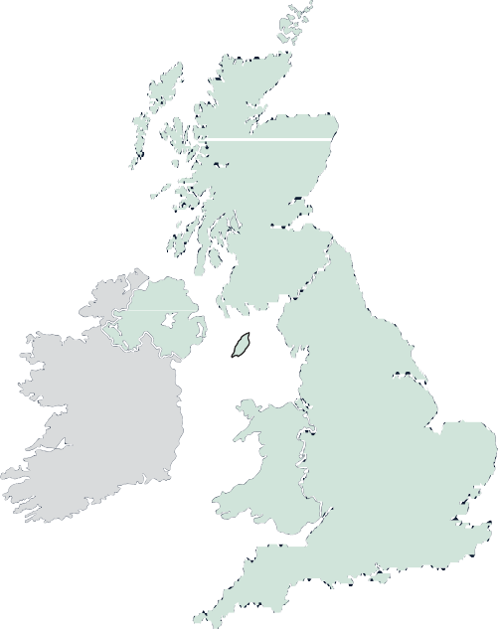

**17°**

**Stornoway**

**18°**

**Wick**

A **weather forecast** is an **informed prediction** about what the **weather** will be like **today, tomorrow, this week or next**.

A meteorologist may **record the forecast** using a weather map.

**21°**

**Inverness 23°**

**Aberdeen**

**18°**

**Isle of Mull**

**21°**

**Glasgow**

**25°**

**Dunbar**

**24°**

**Belfast**

**22°**

**Carlisle**

**28°**

**York**

**26°**

**Liverpool**

**27°**

**Birmingham**

**29°**

**Norwich**

**22°**

**Cardigan**

**28°**

**London**

**23°**

**Southampton**

**23°**

**Plymouth**

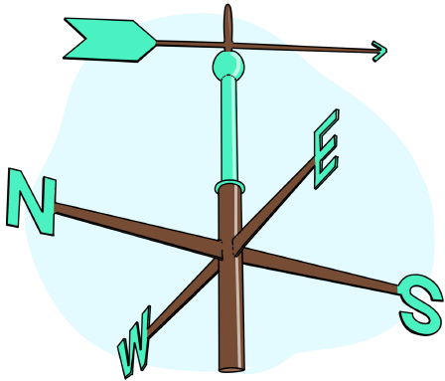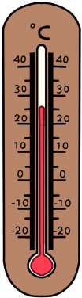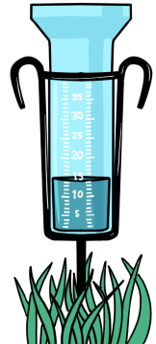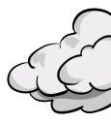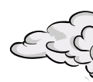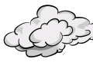

A **thermometer**

measures

**temperature.**

A **weathervane**

measures

**wind direction.**

A **rain gauge**

measures

**precipitation.**

An **okta card**

measures

**cloud cover.**

**heavy snow**

**Fieldwork**

**Weather map symbols**

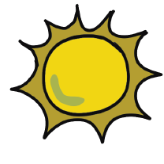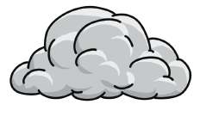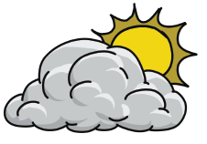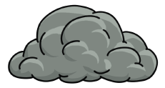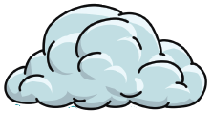

**Symbols** are used to show the **type of weather** expected. Symbols give people a clear and simple understanding of **what weather is on the way.**

**sunny**

**partially sunny**

**light rain**

**heavy rain**

**hailstones**

**cloudy**

**thunderclouds sunny with showers**

**lightning**

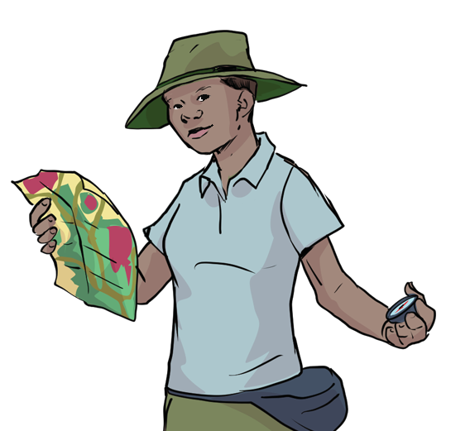

**Fieldwork** is when you go outside and discover things about a place. Fieldwork includes investigating both **human and physical features**.

When conducting fieldwork, we must **ask the following questions before we carry it out**:

* What is the fieldwork you will carry out?
* Where and how will you carry it out?
* Why will you be doing it?



www.grammarsaurus.co.uk