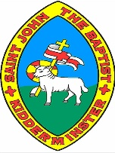

**My Region and Campania**

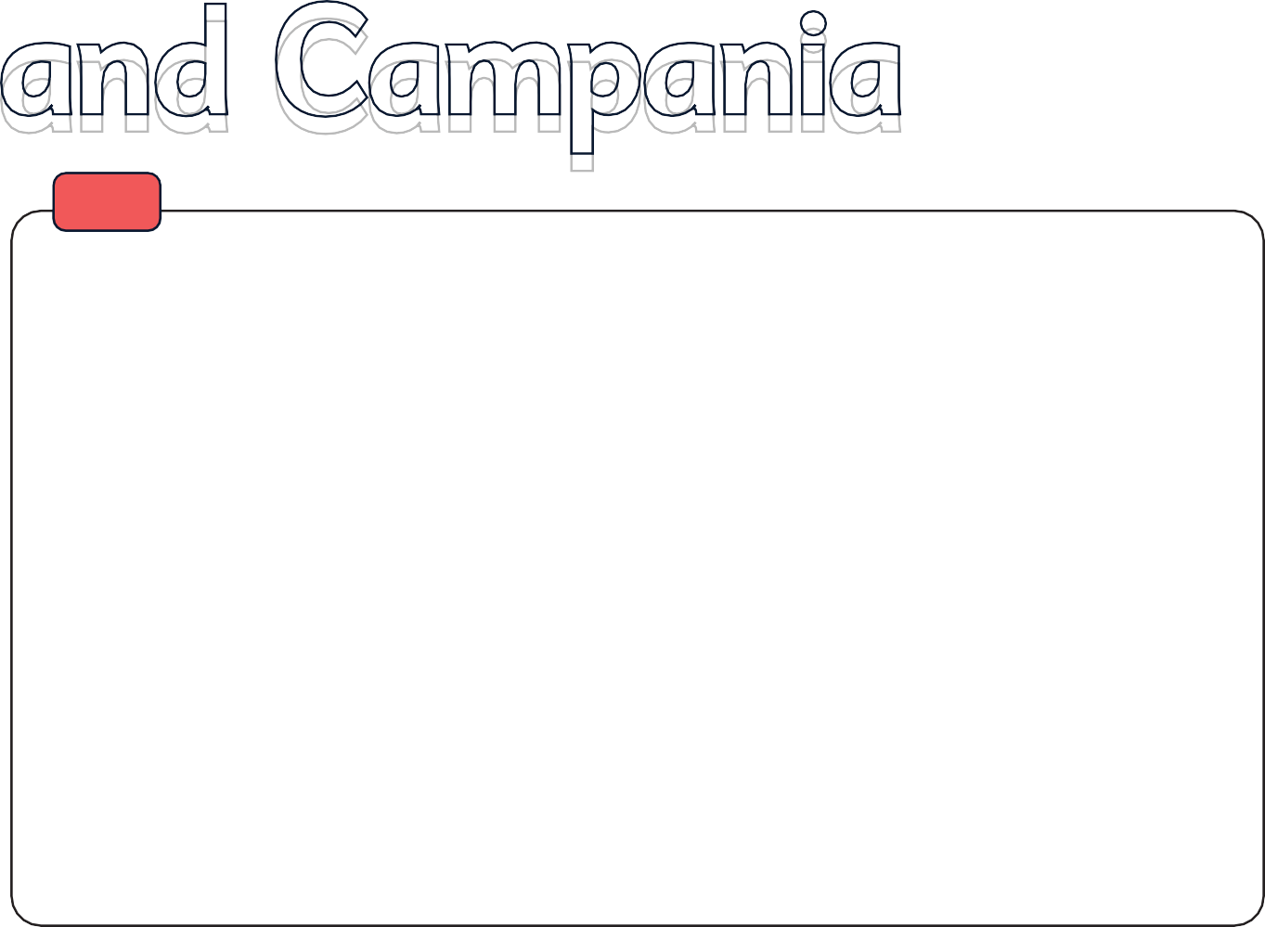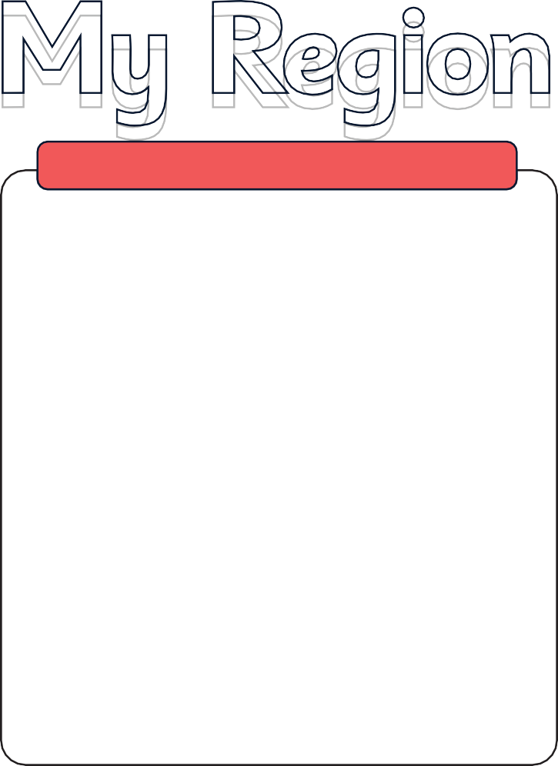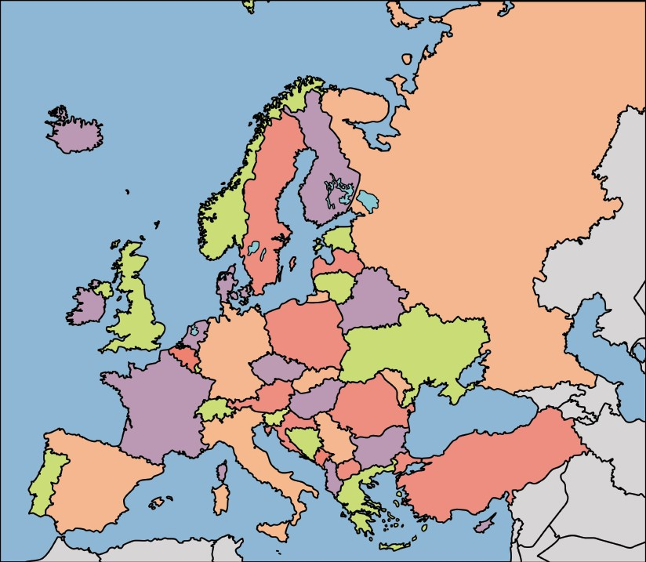

**The countries and capital cities of Europe**



**Knowledge Organiser**

**Italy**

Europe is one of the **seven continents** of the world. It is a collection of **44 individual countries** and **capital cities**.

Italy is located **south of Europe** and **north   
of the Mediterranean Sea**.

# Italy is a **peninsula** which means it is surrounded by water and only connected to land at one end.

The capital city of Italy is **Rome**, and some other famous cities are **Milan, Venice, Naples and Florence**.

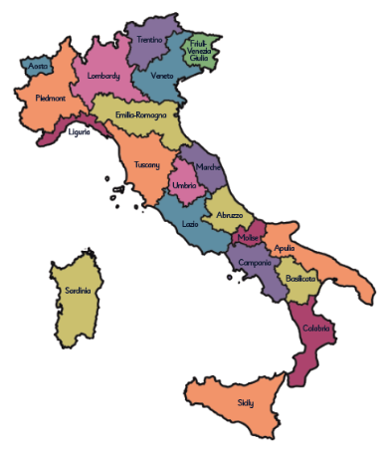

Italy’s land shape looks

like a boot!

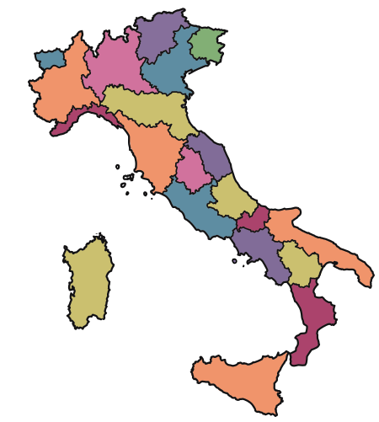

Aosta Piedmont

Lombardy

Trentino

Veneto

Friuli- Venezia Giulia

# Italy’

Liguria

Emilia-Romagna

Tuscany

Marche Umbria

like

Sardinia

Lazio

Abruzzo

Molise Campania

Apulia

Basilicata



Calabria

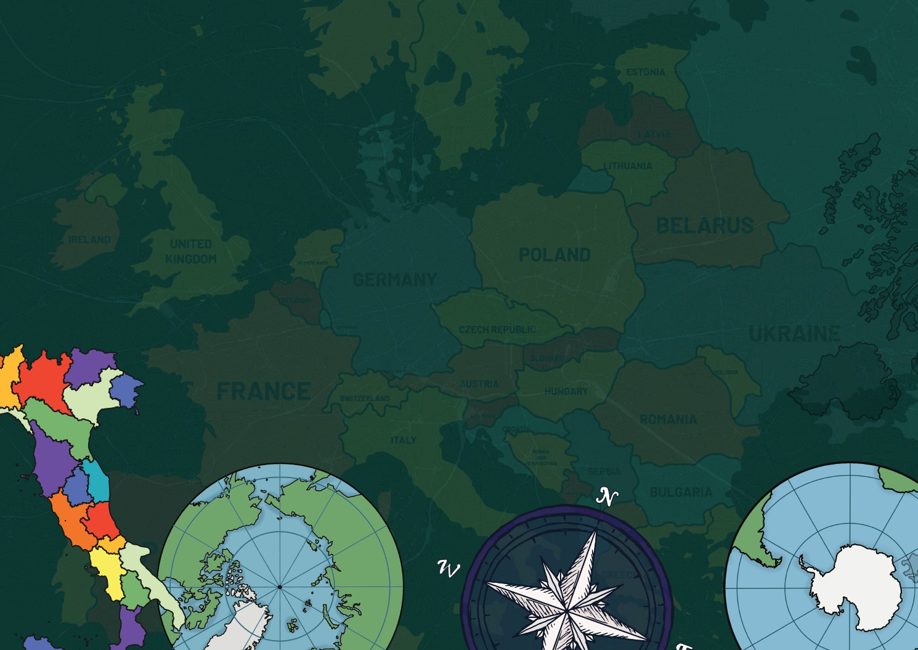



Sorrento

Capri

Gulf of Salerno

Tyrrhenian Sea

Sicily

Another famous settlement in Campania is the town of **Amalfi**. Amalfi is the largest town in the middle of the **Amalfi Coast**. Amalfi has landmarks such as beautiful **medieval buildings**, including a famous **cathedral**.

**Key physical features of Campania**

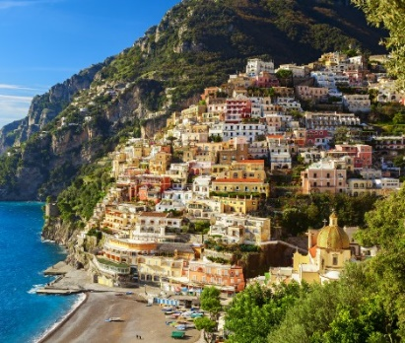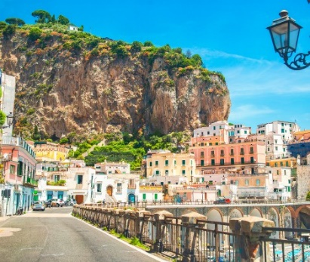

www.grammarsaurus.co.uk

**Positano** is a settlement in the **Campania region**. It is famous for its **pastel-coloured houses** built on cliffs down to the sea.

The island of **Ischia** is famous for it **hot springs**.

**Amalfi Coast**

**Mount Vesuvius**

**Apennine Mountains**

**Key human features of Campania**

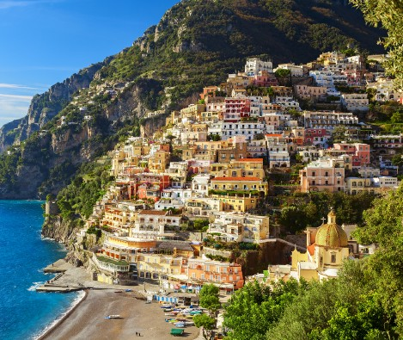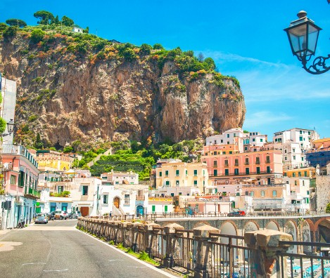

www.grammarsaurus.co.uk

**Positano** is a settlement in the **Campania region**. It is famous for its **pastel-coloured houses** built on cliffs down to the sea.

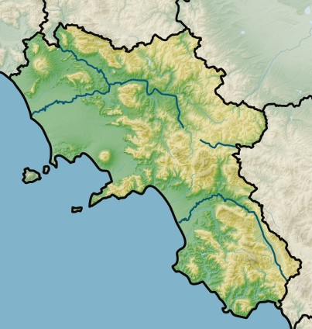

Monte Milleto

2050

Volturno

Campania Plain

Naples

Gulf of Naples

Mount Vesuvius 2050

Ischia

**Amalfi Coast**

The island of **Ischia** is famous for its **hot springs**.

**Mount Vesuvius**

**Apennine Mountains**

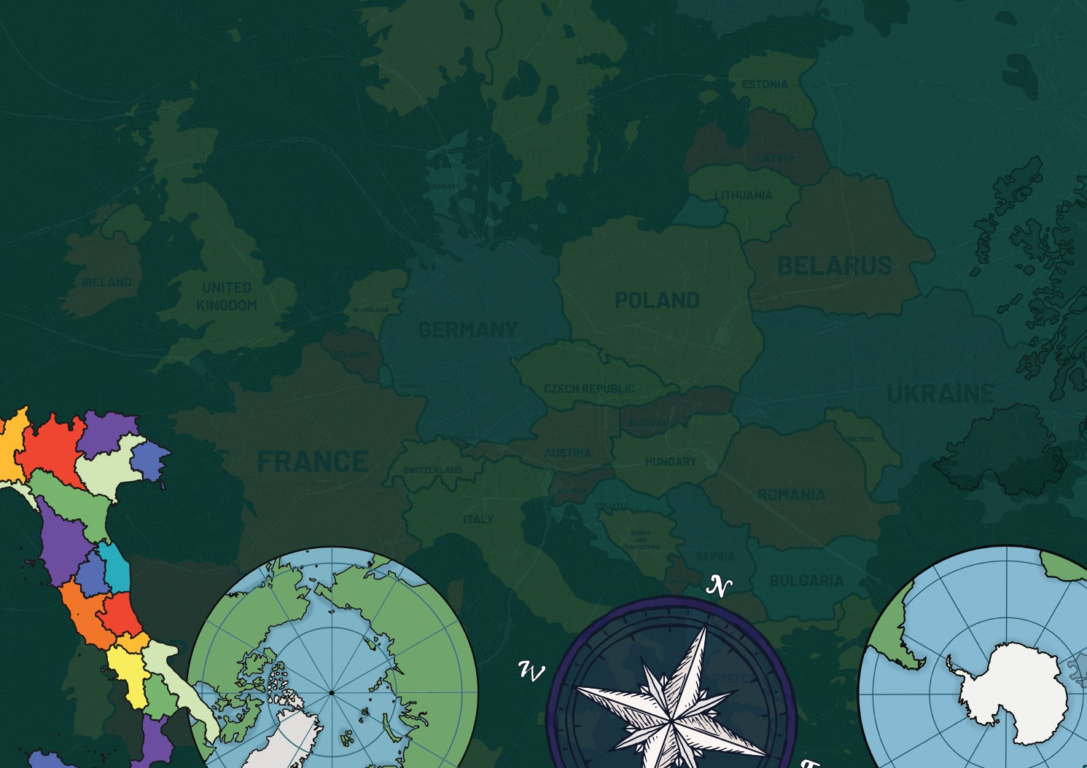

**What are volcanoes?**

**Plate tectonics**

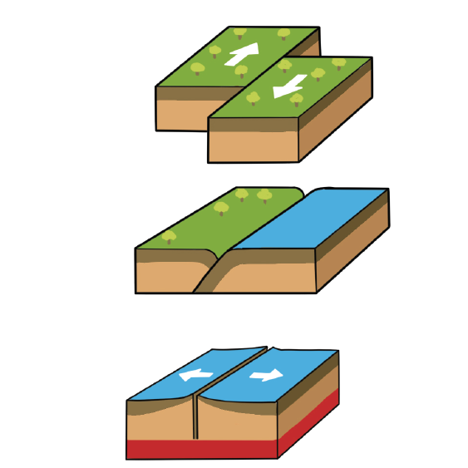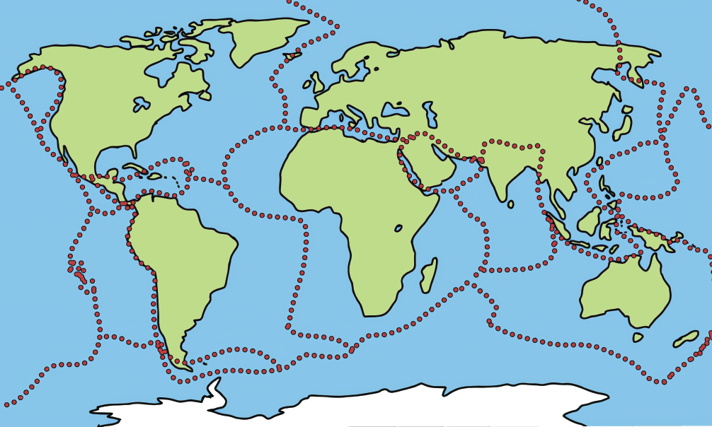

**Juan de fuca Plate**

**Eurasian Plate**

**North American Plate**

**Arabian Plate**

**Carribean Plate**

**African Plate**

**Philippine Sea Plate**

**Cocos Plate**

**Pacific Plate**

**Indian Plate**

**Pacific Plate**

**South American Plate**

**Nazca Plate**

**Australian Plate**

**Easter Plate**

**Juan Fernandez Plate**

**Scotia Plate**

**Antarctic Plate**

These types of movement include:

**moving plate**

**transform** – where plates slide

past each other

**transform**

**moving plate**

**continental plate**

**convergent** – where plates come

together

**convergent**

**oceanic plate**

**oceanic plate**

**divergent** – where plates are

pulled apart from each other

**divergent**

**oceanic plate**

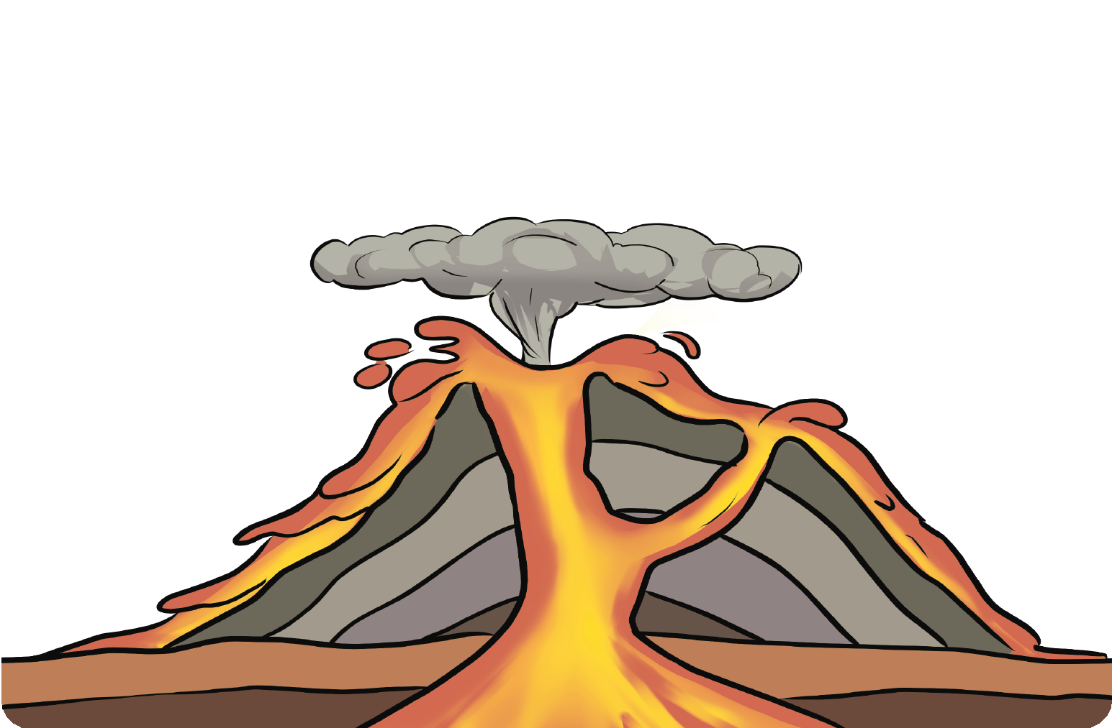

A volcano is an opening in the Earth’s crust from which molten lava, rock fragments, ash, dust and gases are ejected from below the Earth’s surface. A volcanic eruption happens when magma below the surface rises to the top of the mountain, causing gas and bubbles to appear. Pressure from this gas can build so much that a volcano explodes. Then it erupts!

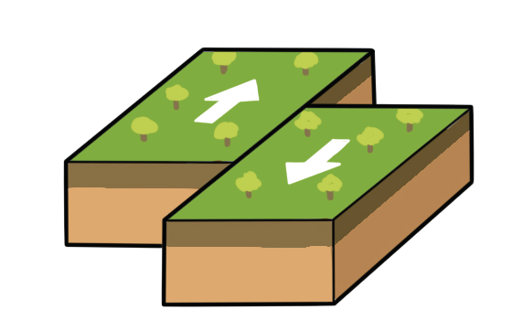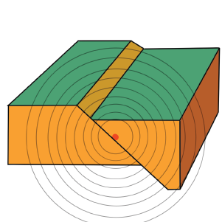

**moving plate**

**moving plate**

**fault plane**

**focus**

**seismic waves**

**epicentre**

**transform**

**Alfred Wegener** believed the continents and ocean floors “**float**” on **moving rock plates** and have been drifting for millions of years. This theory is called **plate tectonics**. The plates move about **1 to 10cm every year**. Plates can move towards each other, away from each other or rub alongside each other.

There are **three types** of **major plate boundary movements**.

A **vent** is an opening in the Earth from which magma may **escape**. There may be more than one on a volcano. The side of a volcano is called **the flank**.

**Lava** is hot, liquid rock that has **erupted** from a volcano. When it cools down, it becomes **solid**.

After an eruption**, layers of ash and lava** are built up, and the volcano grows over time.

**Smoke and ash** form during an eruption above the volcano. This is called an ‘**eruption cloud**’.

A **conduit** is an **underground passageway** which the magma can move through.

A **magma chamber** is an **underground pool** of liquid rock beneath the surface of the Earth. This liquid rock is called **magma**.

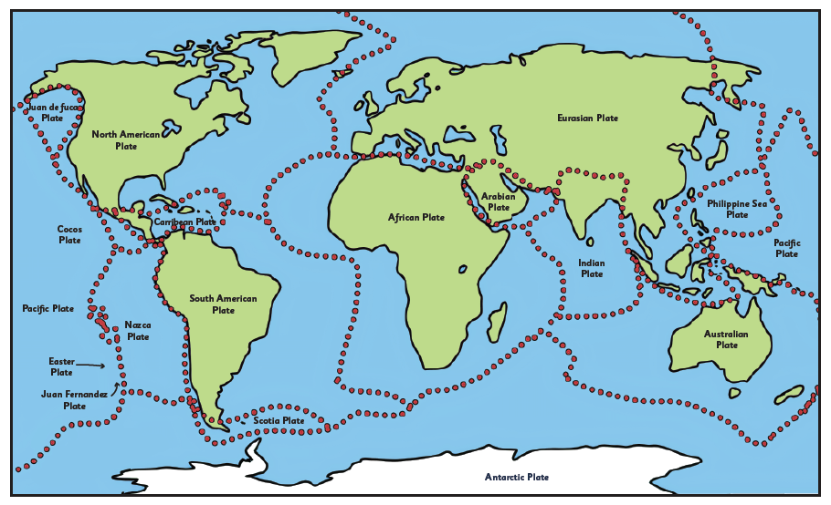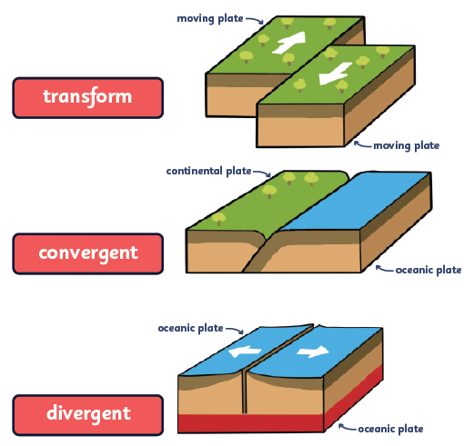

www.grammarsaurus.co.uk

Most of the time, you can’t see the **plate lines** in an aerial photo. However, you can sometimes see evidence of the **tectonic plates moving**.

Evidence you might see includes **valleys, mountains and volcanoes**.

**What are earthquakes?**

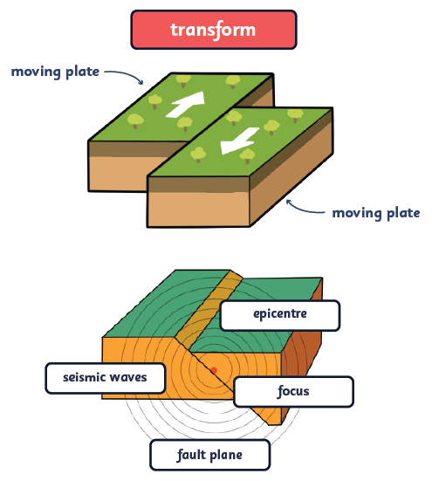

An **earthquake** (or quake, tremor) shakes the Earth's surface and is caused by **sudden movement** in the Earth’s crust. They can be extremely violent. The rock gets stretched or squeezed as the plates move until it splits. This squeezing and stretching are what cause the ground to **tremble and move**. The movements create **seismic waves**.

The point where the earthquake happens is called the **focus**. **Seismic waves** move out from this point. The point at ground

level, directly above the focus, is called the **epicentre**.