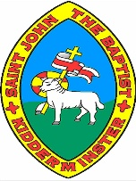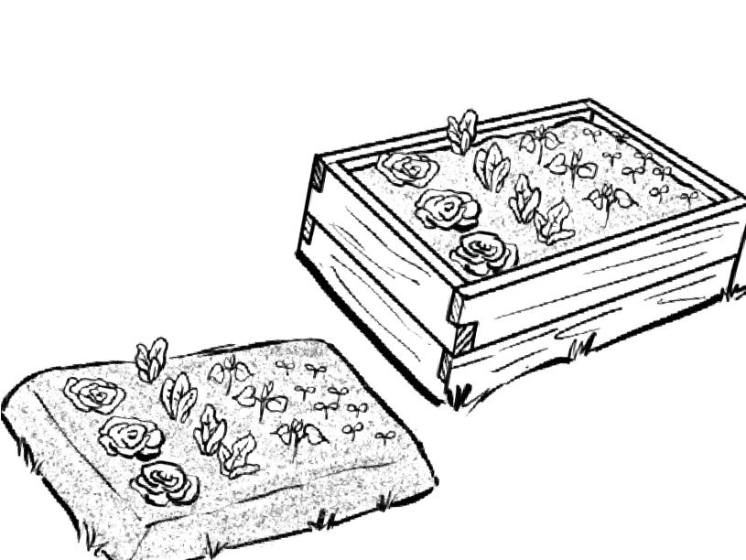

**Our School Grounds**

**Year 1**

**Knowledge Organiser**

**Observational sketches** can be used to **record features**. An architect might draw observational sketches when they are **redesigning a location**. A geographer might draw observational sketches when they are **carrying out fieldwork**.

**Winter Street**

**Red Road**

**Main Street**

**Green Road**

**Maps**

**Observational sketches**

Most maps are **smaller drawings of a real place**. They don’t always have space to include everything. To help us find **important places** on a map, we use **symbols**. This can help to make maps **clearer and easier to read**. It has symbols to represent different places.

**house**

**bank**

**shop**

**post office**

**library**

**school**

**restaurant**

**police station**

**park**

**farm**

**key:**

**key:**

**house**

**bank**

**shop**

**post office**

**library**

**school**

**restaurant**

**police station**

**park**

**farm**

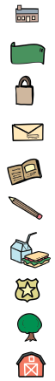

A **key** is used on **maps** to help you understand the

**symbols**.

**Farm Lane**

**Leaf Street**

**Gold Street**

|  |  |
| --- | --- |
| **Observational sketch of a raised flower bed** | **Observational sketch of a vegetable garden** |
|  |  |

**Our Senses**

**Plant life**

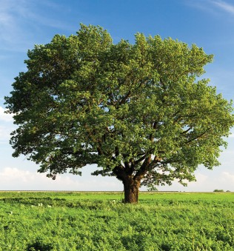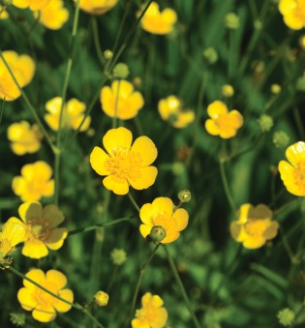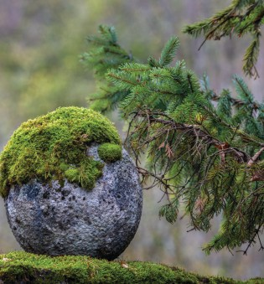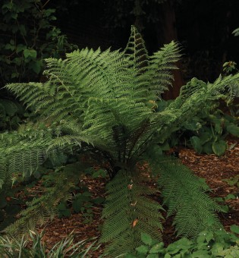

Plants are l**iving things that grow**, usually on the Earth. Plants differ from animals because they **cannot move from one place to another.**

**tree**

**flower**

**moss**

**fern**

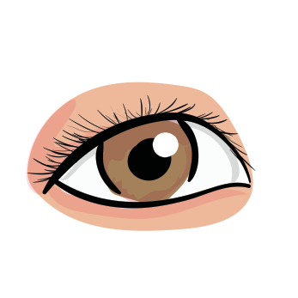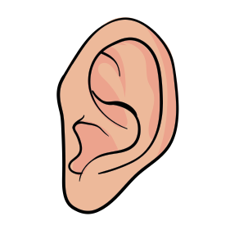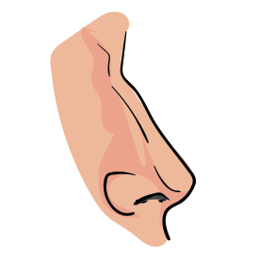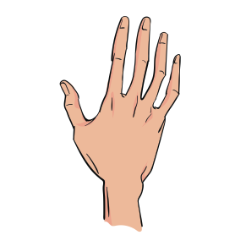

**sight**

**hearing**

**smell**

**touch**



www.grammarsaurus.co.uk

**Fieldwork**

**Sketch maps**

A **sketch map** is a drawing that shows the important things in a place, like a park or a classroom. It helps us remember **where things are located and how to find them**. We use **simple shapes and lines** to show different things when we draw a sketch map. For example, we can draw a **square to represent a building, a circle for a tree, or a line for a path.**

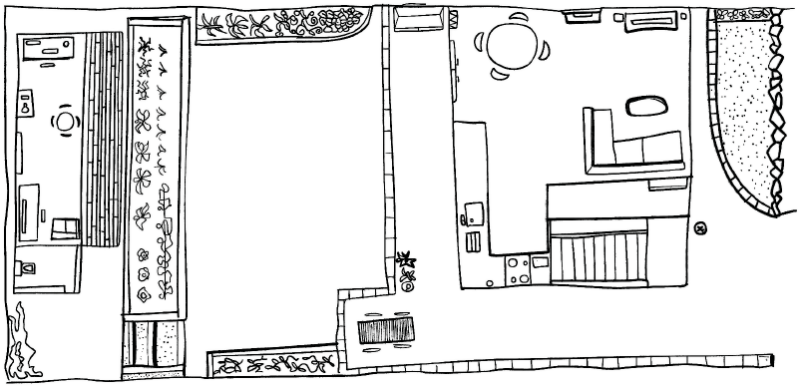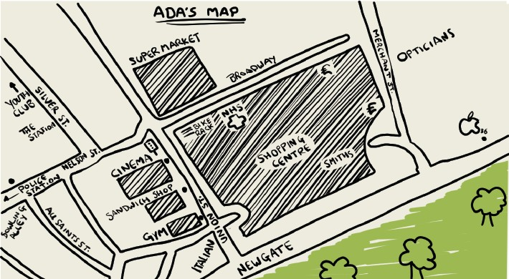

**Fieldwork** is when you go outside and discover things about a place. Fieldwork includes investigating both **human and physical features**.

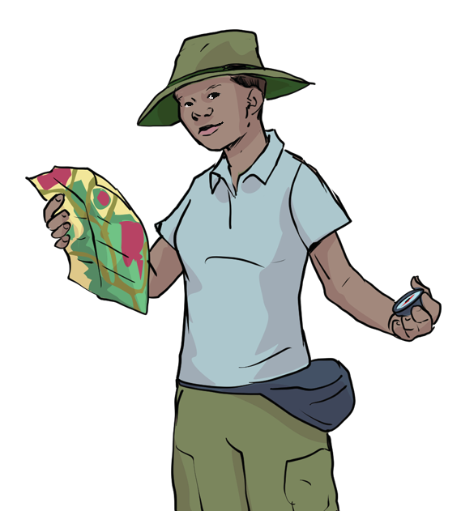

When conducting fieldwork, we must **ask the following questions before we carry it out**:

* What is the fieldwork you will carry out?
* Where and how will you carry it out?
* Why will you be doing it?

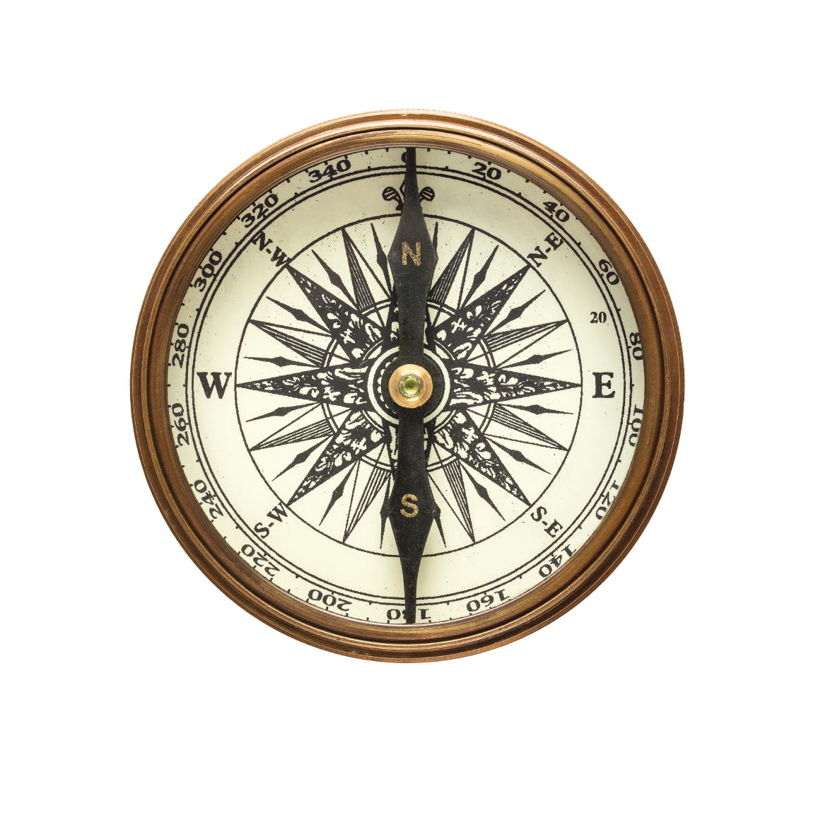

# 

**Directional language**

**Compass**

**forward**

**right**

A compass is a tool used to help find **directions**. It has a **needle** that spins, and the needle **always points north**. The **four directions** on a compass are called **cardinal points**.

**N – north E – east**

**S – south W – west**

You can use this to **help you remember**!

**N**ever **E**at **S**illy **W**orms



**downward**

**left**

www.grammarsaurus.co.uk

