

**Economic Activity of the UK**

**Knowledge Organiser**

**Year 6**

**Agriculture**

**Sectors of the UK economy**

# Geography of the UK

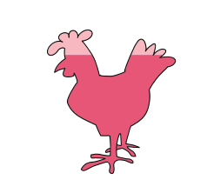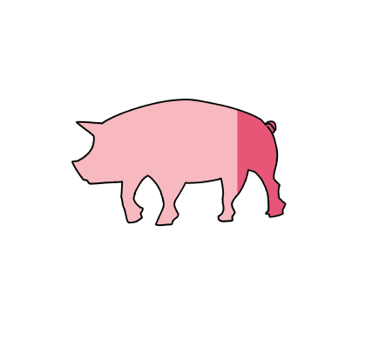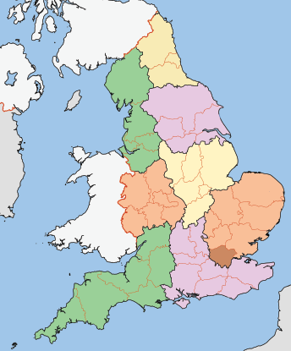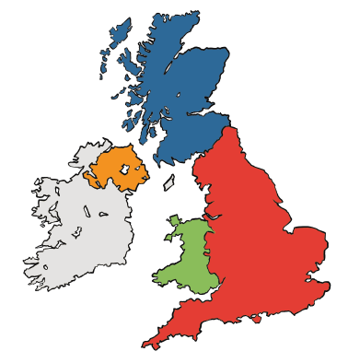

The UK comprises **four countries**: England, Northern Ireland, Scotland and Wales. The **capital cities** of these countries are London, Belfast, Edinburgh and Cardiff. England is made up of nine regions shown in the map below:

In the UK, economic activity can be split into **three different sectors**: primary, secondary and tertiary:

**Primary   
sector**

extracts and uses   
natural resources of the Earth

**Secondary sector**

manufactures goods using the raw materials provided by the primary sector

In the UK, agriculture can be carried out **'intensively' or 'extensively.'** Intensive farming involves small areas of land used for large crop and animal production. Usually, animals are kept in smaller spaces for this to be possible.

**Intensive farming statistics**

**85%**

**85 million**

**25%**

**Tertiary sector**

provides services to customers and their sectors of industries

Over **85%** of the UK’s farmed land animals live in factory farms.

Demand for energy in the UK, 1995-2021

More than **80 million** animals are living in intensive farms at any given time.

The number of **mega-farms** in the UK **rose** by more than **25%** in the six years leading up to **2017** and continues to climb.

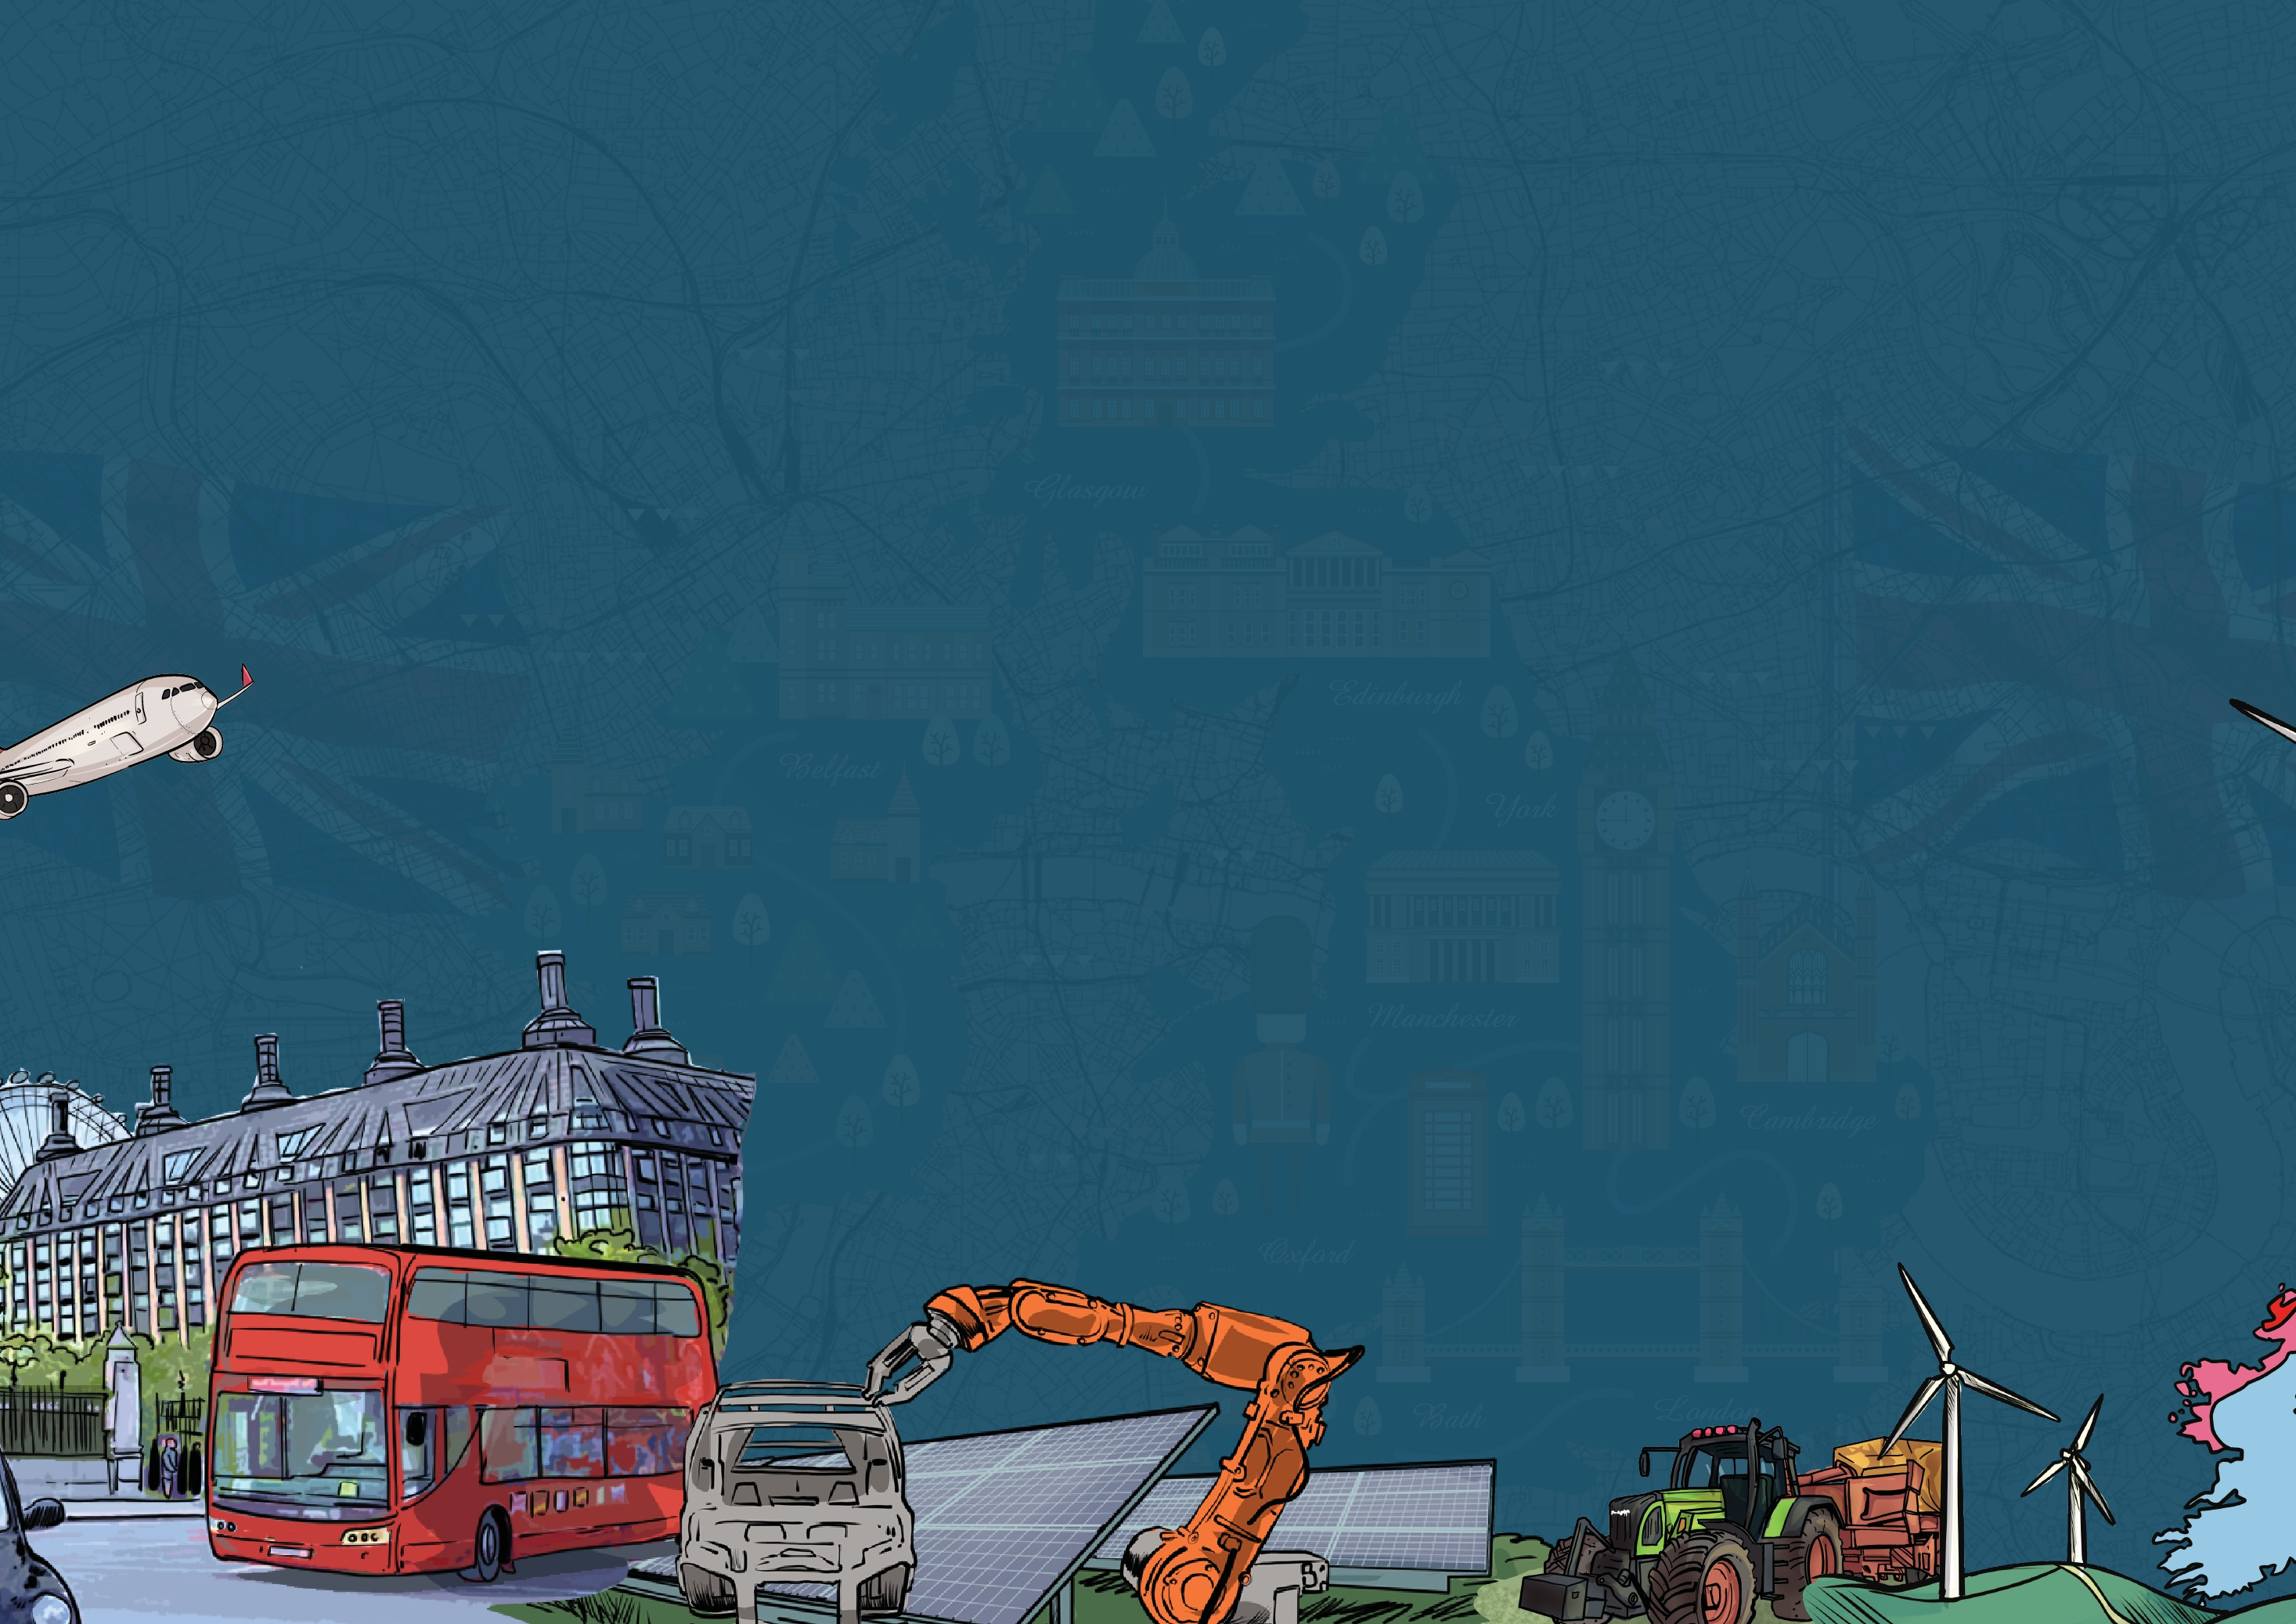

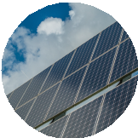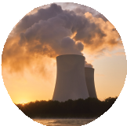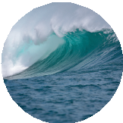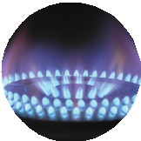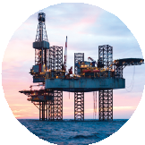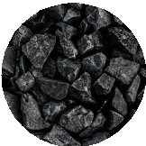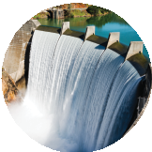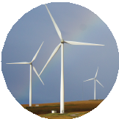

coal

nuclear

petroleum bioenergy and waste

natual gas wind, solar and hydro

Energy can be generated and captured from **multiple different sources**. These sources can be sorted into two categories: **renewable and non-renewable**. Renewable energy sources are **naturally occurring and replenished** in the environment. These could be used indefinitely without running out. Non-renewable energy sources are found on Earth in a **finite supply**, meaning a specific amount that will eventually run out.

**Renewable and non-renewable energy sources**

**300**

**250**

**200**

**150**

**solar – renewable**

**wind – renewable**

**hydro (water) – renewable**

**nuclear – non-renewable**

**100**

**50**

**0**

**wave – renewable**

**coal – non-renewable**

**gas – non-renewable**

**oil – non-renewable**

**1995**

**2000**

**2005**

**2010**

**2015**

**2020**

www.grammarsaurus.co.uk

**Energy Generation**

**millions tonnes oil equivalent**



**Waste management**

**Rare earth elements**

**Water use**

Automation is the technology of **completing a task using machinery** with as **little human assistance as possible**. **AI (artificial intelligence)** is a form of automation which uses **computers** that are programmed with the ability to **'think' and learn.**

Machines are less likely to make **manual errors** than humans. They also **work faster** than humans and **don’t need breaks**, making more products.

Machines can **complete repetitive, tedious tasks**, making human workers more happy. Once the machines have been **purchased,** they are **cheaper to run** than paying humans long-term. Computers can also be used for security and to recruit new staff by **automatically** choosing the best job applications.

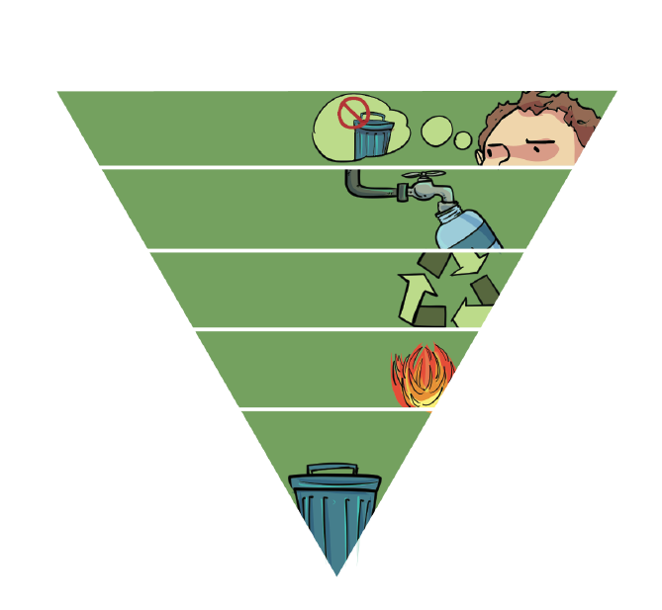

The UK has developed a **waste management hierarchy** for dealing with waste produced in the country. **Waste prevention** is the key element of the hierarchy; **refusing** single-use plastics and using **reusable products** is the first step to **reducing our environmental impact.** Limiting our **reliance on landfills** is very important.

**Waste hierarchy negatives of landfill**

**waste prevention**

**reuse**

**Lance**

**recycle/compost**

**energy recovery**

**disposal**

**Jamie**

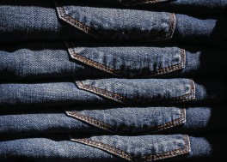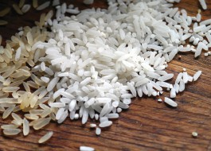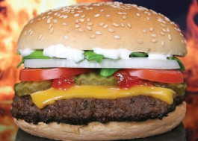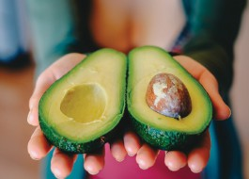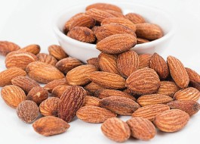

**Water** is one of the most important resources on Earth; we all need it to survive. Unfortunately, water is a **finite resource**, so there is only a certain amount that remains on Earth which is going through the **water cycle**. **‘Virtual water’** is water used to **produce different products**; when the UK uses these products, they ‘use’ the water used in their production.

**Products with a high 'virtual' water footprint**

**coffee**

**cotton**

**rice**

**beef**

**avocados**

**almonds**

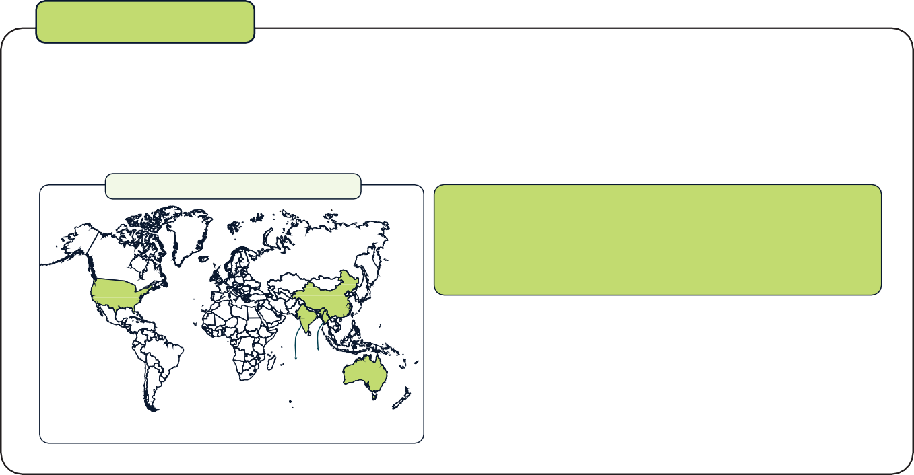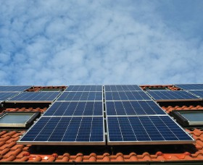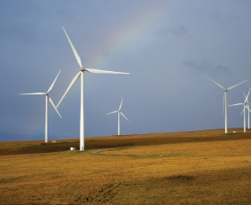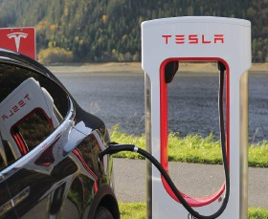

'Rare earth elements' are **seventeen elements** used in many **high-tech devices**, e.g. smartphones and game consoles. A few countries, including **China** and the **USA**, produce most of these REEs. Creating **mines** to extract REEs is difficult as they are found thinly and evenly across the Earth's surface rather than in large amounts.

**Top five** producers of rare earths in 2019

We learnt in our **energy generation lesson** that moving to **renewable energy sources** is very important for the future of our planet.

**Rare earth elements** are needed to **develop green energy technology** like in these images.

Rare earth element shortages **could affect the development of this ‘green’ tech**.

US

**26,000MT**

China

**132,000MT**

Myanmar

all other producers combined

**6,000MT**

India **22,000MT 3,000MT**

Australia

**21,000MT**

**210,000**

Global, metric tonnes

**solar panels**

**wind turbines**

**electric cars**

**Automation**

Landfill sites are **overflowing**, and eventually, we will run out of **landfill space**.

The **hazardous waste** is often improperly disposed of and ends up in a **landfill**. Hazardous waste can **contaminate the soil** and endanger animals, plants and humans.



www.grammarsaurus.co.uk