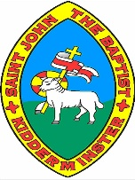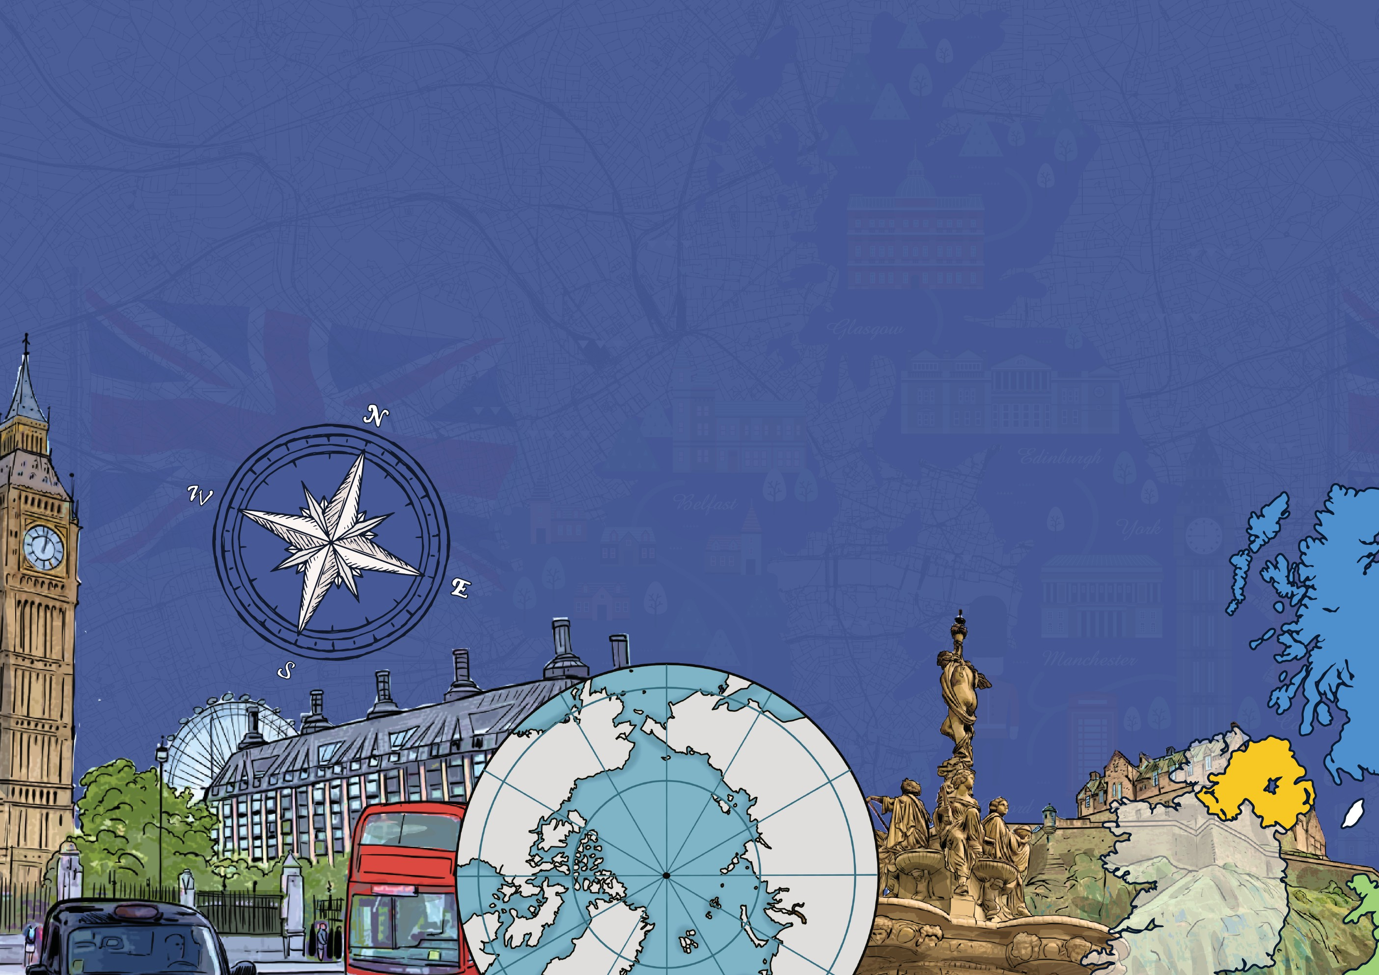

**The United Kingdom and my region**

**Year 3**

**Knowledge Organiser**

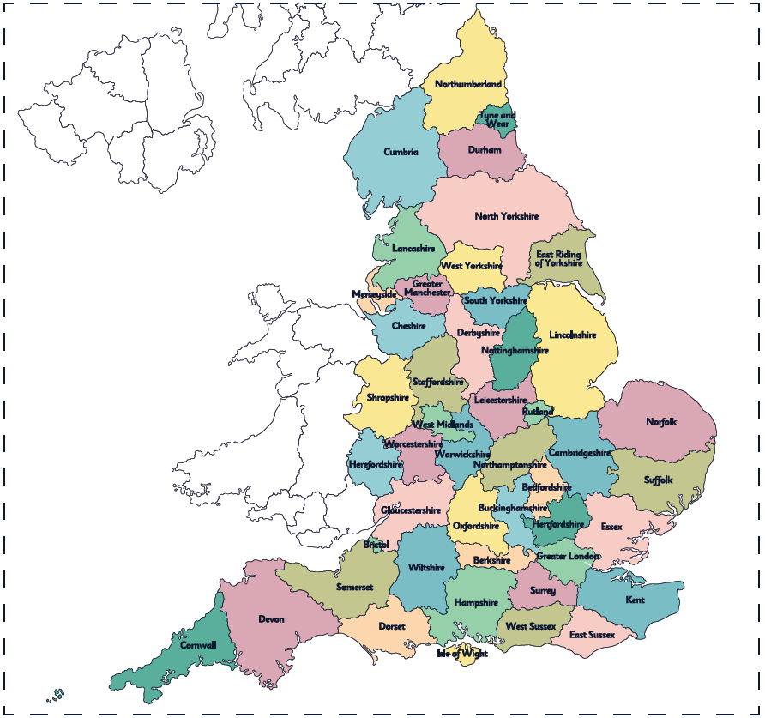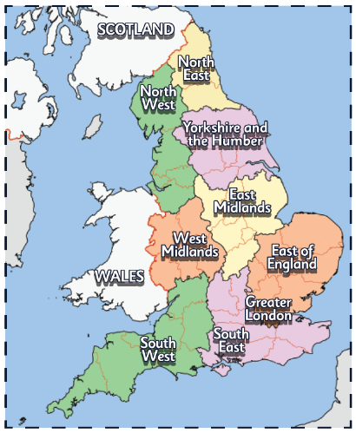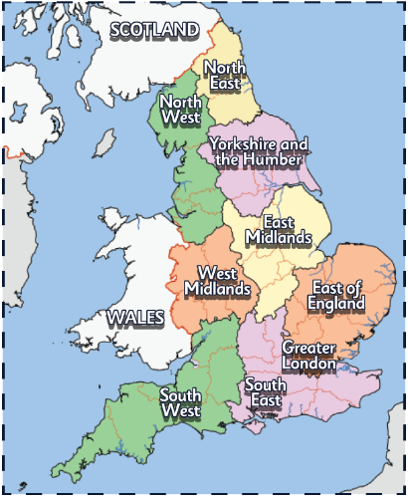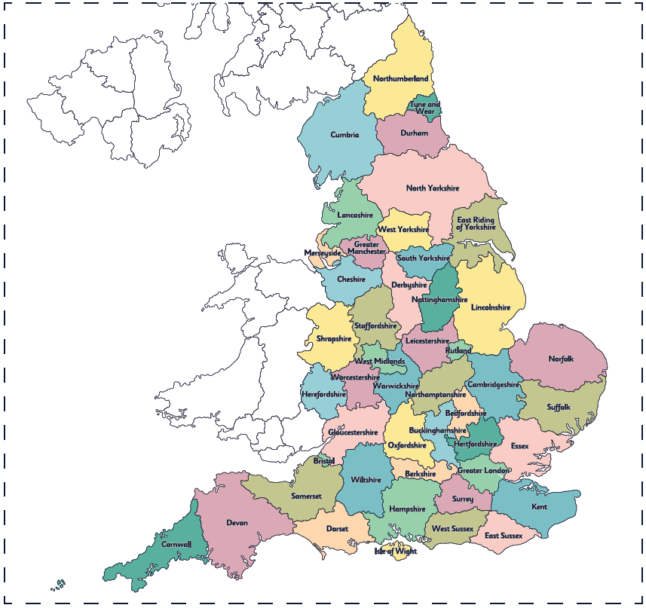

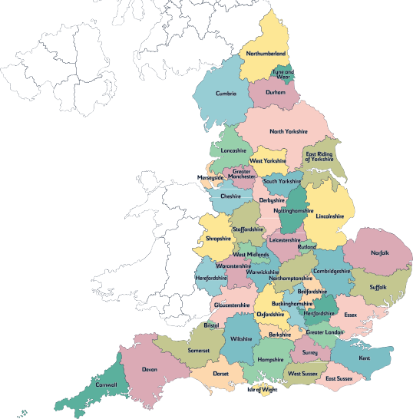

**Counties**

Counties are areas of land made up of **countryside** and

**different settlements**. Here are some **interesting facts**

about counties.

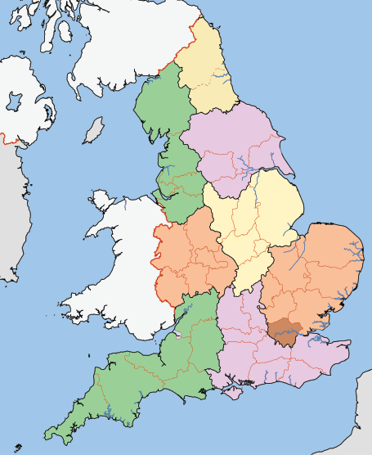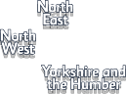

**Regions**

**England** is split up into smaller sections called **regions**.

Each of these **regions** contains **counties**, **cities**, **towns** and **villages**.

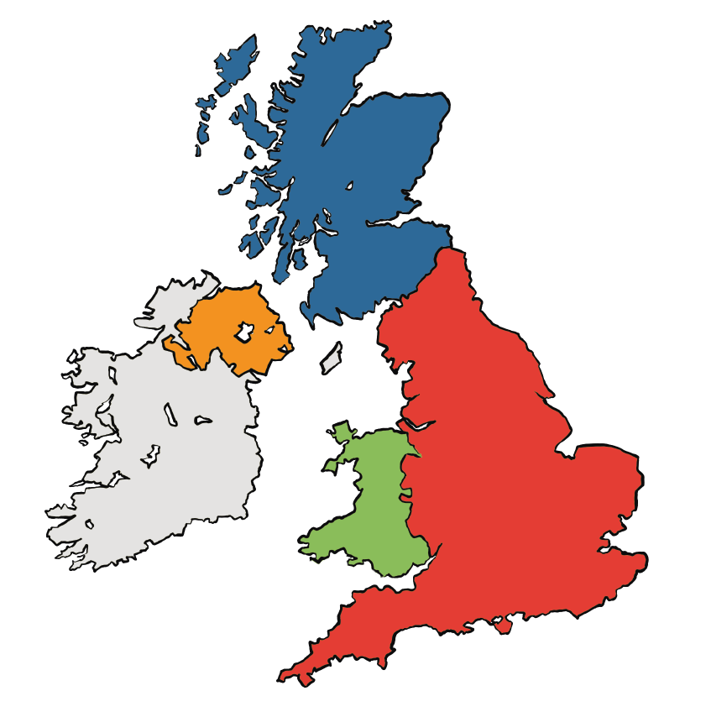

**The United Kingdom**

The **United Kingdom of Great Britain** and **Northern Ireland** is an

**island country in Europe**.

It is made up of four smaller countries: **England, Northern Ireland, Scotland and Wales**.

**SCOTLAND**

**Edinburgh**

Each country has a **capital city**,

as shown on this map.

**NORTHERN**

**IRELAND Belfast**

**ENGLAND**

**WALES**

**Cardiff**

**London**

**Settlements**

There are three main kinds of settlement: **villages, towns and cities**. They are classified depending on how **big or small** the settlements are and the kinds

of **housing and facilities** they have.



**places of worship**

**supermarket**

**shops, restaurants, pubs and hotels**

**swimming pool**

**busy roads**

**secondary school**

**lots of houses**

**What is a town?**

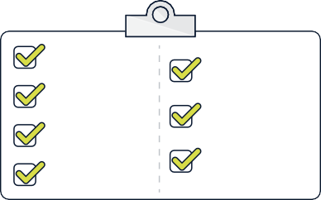

**lots of restaurants, cafes and bars**

**office blocks lots of different**

**houses, including blocks of flats**

**warehouses and factories**

**a university**

**a cathedral**

**lots of different places of worship**

**museums and galleries**

**parks**

**shopping centres**

**What is a city?**

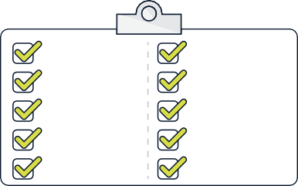

**a primary school**

**a post office and shop**

**a church**

**quiet roads**

**a pub**

**not many houses**

**What is a village?**



[www.grammarsaurus.co.uk](http://www.grammarsaurus.co.uk/)

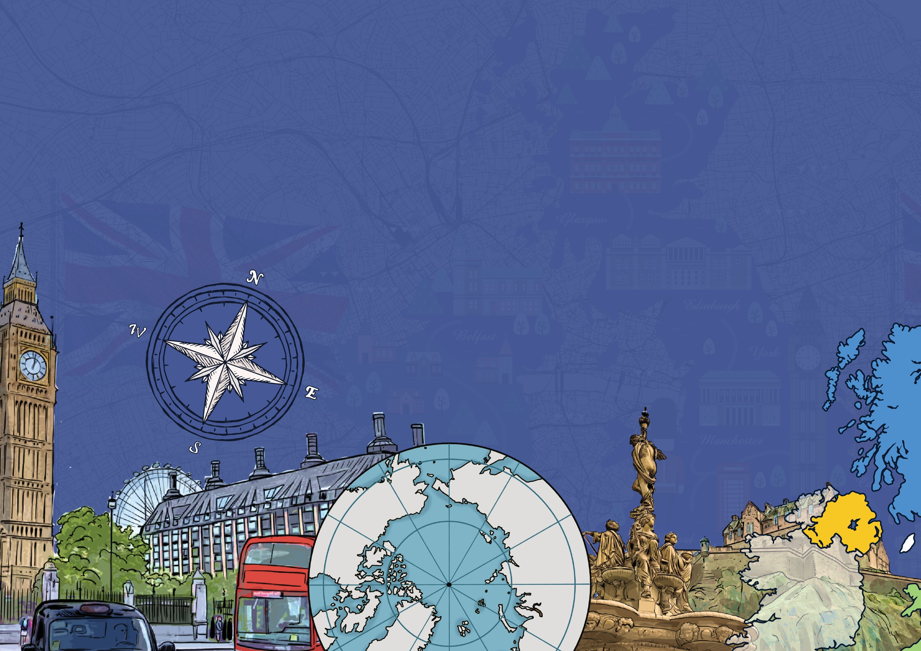

**Compasses**

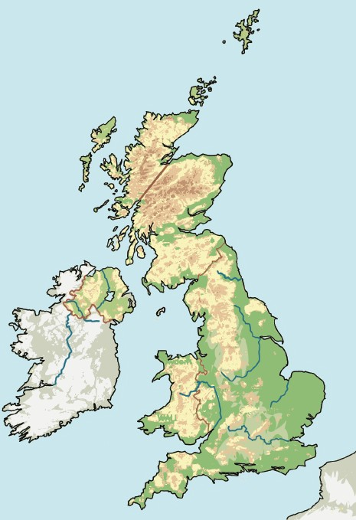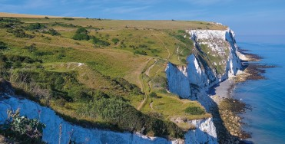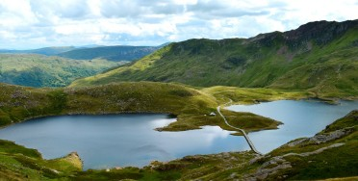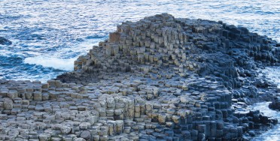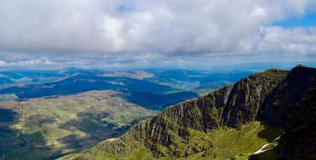

**Physical features of the UK**

The landscape of the UK is very varied. **Physical features** would be here even if there were no people around

**(e.g. seas, mountains, rivers)**.

Shetland Islands

Orkney

**Ben Nevis 1345m**

North Sea

North Atlantic Ocean

**SCOTLAND**

**NORTHERN IRELAND**

**Scafell Pike 978m**

**Snaefell**

**Slieve Donard 850m**

Irish Sea

**IRELAND**

**Snowdon (Yr Wyddfa) 1085m**

**WALES**

**ENGLAND**

English Channel

The cliffs on the coastline are famous here. They are called the **White Cliffs of Dover.**

**Snowdonia National Park, the Cambrian Mountains and the Brecon Beacons** are the mountain ranges in Wales.

**The Northern Highlands and the Grampian Mountains** are the mountain ranges in Scotland.

**The Giant’s Causeway** is an amazing rock formation on the coastline.

**Human features of the UK**

A human landmark is a **human-made feature** of a landscape or town that is recognisable from a distance.

**Glenfinnan Viaduct,** Inverness-shire,

Scotland

**Wales Millennium Centre,** Cardiff,

Wales

**Titanic Belfast,**

Belfast, Northern Ireland

**Stonehenge,**

Wiltshire, England

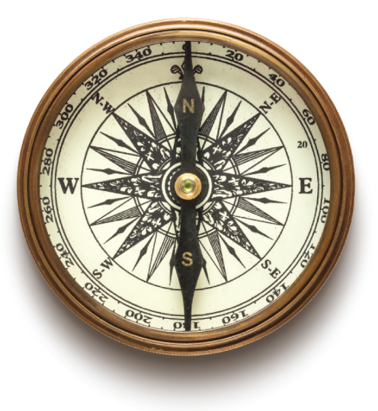

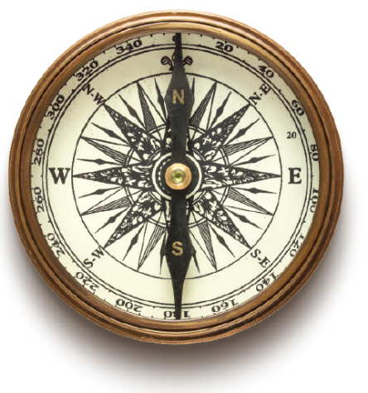

A compass is a **magnetic instrument used for finding directions**. The four directions on a compass are called **cardinal directions**. They are **north, east, south and west**. The needle within the compass will

always point towards the **north**.

**Four-figure grid references**

Four-figure grid references are **four numbers used to pinpoint a particular location on a map**. Numbered lines called **eastings and northings** are used to pinpoint a **square section on a map**.

**grid reference: 3243**

How to use them:

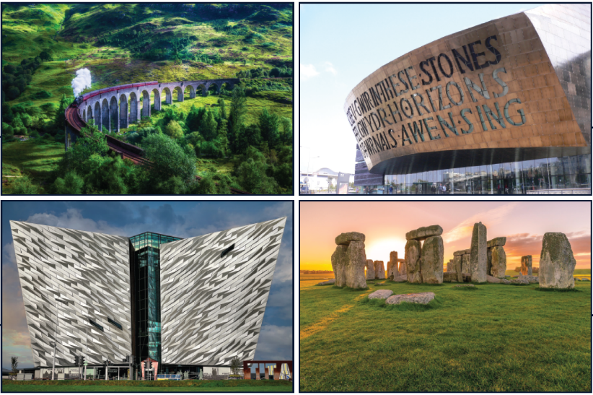

34

33

32

31

42

43

3. When you have found the **correct corner**, look at the square to the **top right of**

**the corner**.

**3243**

2. Then look at the **northings**

until you find the **2nd number**.

44

1. Look at the **eastings** and

find the **1st number**.

45

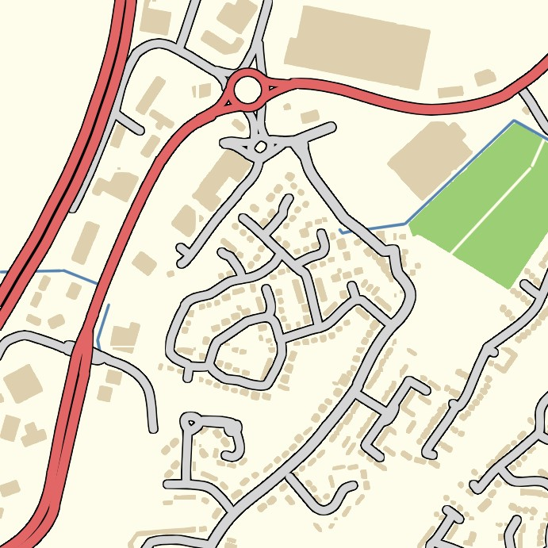

|  |  |
| --- | --- |
|  |  |
|  |  |



www.grammarsaurus.co.uk