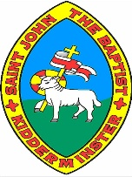

**My Region and**

**the Western United States**

**Knowledge Organiser**

**Year 5**

The Western region of the USA consists of **13 states**: **Alaska, Arizona, Colorado, California, Hawaii, Idaho, Montana, Nevada, New Mexico, Oregon, Utah, Washington and Wyoming.**

The USA is one of the **23 countries** which make up the continent of **North America**. The country is divided into **four regions**: **the West, the Midwest, the Northeast and the South**.

is the **Cascade Range** which is formed by thousands of small volcanoes. Rising above this volcanic platform are a few large volcanoes, like **Mount Saint Helens**, which dominates the landscape.

One of the large tectonic plates is the **North American Plate**. The edges of the North American Plate exhibit all three of the **major plate boundary type of movements**. California, Oregon and Washington have **earthquakes and even volcanoes**! Hawaii also has many **active volcanoes**, and **extinct volcanoes** can be found throughout the Western United States. An example of the volcanic zones in the Western United States

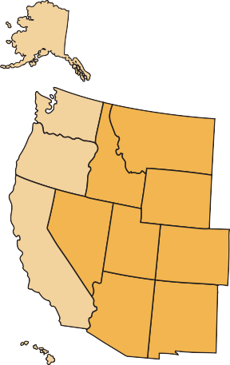

**Alaska,**

Juneau

**Washington,**

Olympia

**Oregon,**

Salem

**Montana,**

Helena

**Idaho,**

Boise

**Wyoming,**

Cheyenne

**Nevada,** Carson Cty

**Utah,** Salt Lake City

**Colorado,**

Denver

**Arizona,**

Phoenix

**New Mexico,** Santa Fe

**Hawaii,**

Honolulu

**Volcanoes and earthquake zones of the Western United States**

**The Western United States**

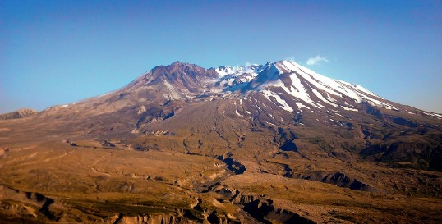

**The biomes and climate zones of the Western United States**

**The vegetation belts of the Western United States**

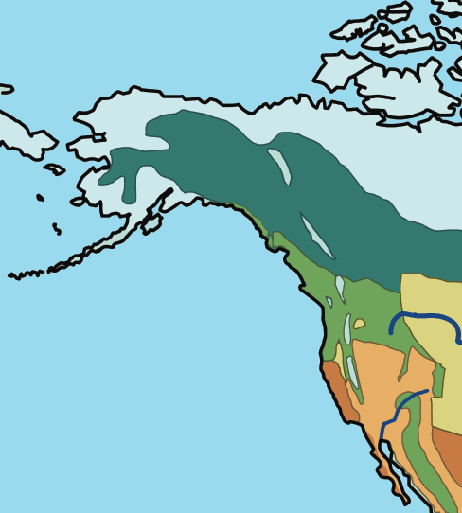

The Western United States extends across a wide range of **vegetation belts**, including the following: tundra, coniferous forest, desert and dry shrub, Mediterranean shrub and temperate grassland.

A biome is a large area on the Earth’s surface defined by the **types of animals and plants** living there. We can also consider these “**life zones**” (“bio” means life). The Western United States includes tropical rainforest, desert and tundra biomes, to name a few.

**Climate change** is an ongoing issue that affects each of these vegetation belts. We have seen the devastation of forest fires, particularly across desert areas of California, which have destroyed homes and habitats for humans and animals alike. In addition, the **polar ice caps** are reducing rapidly, and northern Alaska is directly impacted as a result as it lies within the **Arctic Circle**.

**tropical rainforest temperate forest desert**

**tundra**

**taiga (boreal forest)**

**grassland**

**savannah (tropical grassland) freshwater**

**marine**

**ice**

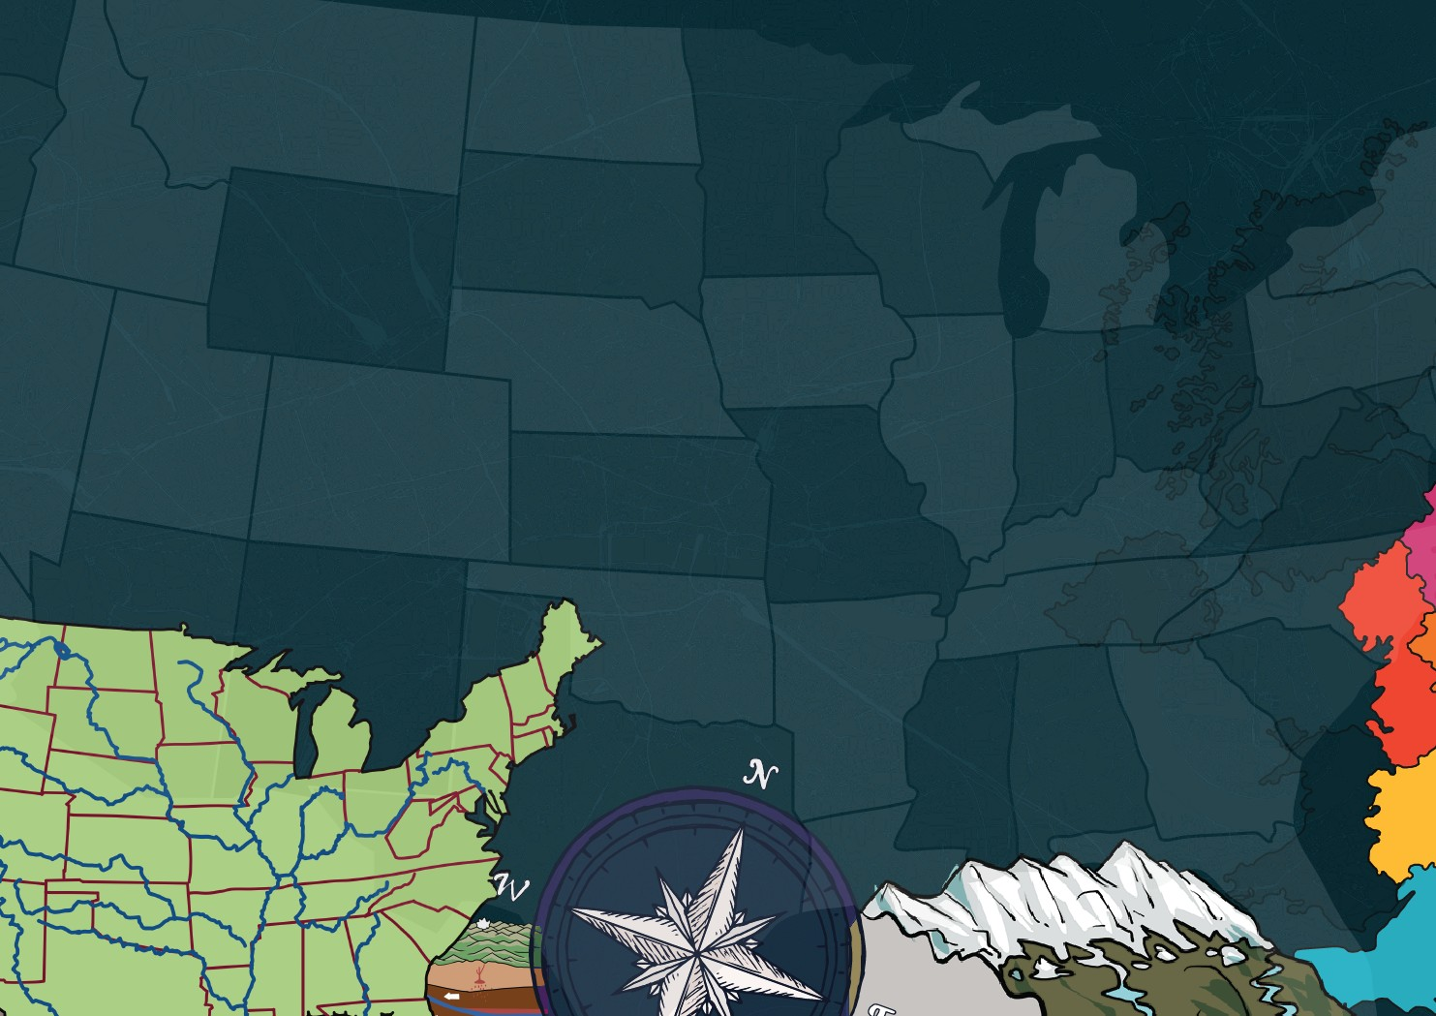



[www.grammarsaurus.co.uk](http://www.grammarsaurus.co.uk/)



**What are mountains?**

**The water cycle**

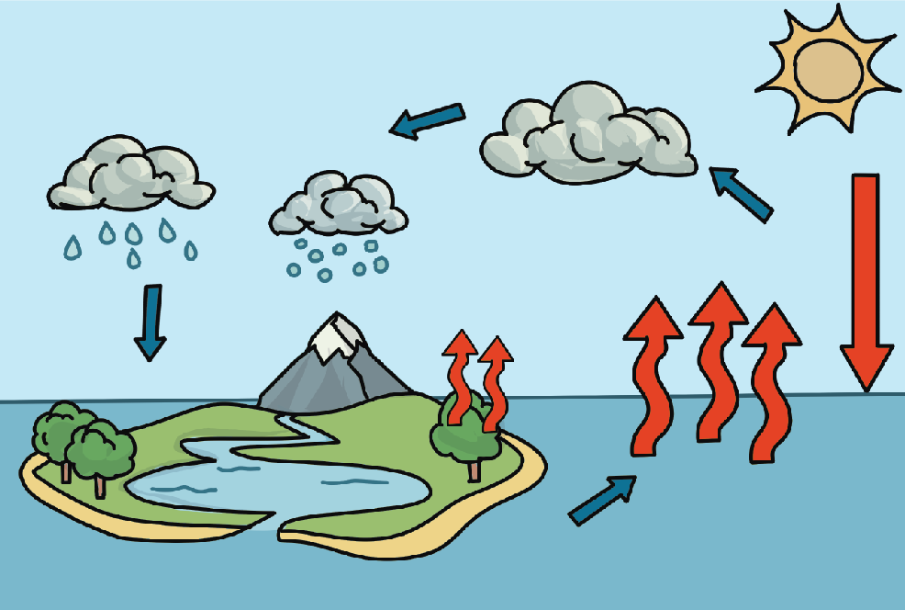

**The water cycle**

**condensation**

**precipitation**

**heat**

**evaporation**

**transpiration**

**run-off**

**accumulation**

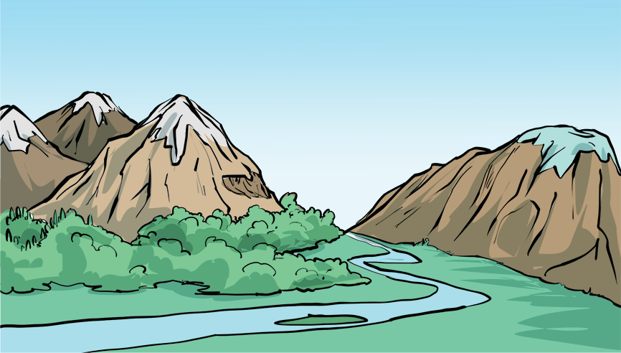

**Key features**

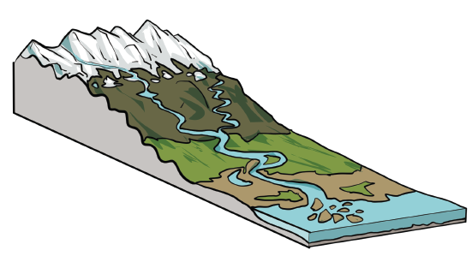

**delta**

**mouth**

**channel**

**oxbow lake**

**meander**

**estuary**

**levee**

**river**

**source**

**confluence**

**tributary**

**Diagram of a river system**

Mountains are areas of land much **higher** than the land surrounding them. They are higher and usually steeper than a hill. They are normally over **600 metres high**. They are usually found in a group called a **mountain range**. Lines of ranges form mountain belts

The water cycle has **four main parts**: evaporation, condensation, precipitation and accumulation.

**outcrop**a rock formation visible from the surface

**valley**

the area of low land between mountains

**summit**

the top of a mountain

**slope**

an area of ground increasing in height

**snow line**

above here snow and  
 ice cover the mountain   
all year

**plateau**

an area of flat,   
high ground

**face**

the “side” of a mountain

**foot**

the bottom of the mountain

**ridge**

a long, narrow, high section of land

**treeline**

the highest point at which forests are found

**What are rivers?**

1. **Evaporation** happens when the Sun causes the water in the rivers, lakes and oceans to heat up and turn into a water vapour gas, which then goes into the air. Water from plants and trees also enters the atmosphere. This is called transpiration.
2. As the water vapour rises during the evaporation stage, it cools down and turns back into liquid, causing droplets to form, becoming clouds. This is called **condensation**.
3. When a cloud becomes too full and heavy, the water falls to the ground as **precipitation**. Precipitation can take the form of rain, sleet, hail or snow.
4. When water falls back to Earth as precipitation, the Earth absorbs some of the water that falls to the ground. When the ground cannot absorb the water, it flows over the land, known as ‘run-off’. The water that runs over the ground accumulates in rivers, lakes and oceans. This is called **accumulation**.

A river is a naturally **moving body of water**. It flows from its source on high ground, across the land, and then into another body of water. This could be a lake, the sea, an ocean or even another river.



[www.grammarsaurus.co.uk](http://www.grammarsaurus.co.uk/)