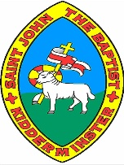

**Year 1**

**Knowledge Organiser**

**The World and My School**

**Aerial plans**

**Human and physical features**

**Aerial photos**

**Street names**

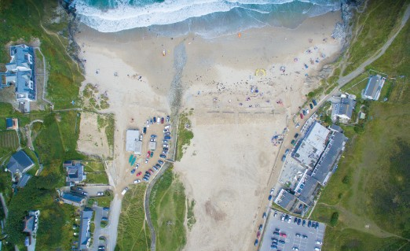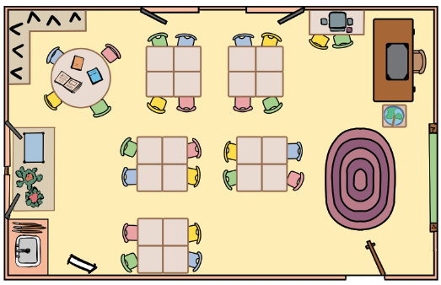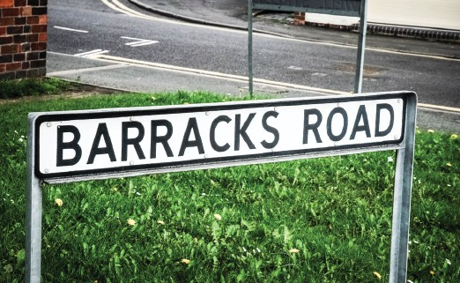

Human and physical features are things that you can see all around you.

**Physical features** like seas, mountains and rivers are natural. They would be here even if there were no people around.

**Human features** are things like houses, roads and bridges. People have built them.

An aerial view is a photo **taken from above**. You can look at the **geographical features** of a place using an aerial photo.

Buildings are usually placed **along streets**. Each street has a **name**.

Sometimes the street name can give you information about a **feature** on or near that street.

www.grammarsaurus.co.uk

**Physical features**

city

**Human features**

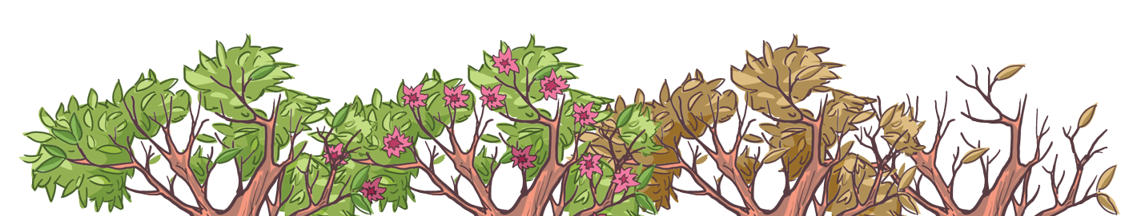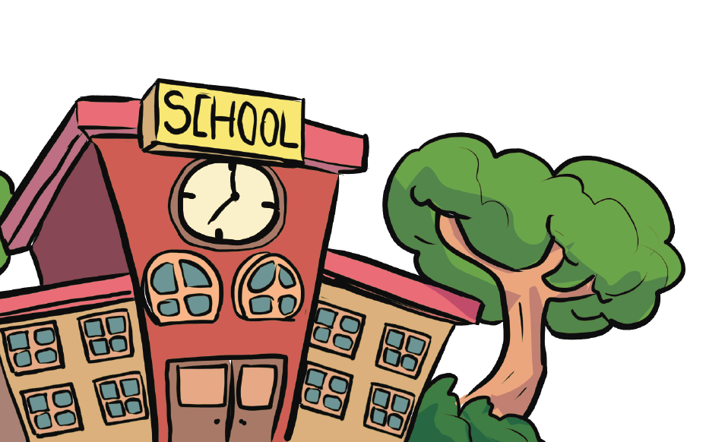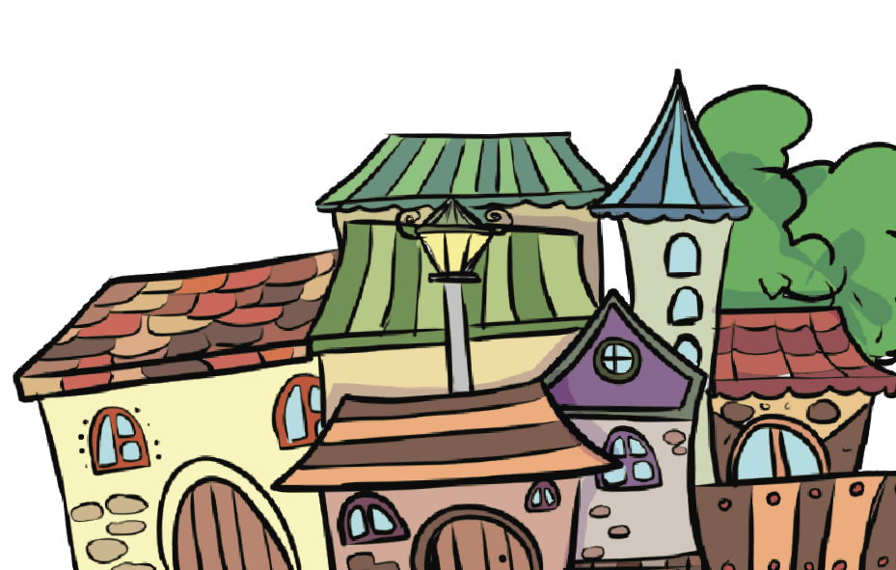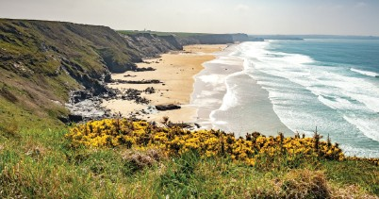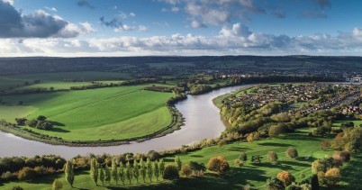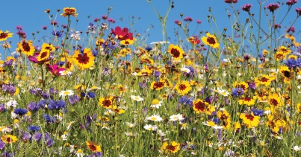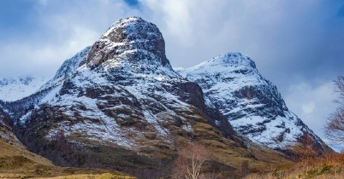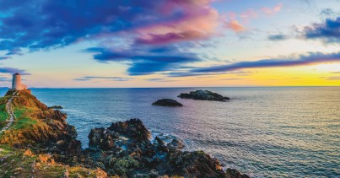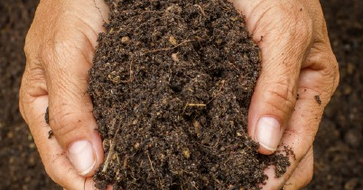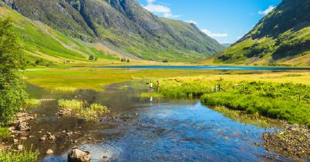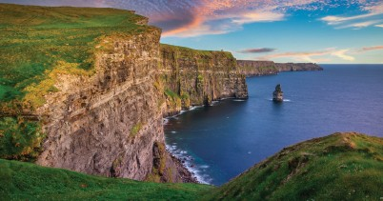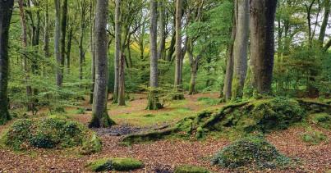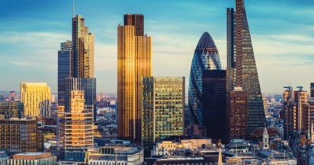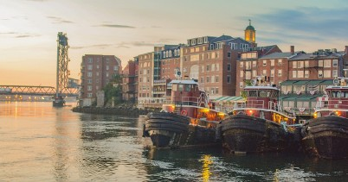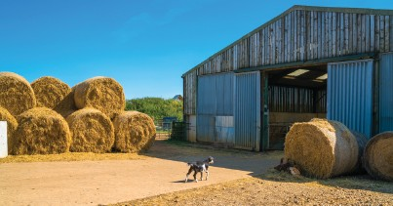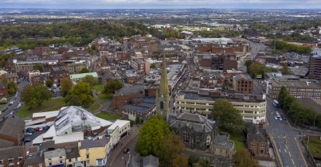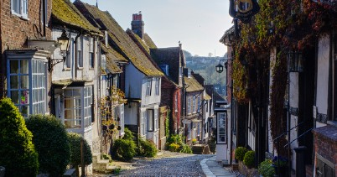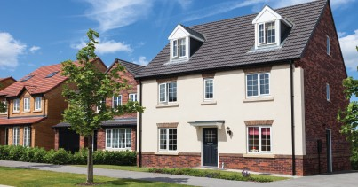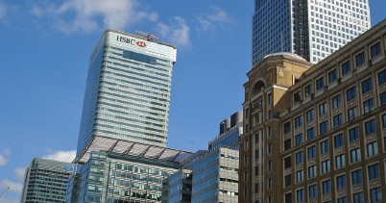

valley

soil

vegetation

farm

shop

port

ocean

mountain

river

forest

cliff

beach

factory

office

house

village

town

An aerial plan is a drawing that shows a **small area or a building**. It is useful because it tells us exactly where things are on the ground.

# 

**Climate**

**Weather**

**Types of settlements**

The weather includes **changes in temperature, the wind, the rain and much more**. The weather can change **daily**.

The climate is **the normal weather over time**. The climate is like the weather but **over a long time**.

Settlements are places where people live and sometimes work. They can be small or large depending on how many people live and work there.

There are **three types of settlements**: villages, towns and cities.

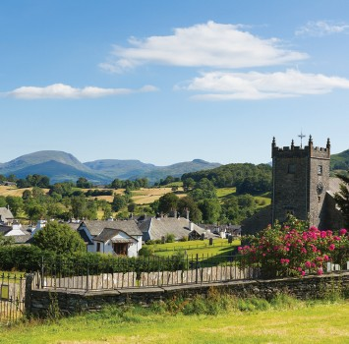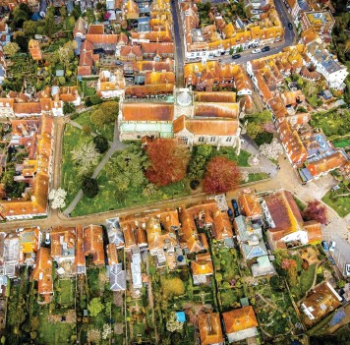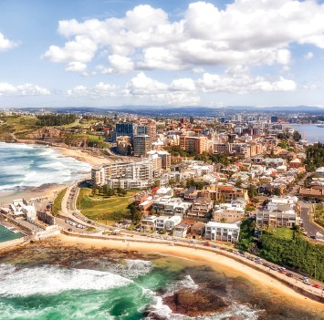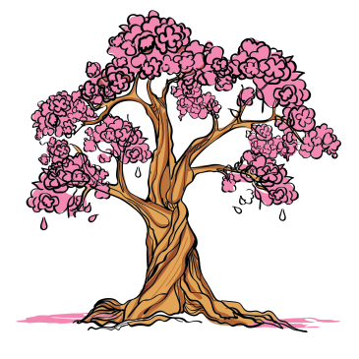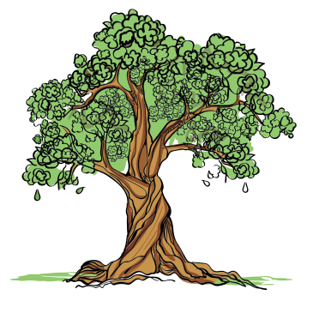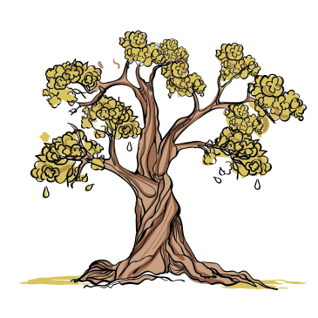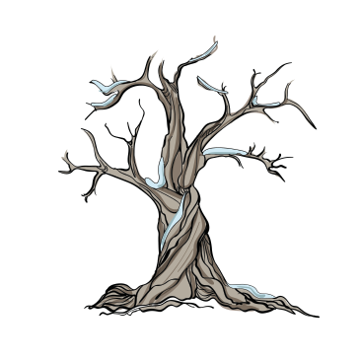

**Newcastle City**

**Rye, Town**

**Hawkshead, Village**

**autumn**

**summer**

**winter**

**spring**

# 

**Climate around the world**

**The United Kingdom**

Where a place is on the planet will affect its **weather and climate**. The closer a country is to the **equator,** the hotter the climate! Some places have warm climates, neither too hot nor too cold. This is because they aren’t close to the equator or the **North or South Pole**.

The United Kingdom comprises four different countries: **England, Scotland, Wales and Northern Ireland**. It is sometimes referred to as **Great Britain**.

**Climate key**

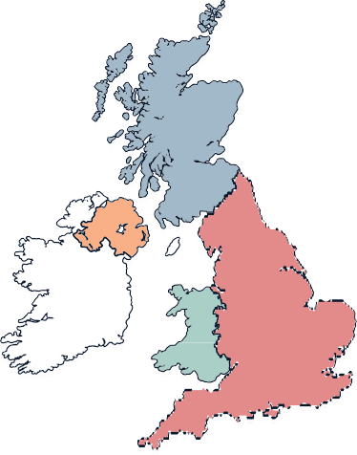

**Scotland**

**Scotland**

**Northern Ireland**

**Northern Ireland**

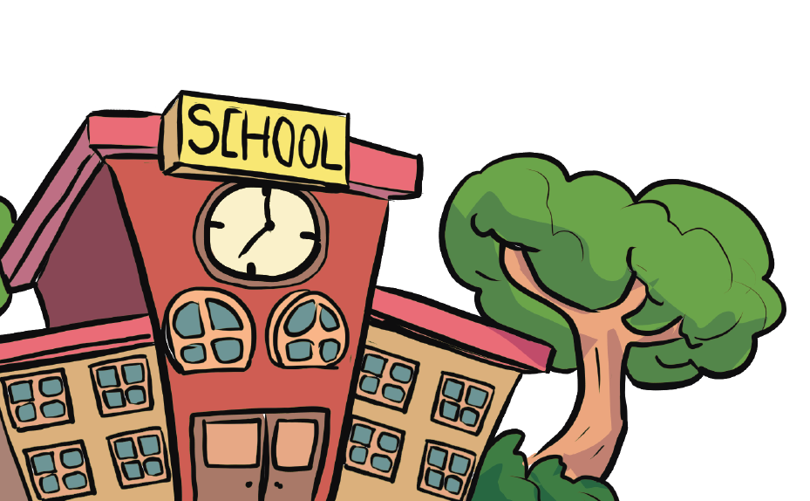

**Wales**

**Wales**

**England**

**England**

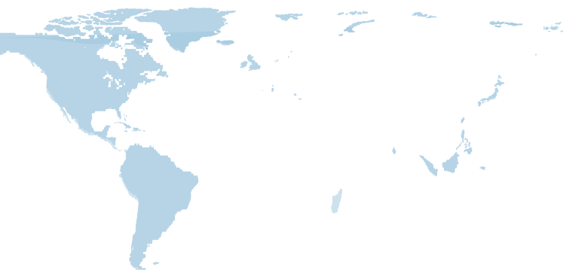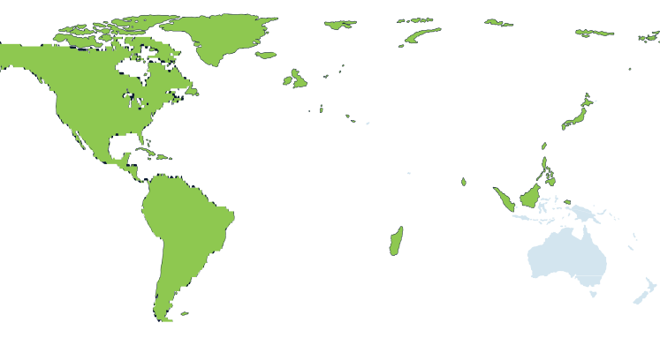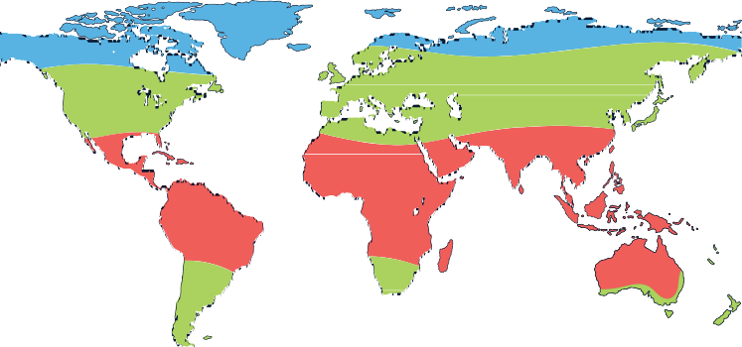

**equator**

**North Pole**

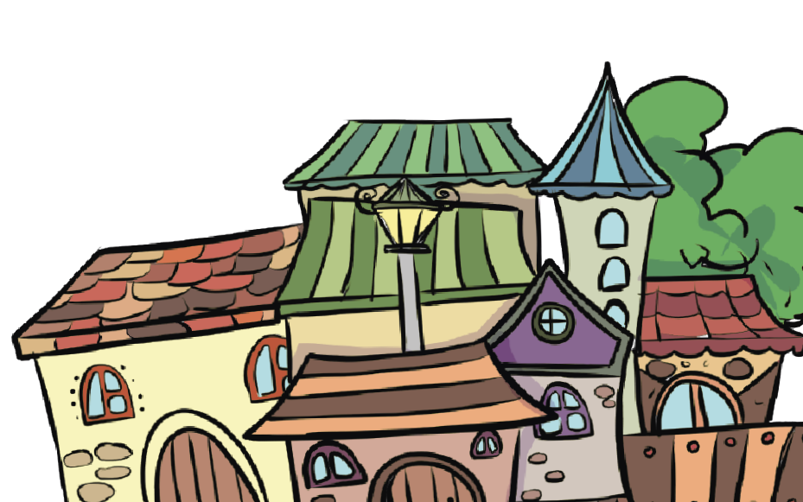

**Climate key** hot warm cold

hot

warm

cold



**The United Kingdom**

**The United Kingdom**

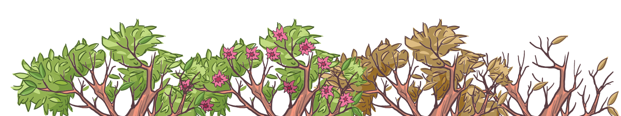

**South Pole**

www.grammarsaurus.co.uk





www.grammarsaurus.co.uk

**The world has big areas of water called oceans**

**The world is divided into big pieces of land called continents**

**Continents and Oceans of the World**

There are **five oceans**: **the Pacific Ocean, the Atlantic Ocean, the Indian Ocean, the Southern Ocean, and the Arctic Ocean.**

There are **seven main continents: North America, South America, Europe, Asia, Africa, Oceania, and Antarctica**. Each continent has its own **countries, animals, and people**.

