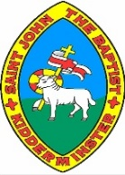

**Conservation of bees**

**Why are bees so important?**



**Body parts of a bee**

**What is the current picture?**

Bees spread pollen between different parts of flowers and plants, which allows them to grow seeds and fruit. They are the best pollinators among all animals to help plants to reproduce.

Bees are essential in holding the food chain together: animals like frogs and lizards eat bees to survive and will eventually die if bees become extinct. This would affect the entire food chain. The UK population of bees has shrunk by around one-third in the last ten years. Many different species of bees are close to becoming extinct.

Bees produce a range of useful products: honey, beeswax (used in candles and skincare products), royal jelly and propolis (used for medical purposes).

People who work with bees, such as beekeepers, could become jobless if bees become extinct.

**Year 3**

**Knowledge Organiser**

**wings**

**thorax**

Between 1985 and 2005, the number of honeybee colonies in the UK fell by 53% and wild honeybees were considered nearly extinct throughout Britain.

The East of England region is one of the richest regions for bees due to the range of habitats present. This is partly because many bees prefer the warmer and drier conditions of the region.

Of the 228 bee species in this region, 25 are

**head**

**antennae**

**stinger (only seen on females)**

**six jointed legs**

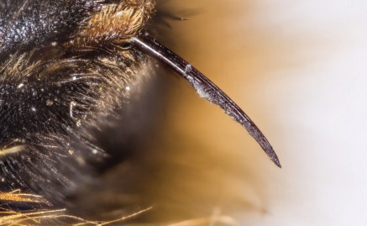

**abdomen**

threatened to become extinct. An additional 31 species are also known as a ‘conservation concern’, which means they are not as highly threatened, but their future is far from secure.

A common myth is that all bees can sting. However, only female bees can sting. Bees often sting to defend themselves, especially if their nest or hive is disturbed.

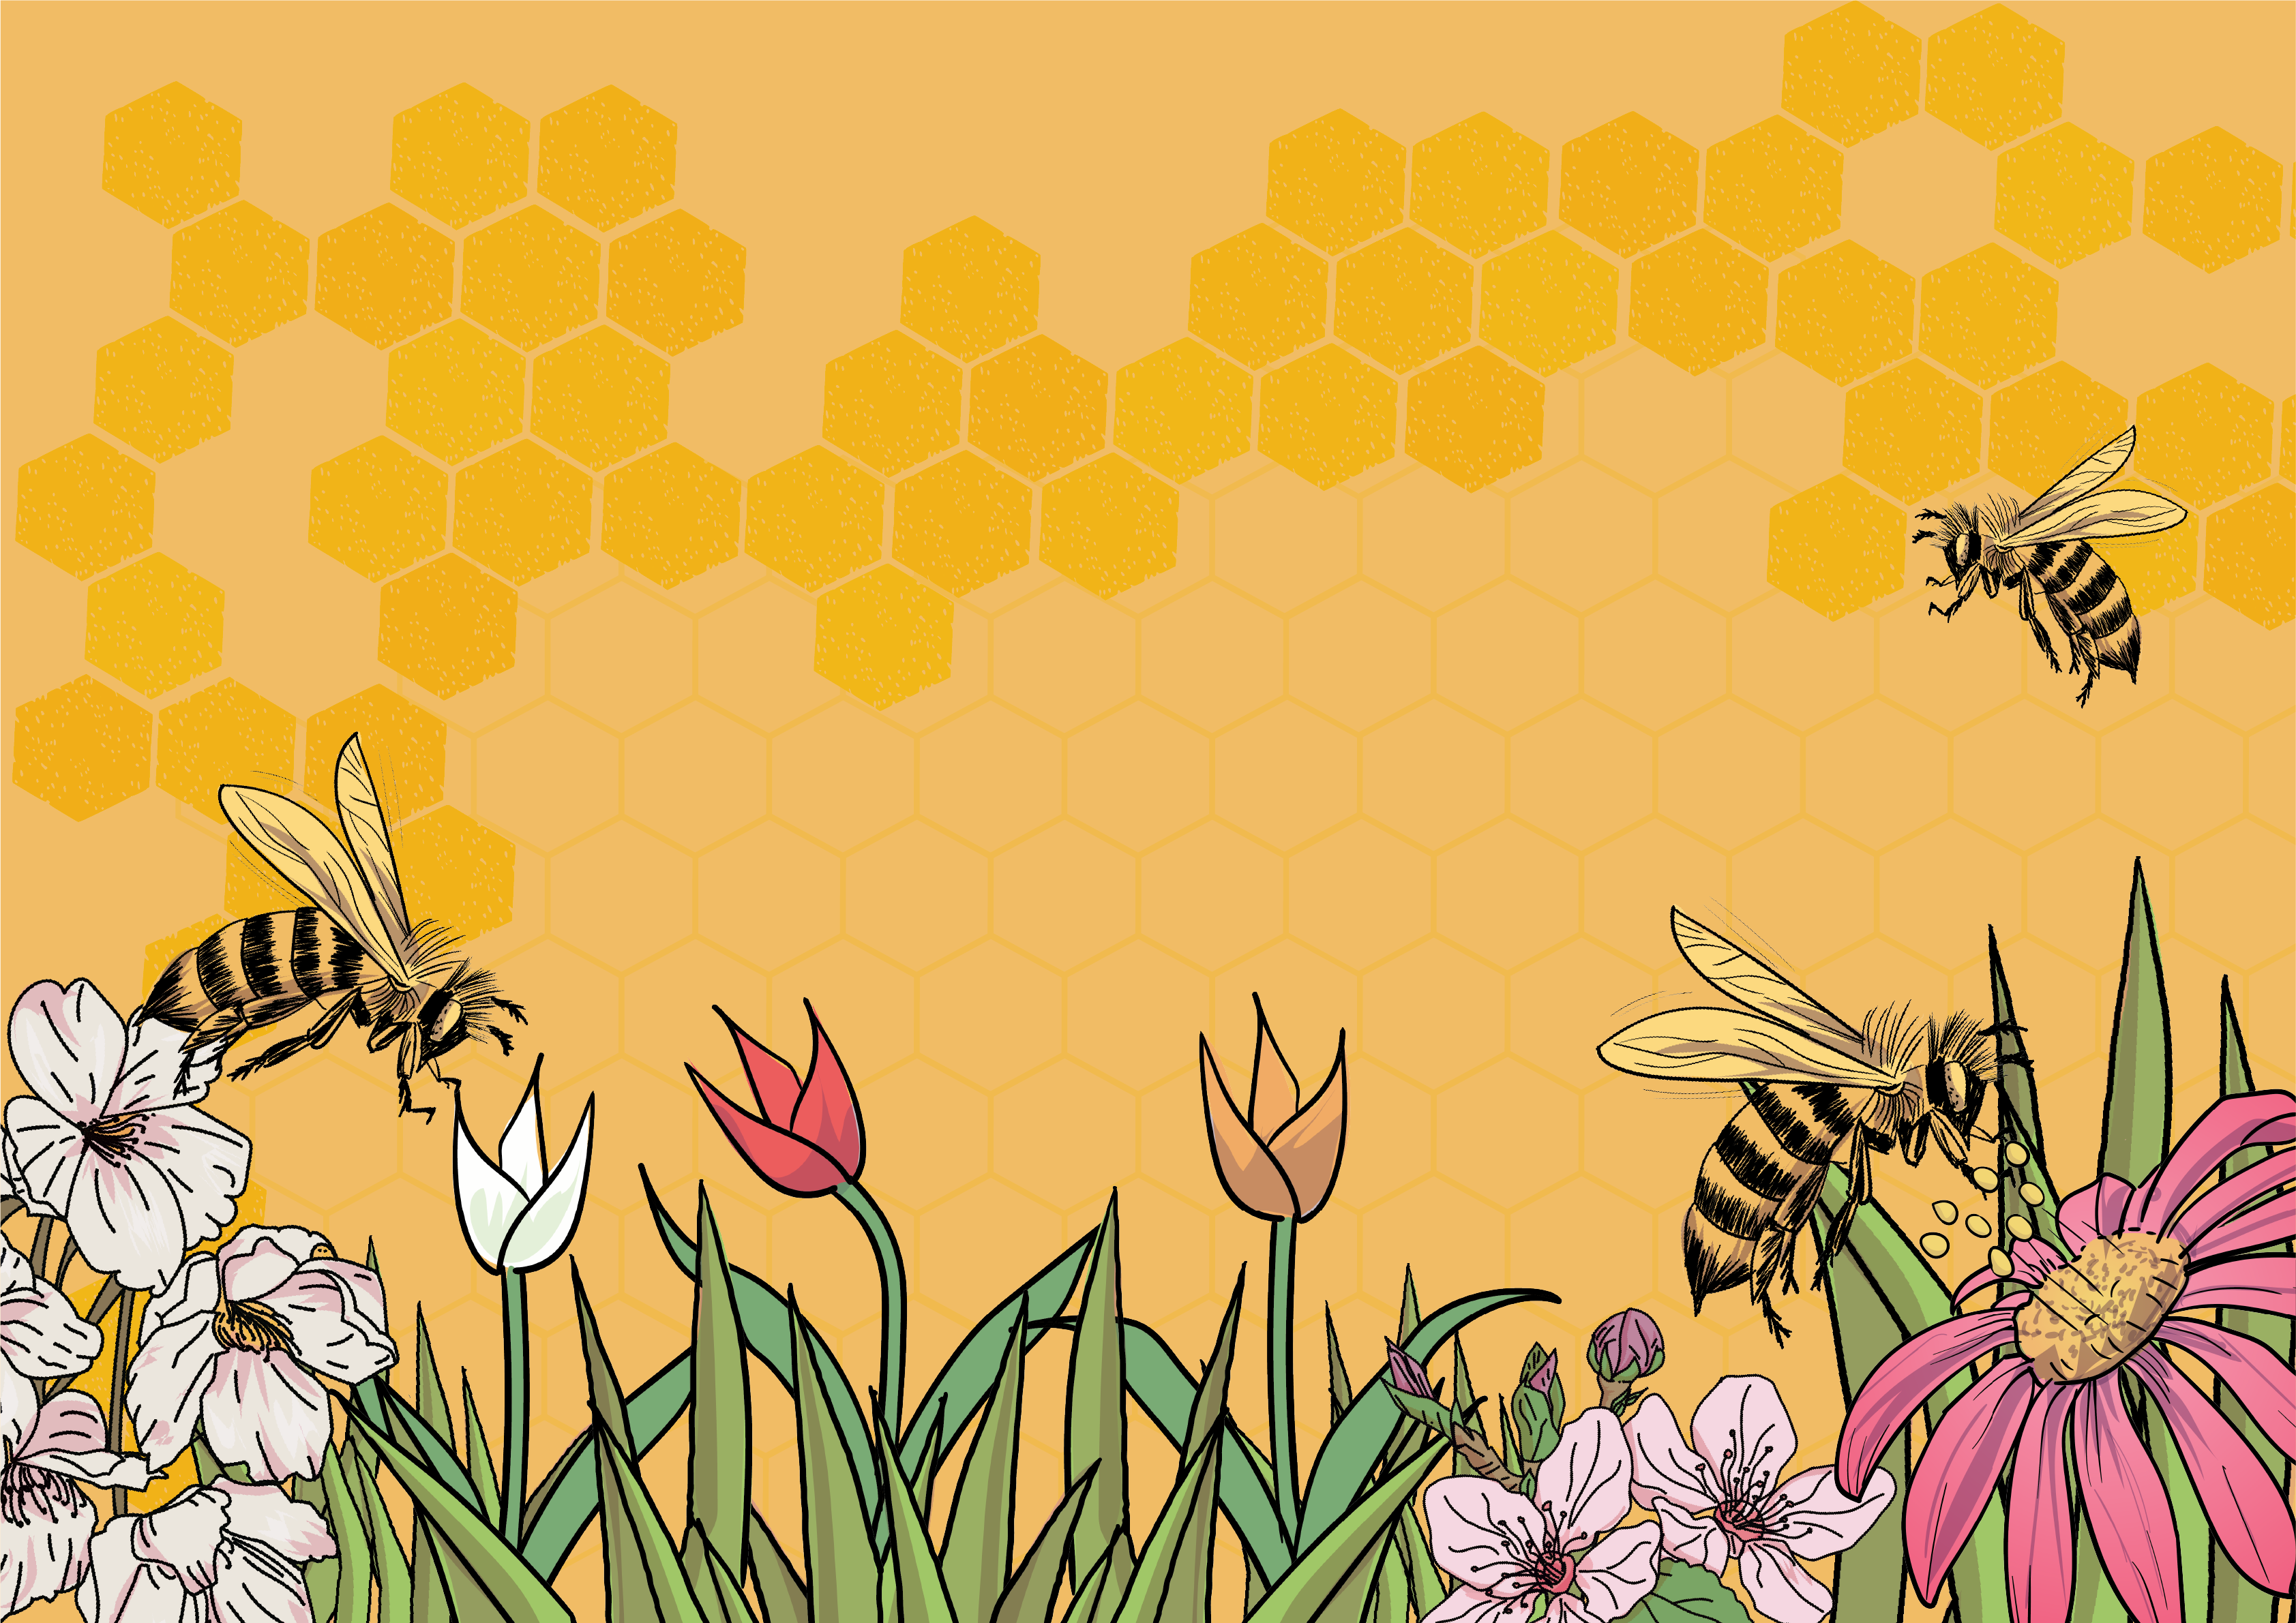

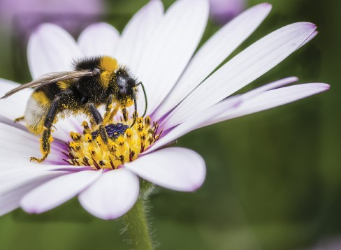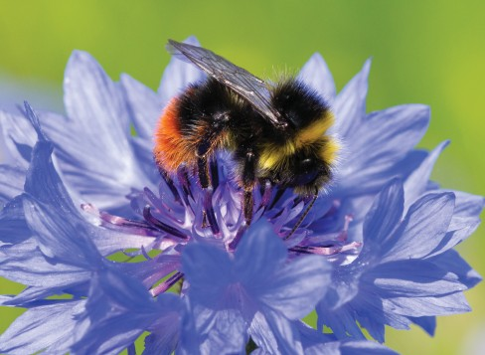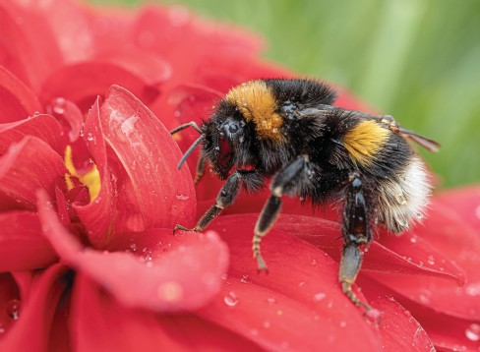

**Types of bees**

There are over 270 species of bees in the UK and over 20,000 known species of bees worldwide! Most of the bees in the UK are species of solitary bees, meaning they do not live in colonies like honeybees.

The most common species of bees in the UK are the bumblebees, and there are three you will recognise: the buff-tailed bumblebee, the white-tailed bumblebee, and the red-tailed bumblebee. The honeybee is the only species of bee that produces honey and is kept by beekeepers for this reason.

**buff-tailed bumblebee**

**white-tailed bumblebee**

**red-tailed bumblebee**

www.grammarsaurus.co.uk





**Why are bees in danger of becoming extinct?**

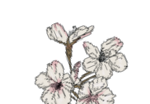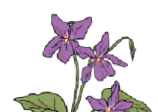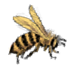

When to sow When to plant

When it grows



**A year of pollinator-friendly flowers**

|  |  |  |  |  |  |  |  |  |  |  |  |  |
| --- | --- | --- | --- | --- | --- | --- | --- | --- | --- | --- | --- | --- |
|  | Jan | Feb | Mar | Apr | May | Jun | Jul | Aug | Sep | Oct | Nov | Dec |
| Hellebores |  | |  | | |  | | |  | | |  |
| Snowdrop |  | |  | | |  | | |  | | |  |
| Winter aconite |  | |  | | |  | | |  | | |  |
| Crocus |  | |  | | |  | | |  | | |  |
| Lungwort |  | |  | | |  | | |  | | |  |
| Pussy willow |  | |  | | |  | | |  | | |  |
| Magnolia |  | |  | | |  | | |  | | |  |
| Peony |  | |  | | |  | | |  | | |  |
| Hawthorn |  | |  | | |  | | |  | | |  |
| Foxglove |  | |  | | |  | | |  | | |  |
| Marjoram |  | |  | | |  | | |  | | |  |
| Sedum |  | |  | | |  | | |  | | |  |
| Dahlias |  | |  | | |  | | |  | | |  |
| Honeysuckle |  | |  | | |  | | |  | | |  |
| Lavender |  | |  | | |  | | |  | | |  |
| Asters |  | |  | | |  | | |  | | |  |
| Mahonia |  | |  | | |  | | |  | | |  |
|  | Winter | | Spring | | | Summer | | | Autumn | | |  |

We have lost around 97% of flower-rich grassland in the UK during the past 90 years. Many gardens are now covered with paving, decking or gravel, so flowers cannot grow, and there is no food for bees.

There is evidence that pesticides and herbicides affect how bees communicate with each other, their sense of smell, how they fly and how they hunt for food.

Climate change is widely predicted to increase extreme events such as summer droughts, flooding and storms, which could directly impact bees.

Mobile phone masts can upset a bee’s sense of direction as it struggles to return to its nest or hive.

Changes in our land use have caused significant losses of pollinator-friendly habitats. For bees, this means losing the wide range of food sources they need for a healthy diet.

Also, farming methods have changed over time, leading to the loss of hay and flower meadows, hedgerows,   
trees and other habitats such as ponds and water meadows.

bee hotel

tree

pollinator-friendly flowerbed

deadwood habitat

mini meadow

water butt

compost heap

wild area

bug hotel

pond

bee lawn

climbing parts

herb garden

stone pile

bog garden

flowering shrubs

**We can ensure the conservation of bees by:**

* planting wildflowers
* having more bee-friendly gardens
* trying to buy organic food that has not been sprayed with pesticides or herbicides
* supporting British bees and beekeepers by buying local honey
* creating a bee hotel
* spreading the word in school and the local community about ways to protect bees

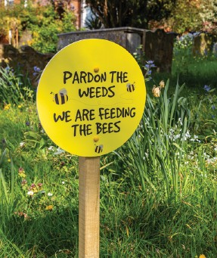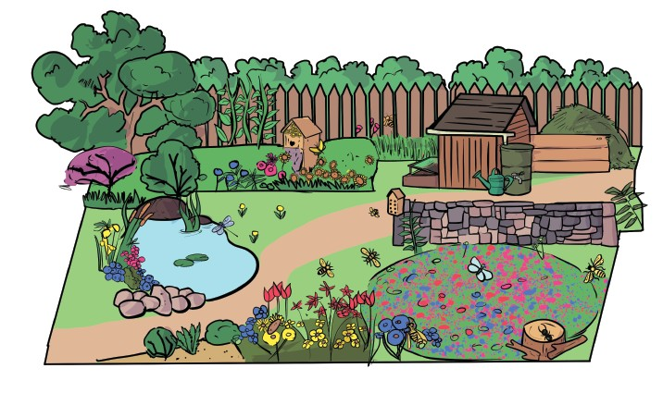

**tree**

**bug hotel**

**wild area**

**bee lawn**

**pond**

**bee hotel**

**stone pile**

**deadwood habitat**

**pollinator-friendly flowerbed**

**herb garden**

**mini meadow**

**bog garden**

**water butt**

**flowering shrubs**

**Conservation of bees**

Buglife is a wildlife charity working to conserve pollinators, and they have come up with a beautiful solution to the loss of wildflowers, specifically B-Lines! This involves creating a series of ‘insect pathways’ that go across the UK, like a rail network, connecting all the good wildflower patches so pollinators can travel freely across Britain. The B-Lines network has already been mapped in the East of England region, and it sets out a map of connected habitats for a bee-friendly future.

**climbing plants**

**Conservation of bees**

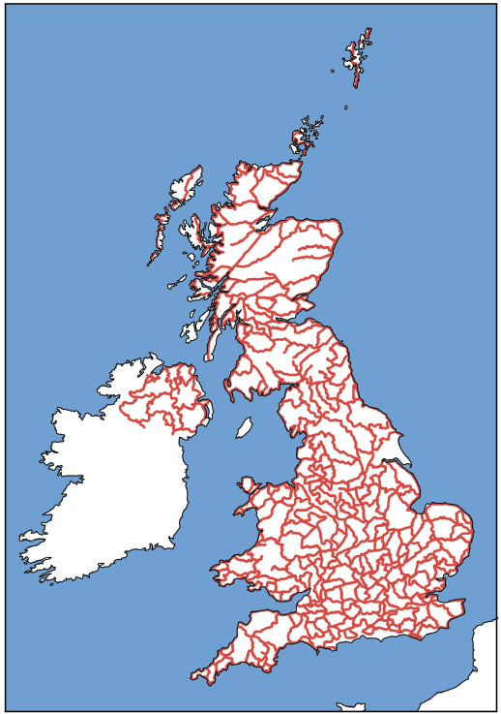

Buglife is a wildlife charity working to conserve pollinators, and they have come up with a beautiful solution to the loss of wildflowers, specifically B-Lines! This involves creating a series of ‘insect pathways’ that go across the UK, like a rail network, connecting all the good wildflower patches so pollinators can travel freely across Britain. The B-Lines network has already been mapped in the East of England region, and it sets out a map of connected habitats for a bee-friendly future.



www.grammarsaurus.co.uk