**Key Knowledge for the unit:**

1. Access Google Drawing through the internet.
2. Sign in to Google Drawing using your Google Classroom login.
3. Think carefully about what shapes make up an image.
4. Be controlled with the mouse in order to be precise.
5. Try something and use undo if it doesn’t work or look right.
6. Use copy and paste to save time.
7. Use grouping to keep your shapes as one object.
8. Use the zoom tool to be precise.

**Useful diagrams for the unit:**

 Google drawings

 Draw shapes

 Select tool

 Change the colours

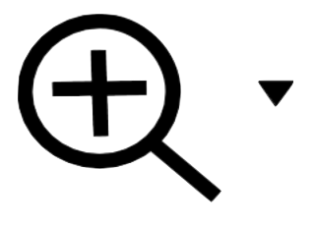 Zoom tool

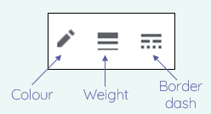

**Key Vocabulary for the unit:**

Alignment grids – Help you to line and centre objects on a page.

Background – A picture to cover the back layer.

Duplicating – To make an exact copy of something.

Gradient – Two or more colours blend together in a direction that you choose.

Group – Selecting more than one object to group as one.

Layer – To understand whether an object is in front or behind another object on the screen.

Modify – Make partial or minor changes to something.

Move – To put something somewhere different on your page.

Resize – To make something bigger or smaller.

Rotate – To turn something in a direction.

Vector drawings – A drawing made on the computer out of lines and shapes.

Zoom – Makes the shape look bigger but does not change the shape.

Year 5 – Vector Drawing