**Key Knowledge for the unit:**

1. Start blocks are used to run your programs.
2. Programming blocks are used to give instructions to each of the sprites.
3. Blocks can be joined together to make a sequence.
4. Blocks can be chosen to fulfil a specific purpose.
5. Using different blocks can alter the outcome.
6. Extensions can be used for extra tools such as the pen.
7. Loops can be created to save code and the number of blocks.

**Useful diagrams for the unit:**

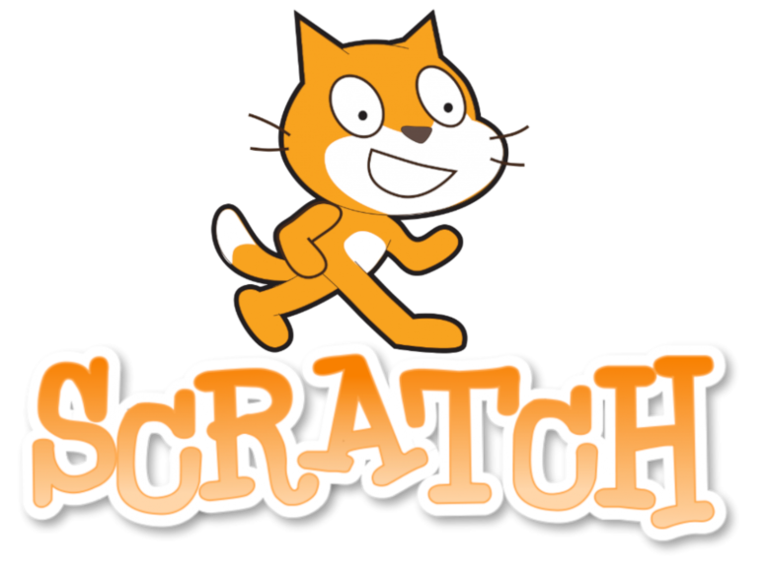

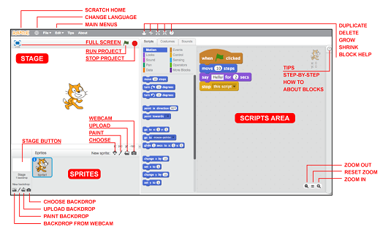

**Key Vocabulary for the unit:**

Algorithms – instructions that are split into little steps.

Block – puzzle-piece shapes that are used to create code.

Code – a set of rules or instructions.

Command – an order or instruction.

Counter-controlled loops – when the number of repetitions to occur is already known.

Debugging – process of detecting and removing of existing and potential errors.

Duplicating – make or be an exact copy of.

Event – something that happens.

Infinite loops – a sequence of instructions in a computer program which loops endlessly.

Modifying – make partial or minor changes to something.

Program – steps of instructions for a computer.

Repetition – the process of looping or repeating sections of a computer program.

Sprite – a character or object that you can code.

Year 4 – Repetition in Games