**Key Knowledge for the unit:**

1. Start blocks are used to run your programs.
2. Programming blocks are used to give instructions to each of the sprites.
3. Blocks can be joined together to make a sequence.
4. Blocks can be chosen to fulfil a specific purpose.
5. Using different blocks can alter the outcome.

**Useful diagrams for the unit:**

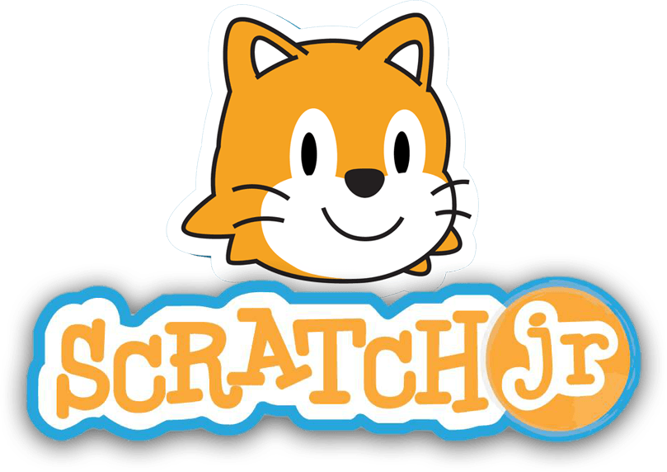

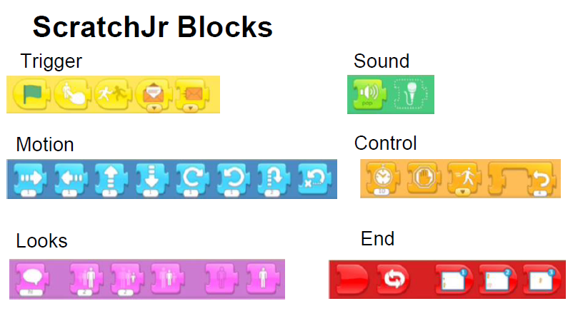

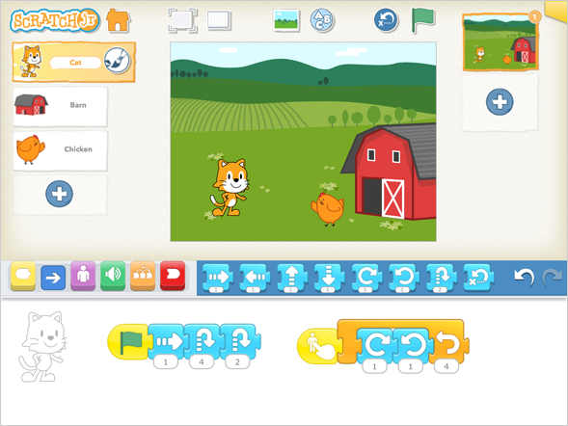

**Key Vocabulary for the unit:**

Algorithms – instructions that are split into little steps.

Backgrounds – the back part of a picture.

Block – puzzle-piece shapes that are used to create code.

Command – an order or instruction.

Program – steps of instructions for a computer.

Sprite – a character or object that you can code.

Year 2 – Programming Quizzes