**Key Knowledge for the unit:**

1. If something doesn’t sound right, debug it and try again.
2. Listen carefully to the music created.
3. Experiment with the sounds – don’t be afraid to try something new.
4. Think about giving other people positive feedback.

**Useful diagrams for the unit:**

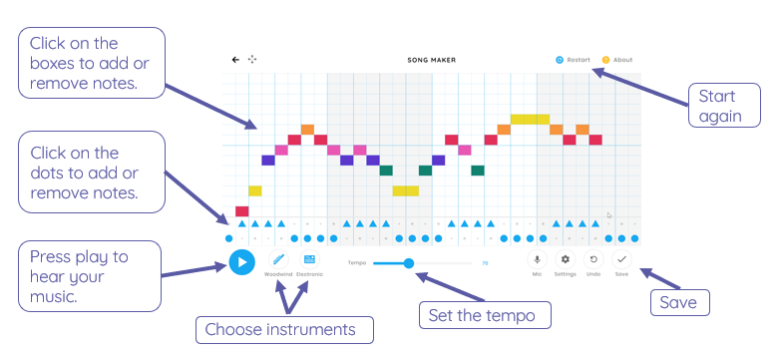

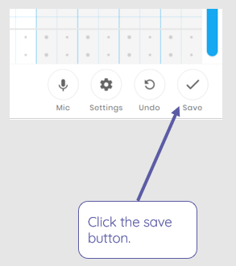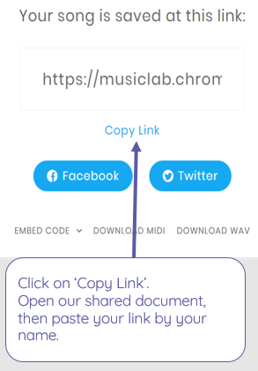

**Key Vocabulary for the unit:**

Duration – is an amount of time or how long or short a note

Pattern – any regularly repeated arrangement

Pitch – is the term for how “high” or “low” the note sounds

Pulse – a steady beat like a ticking clock or your heartbeat.

Rhythm – is music's pattern in time

Sequence – sequence is where a passage of music is repeated at a higher or lower level of pitch

Tempo – is the speed of the underlying beat

Year 2 – Making Music