**Key Knowledge for the unit:**

1. Access tinkercad through the internet.
2. Login using the class code.
3. Always name your work and save as you go along.
4. Try something and if it doesn’t work out, use undo and try again.
5. Think carefully about what you want to create first.
6. Plan your ideas thoroughly.

**Useful diagrams for the unit:**

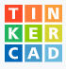

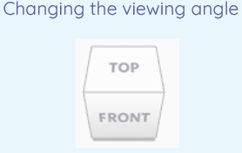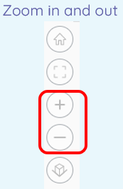

**Key Vocabulary for the unit:**

Delete – To get rid of something on your page.

Duplicating – To make an exact copy of something.

Group – Selecting more than one object to group as one.

Modify – Make partial or minor changes to something.

Move – To put something somewhere different on your page.

Resize – To make something bigger or smaller.

Rotate – To turn something in a direction.

Select – To select something in order to manipulate it.

Zoom – Make the shape look bigger but does not change the shape.

Year 6 – 3D Modelling