**Key Knowledge for the unit:**

1. To close your word processor use the x in the top right corner.
2. Click ‘Save...’ if it asks you to save!
3. Remember to log off correctly.
4. Click the left button on the mouse at the same time as moving the mouse to drag and select the text.
5. Use both hands to type
6. Caps lock turns capital letters on or off

**Useful diagrams for the unit:**

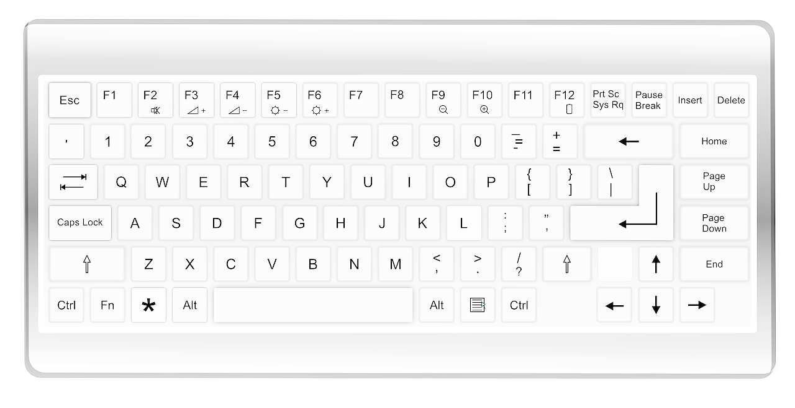

mouse cursor

 text cursor

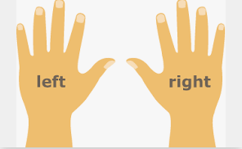

**Key Vocabulary for the unit:**

Backspace – takes away letters or numbers

Bold – **makes letters strong in colour**

Font – changes the look of the words

Google docs/Microsoft word – examples of word processors

Italic – *makes letters slanted*

Keyboard – essential tool for typing

Keys – the buttons on the keyboard

Space – creates a space between words

Text cursor - shows you where you will type

Toolbar – a group of tools

Underline – makes letters have a line underneath

Undo – cancel or reverse the last command

Word processor – a program you can use to type

Year 1 – Digital Writing