**Key Knowledge for the unit:**

1. Start blocks are used to run your programs.
2. Programming blocks are used to give instructions to each of the sprites.
3. Blocks can be joined together to make a sequence.
4. Blocks can be chosen to fulfil a specific purpose.
5. Using different blocks can alter the outcome.
6. Extensions can be used for extra tools such as the pen.

**Useful diagrams for the unit:**

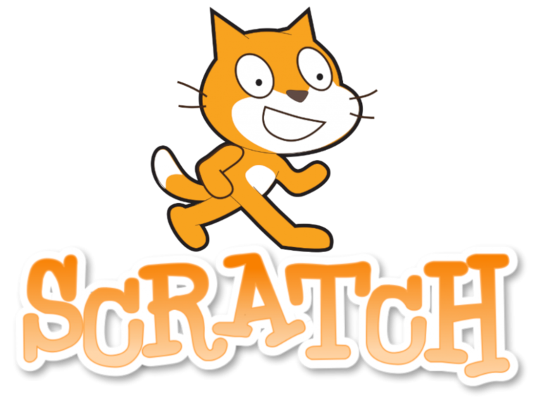

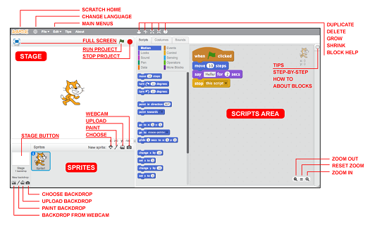

**Key Vocabulary for the unit:**

Algorithms – instructions that are split into little steps.

Backgrounds – the back part of a picture.

Block – puzzle-piece shapes that are used to create code.

Code – a set of rules or instructions.

Command – an order or instruction.

Debugging – process of detecting and removing of existing and potential errors.

Duplicating – make or be an exact copy of.

Event – something that happens.

Modifying – make partial or minor changes to something.

Program – steps of instructions for a computer.

Sprite – a character or object that you can code.

Year 3 – Events and Actions