**Key Knowledge for the unit:**

1. Collecting data needs to be accurate.
2. Data needs to be checked carefully before inputted.
3. Charts need to be clear.
4. Headings need to be clear.

**Useful diagrams for the unit:**

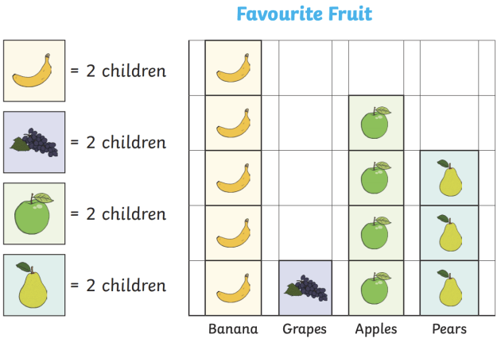

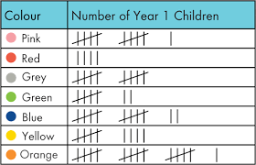

**Key Vocabulary for the unit:**

Attribute – a piece of information which determines the properties of a field or tag in a database or a string of characters in a display.

Chart – a sheet of information in the form of a table, graph, or diagram

Data – Computer data is information processed or stored by a computer.

Debugging - To detect and correct the errors in a computer program.

Pictogram – a chart or graph which uses pictures to represent data

Tally chart – used to collect data quickly and efficiently.

Year 2 – Pictograms