**Key Knowledge for the unit:**

1. Think carefully about how things are similar and different.
2. Use adjectives to describe objects.
3. Record information carefully.

**Useful diagrams for the unit:**

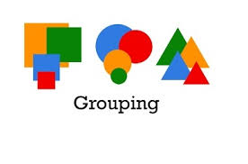

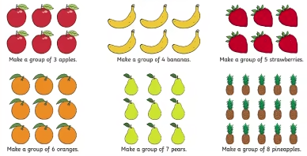

**Key Vocabulary for the unit:**

Attribute – a piece of information which determines the properties of a field or tag in a database or a string of characters in a display.

Data – Computer data is information processed or stored by a computer.

Data set – a collection of data

Debugging - To detect and correct the errors in a computer program.

Labels – A label is a property used to describe an object, eg ‘green’.

Object - describe anything that can be labelled with properties, eg animals, pencils, or trees.

Property – a quality or trait belonging and especially peculiar to an individual or thing.

Tally chart – used to collect data quickly and efficiently.

Year 1 – Grouping Data