**Key Knowledge for the unit:**

1. Instructions need to be accurate for the device to understand.
2. Programs need to be tried and tested more than once.
3. Computing language needs to be understood by the device.
4. Some programming tasks need to be broken down into smaller parts, known as decomposition.

**Useful diagrams for the unit:**

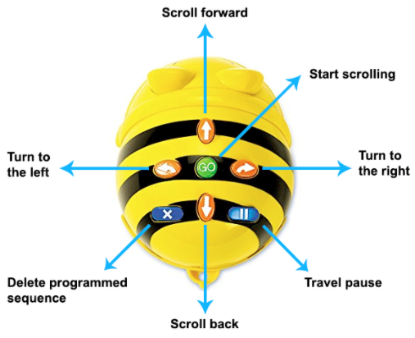

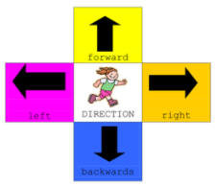

**Key Vocabulary for the unit:**

Algorithm – steps to follow to achieve a task

Coding – See program

Command – Tell something to a computer program to perform a specific task.

Debugging - To detect and correct the errors in a computer program.

Decomposition – Splitting things into smaller parts

Device – Electronic equipment that is used to send, receive or process data.

Instruction – Order given to a computer system

Logical reasoning – Using rules to solve problems

Predict – estimate what might happen

Program – instructions written in a language (code) computers can understand.

Sequence – A set of instructions that are followed in order.

Year 2 – Robot Algorithms