**Key Knowledge for the unit:**

1. ‘Along the corridor, up/down the stairs’.
2. Columns the information that goes down.
3. Rows the information that goes across.
4. Data is information collected on a specific topic.

**Useful diagrams for the unit:**

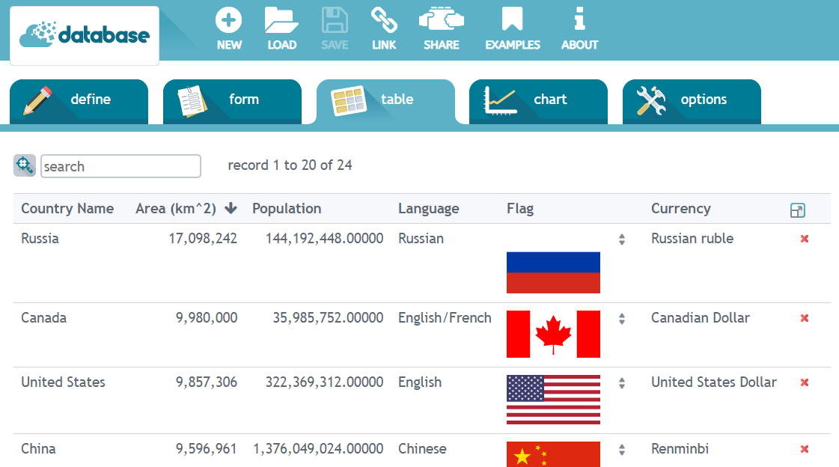

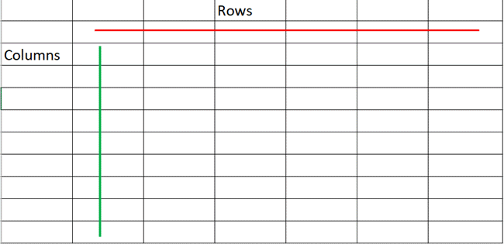

**Key Vocabulary for the unit:**

Column – is a vertical series of cells in a chart, table, or spreadsheet.

Database - a structured set of data held in a computer, especially one that is accessible in various ways

Fields - a field is a data structure for a single piece of data. Fields are organized into records, which contain all the information within the table relevant to a specific entity.

Flat-file database – A flat-file database is a database of just one table. Flat-file databases could be used for a number of things, for example, usernames and passwords or contact details.

Records - A record is a collection of *fields*, possibly of different data types, typically in a fixed number and sequence.

Row – is a horizontal series of cells in a chart, table, or spreadsheet.

Sorting - is any process that involves arranging the data into some meaningful order to make it easier to understand, analyse or visualise.

Year 5 – Flat-File Databases