**Key Knowledge for the unit:**

1. Scratch is a programming environment,
2. Commands in Scratch are represented as blocks.
3. Sequences are made up of connected commands.
4. Sequences of commands can have an order.
5. Commands are written in blocks.
6. Blocks join together to make a code.
7. Blocks can be found under scripts.
8. Sprites are the characters.
9. Costumes change the way the sprite looks.

**Useful diagrams for the unit:**

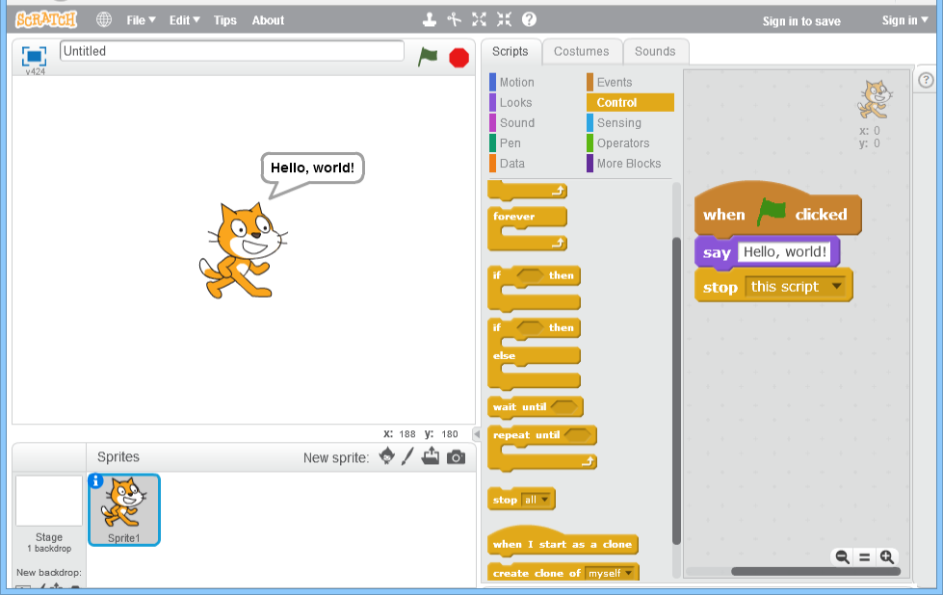

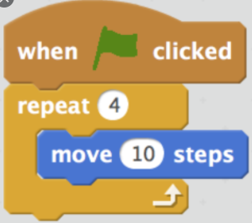

**Key Vocabulary for the unit:**

Algorithm – steps to follow to achieve a task

Coding – See program

Command – Tell something to a computer program to perform a specific task.

Debugging - To detect and correct the errors in a computer program.

Decomposition – Splitting things into smaller parts

Design – to make to draw plans for something

Logical reasoning – Using rules to solve problems

Predict – estimate what might happen

Program – instructions written in a language (code) computers can understand.

Sequence – A set of instructions that are followed in order.

Year 3 – Sequence in Music