**Key Knowledge for the unit:**

1. Scratch is a programming environment,
2. Commands in Scratch are represented as blocks.
3. Sequences are made up of connected commands.
4. Sequences of commands can have an order.
5. Commands are written in blocks.
6. Blocks join together to make a code.
7. Blocks can be found under scripts.
8. Sprites are the characters.
9. Costumes change the way the sprite looks.

**Useful diagrams for the unit:**

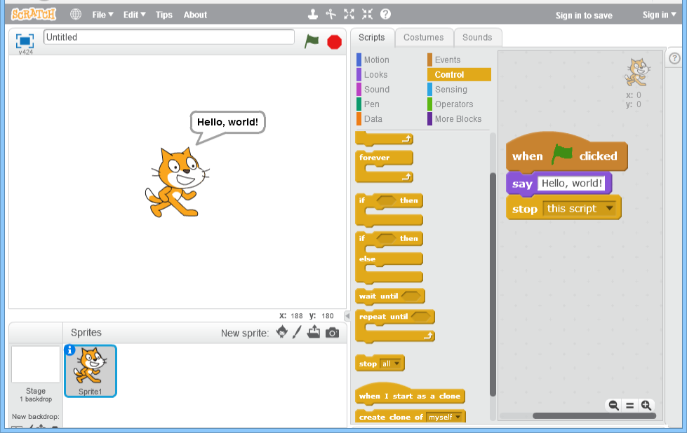

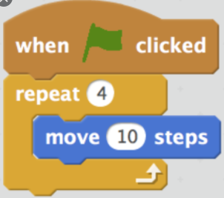

**Key Vocabulary for the unit:**

Algorithm – Steps to follow to achieve a task.

Command – Tell something to a computer program to perform a specific task.

Debugging - To detect and correct the errors in a computer program.

Decomposition – Splitting things into smaller parts.

Logical reasoning – Using rules to solve problems.

Predict - Estimate what might happen.

Program – Instructions written in a language (code) computers can understand.

Repetition – A programming construct in which one or more instructions are repeated, perhaps a certain number of times, until a condition is satisfied or until the program is stopped.

Sequence – A set of instructions that are followed in order.

Variables - a way in which computer programs can store, retrieve or change simple data, such as a score, the time left, or the user’s name.

Year 6 – Variables in Games