**Key Vocabulary for the unit:**

Coding – See program

Command – Tell something to a computer program to perform a specific task.

Debugging - To detect and correct the errors in a computer program.

Device – Electronic equipment that is used to send, receive or process data.

Instruction – Order given to a computer system

Predict – estimate what might happen

Program – instructions written in a language (code) computers can understand.

Sequence – A set of instructions that are followed in order.

Logical reasoning – Using rules to solve problems

**Useful diagrams for the unit:**

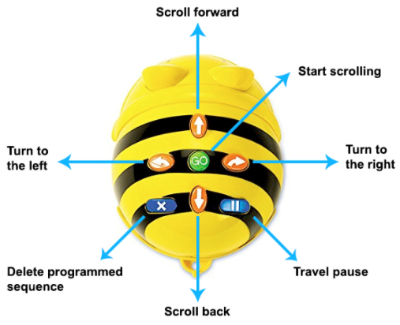

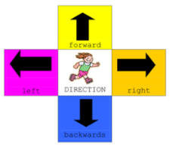

**Key Knowledge for the unit:**

1. Instructions need to be accurate for the device to understand.
2. Programs need to be tried and tested more than once.
3. Computing language needs to be understood by the device.

Year 1 - Moving Robot