**Key Knowledge for the unit:**

1. To insert text, images, links or documents select from ‘insert’.
2. To add another page, select page and add new page or add new link.
3. Themes are used to change the colour scheme and layout of the whole document.
4. The work completed through Google Sites auto-saves.
5. Creating a web address and publishing will allow other viewers to see the site created.

**Useful diagrams for the unit:**

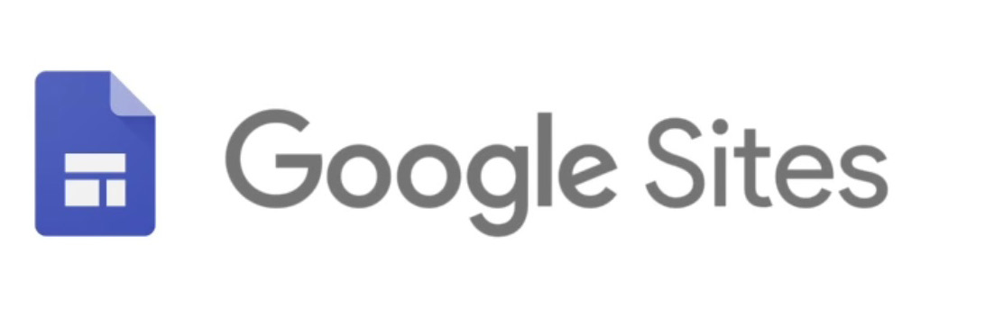

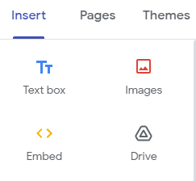

Undo Redo Preview



**Key Vocabulary for the unit:**

Content – often refers to text, pictures, video, or anything else in the viewable page or file.

Copyright – is a law that gives the owner of a written document, musical composition, book, picture, or other creative work, the right to decide what other people can do with it.

HTML code – the standard mark-up language for creating Web pages.

Hyperlinks – a link from a hypertext document to another location, activated by clicking on a highlighted word or image.

Media – videos, music and photographs that are stored as particular types of file on a computer.

Navigation path – the way that pages are linked together.

Year 6 – Web Page Creation