**Key Knowledge for the unit:**

1. Computer networks work together to pass messages from one device to another.
2. A system is made up of people and computers. It can has part in different countries as long as the parts are able to communicate.
3. Computers use special addresses called IP addresses.
4. Web crawlers create an index of the WWW. Search engines use the index to work out which web pages contain the user’s search term(s)

**Useful diagrams for the unit:**

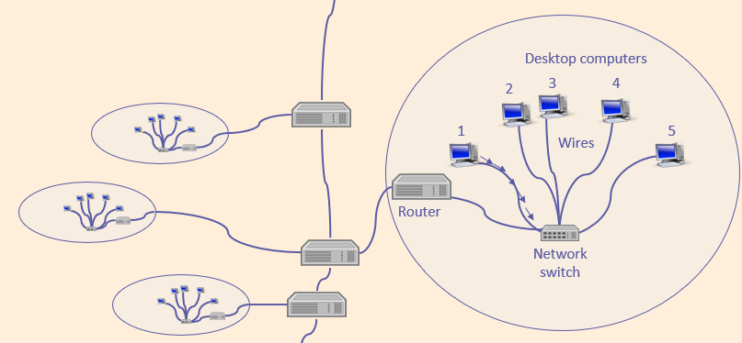

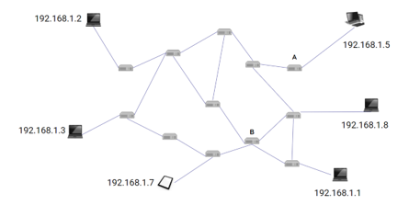

**Key Vocabulary for the unit:**

Computer network – A number of connections linking devices together

Network switch – A device that connects multiple devices on a network with one another

Ranked – a way of measuring the importance of website pages.

Router – enables us to connect a network to the internet and to connect lots of networks together.

Search engines – a program that searches for and identifies items in a database that correspond to keywords or characters specified by the user, used especially for finding particular sites on the World Wide Web.

Server – a networked computer for storing files.

SMART rules – Our online safety rules. Smart, Meet, Accepting, Reliable, Tell.

Web crawlers – a type of bot that is typically operated by search engines.

Wireless access point – A wired device that sends and receives wireless signals for devices with wireless connectivity to and from the rest of the network connectivity.

Year 6 – Communication