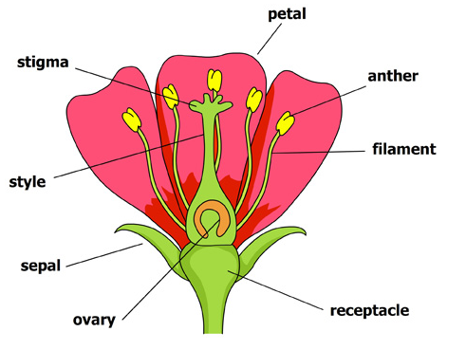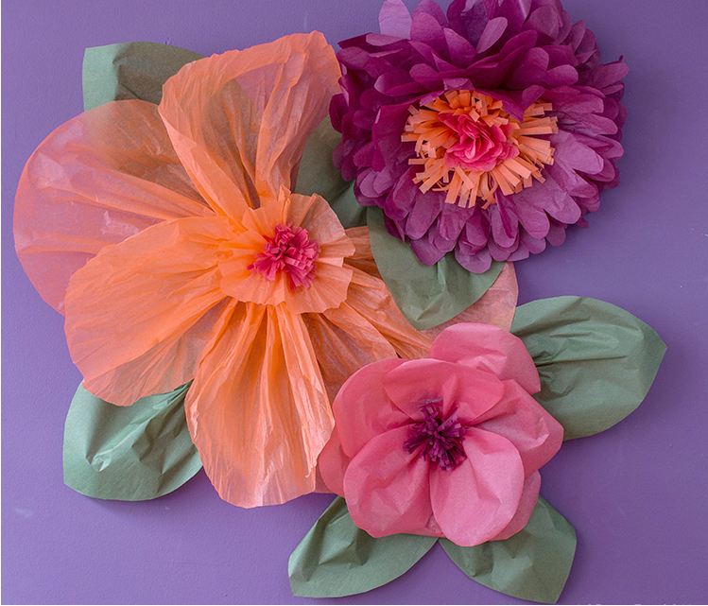

**Key vocabulary**

Pattern – a repeated design

Detail – The smaller parts of a picture or item e.g. the detail on the inside of this flower

Shaping – bending the wire into the shapes of the petals

Joining – attaching other pieces of the wire to each other 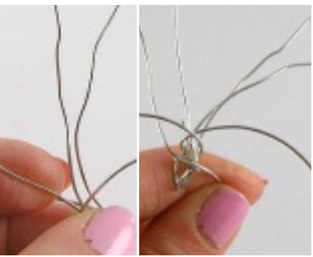

Texture – what things are made from.

**Key knowledge**

* Know how to safely cut wire
* Know how to bend and manipulate wire into different shapes
* Know how to join wire by twisting it together
* Understand that tissue paper is delicate and needs to be added carefully

**Key skills**

1. Use joining techniques to join pieces of wire and tissue paper together
2. Be able to shape wire into petals, stem and inside of the flower carefully
3. Add tissue paper to create pattern and texture of petals and leaves.
4. Use wire cutters safely

Year 5 – form