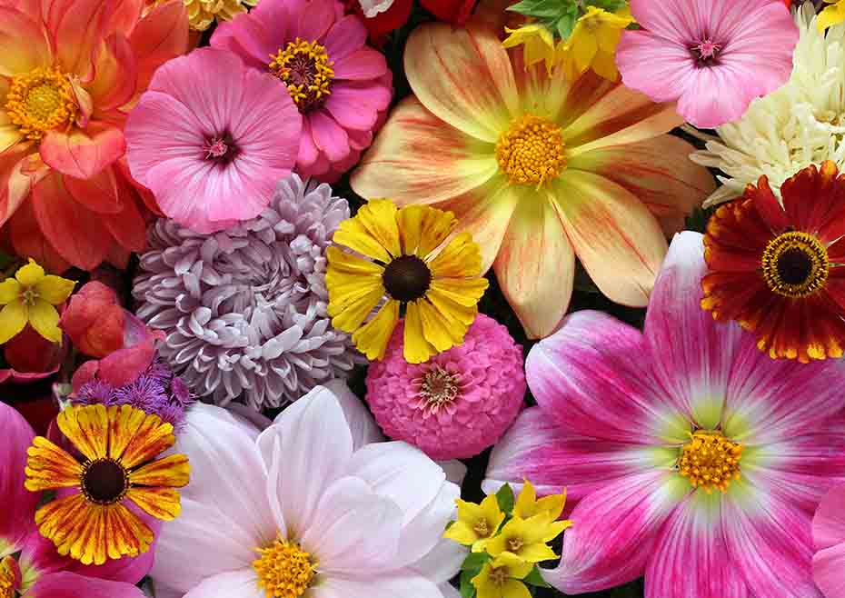

**Key knowledge**

* To know what the natural patterns and textures are in a flower
* To know and explain what shaping, carving and joining means.
* To know how to use our hands and fingers to shape petals
* To know how to use tools to carve out patterns in the petals and the middle of the flower
* To know how to join pieces of clay together.

**Key skills**

1. Mould and shape petals out of clay using fingers and tools.
2. Use different tools to carve patterns into the clay.
3. Use different joining techniques to join the petals and the middle of the flower together.
4. Mix the primary colours to make secondary colours.
5. Paint the different parts of the flower carefully

**Key vocabulary**

Shaping (moulding) – making a shape using your fingers

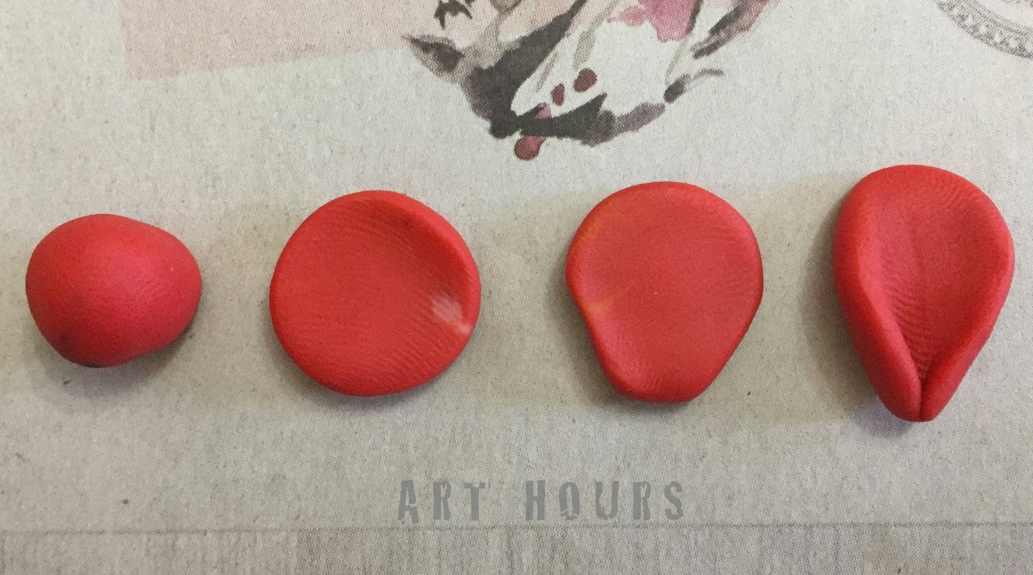

Carving – removing clay using tools

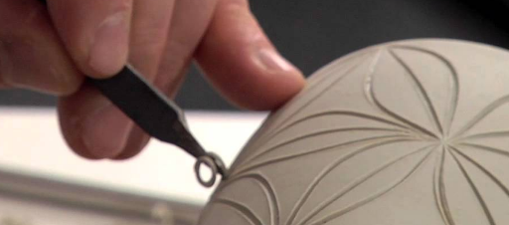

Joining – putting pieces of clay together

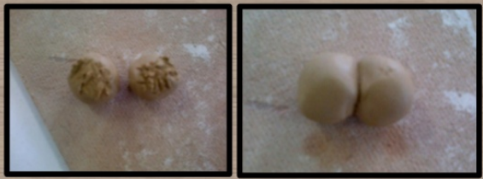

**Key vocabulary**

Pattern – a repeated design

Natural – something that is made naturally like flowers or trees.

Detail – The smaller parts of a picture or item e.g. the small stripes inside this flower

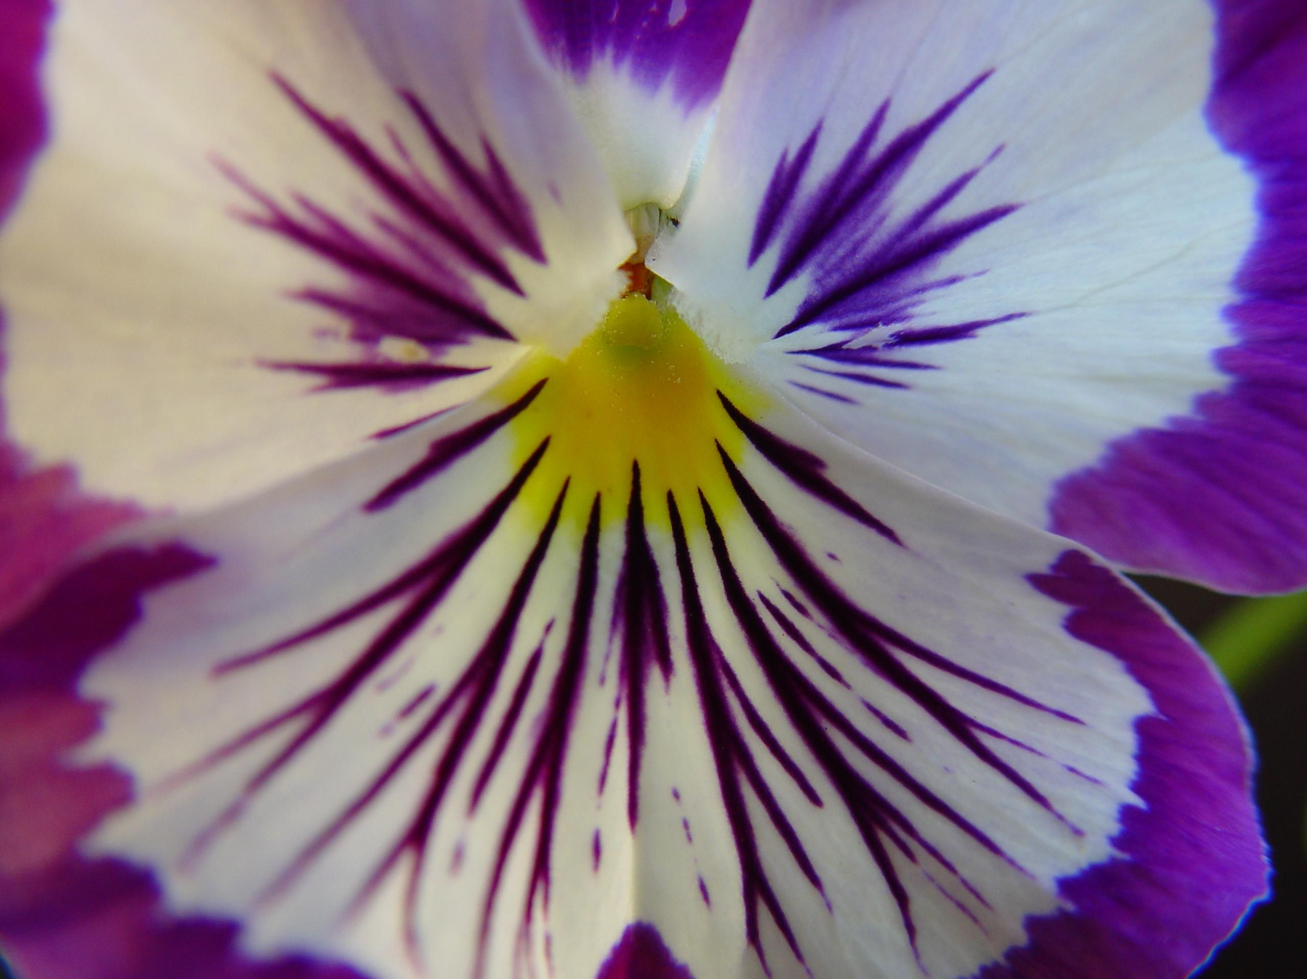

Texture – what things are made from.

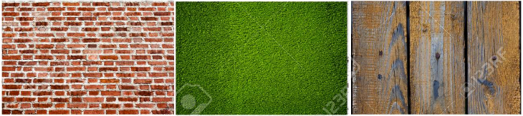

Year 2 – form