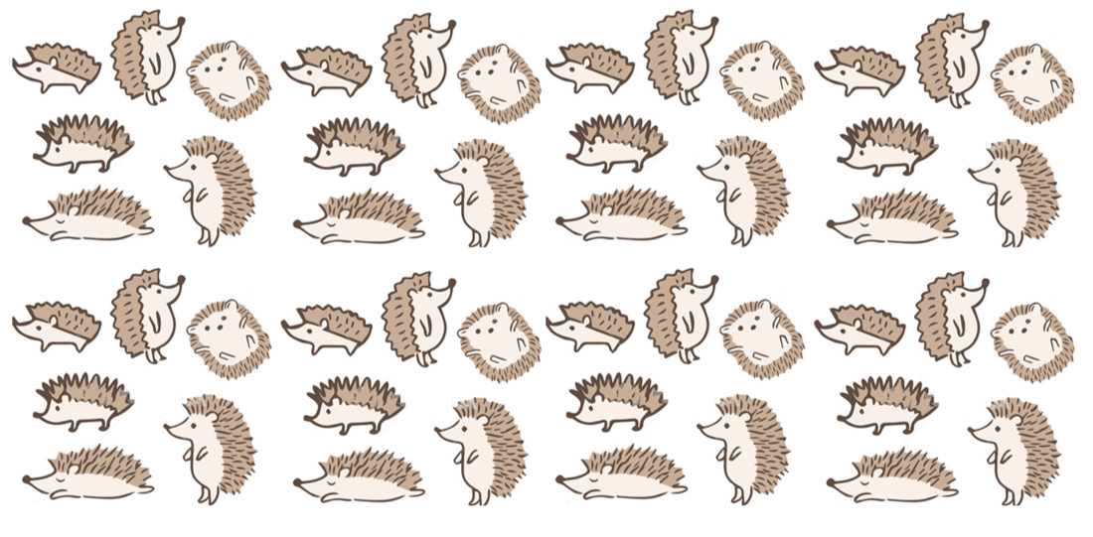

**Key vocabulary**

Pattern – a repeated design.

Spikes



Texture – what things are made from.

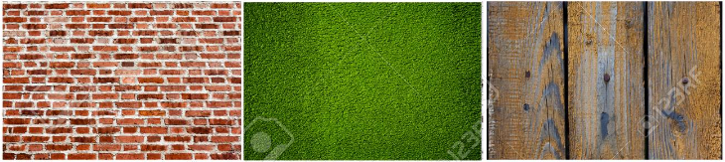

Mixing - putting two colours together to make another colour

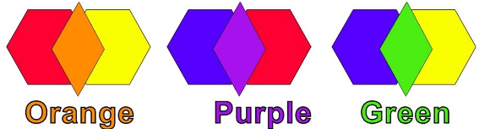

**Key vocabulary**

Shaping – making a shape using your fingers

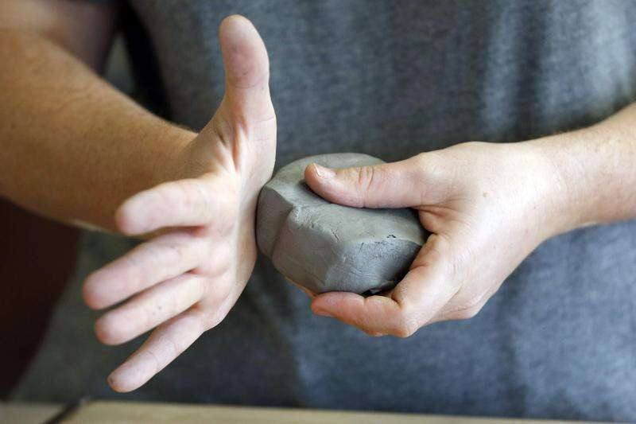

Carving – removing clay using tools

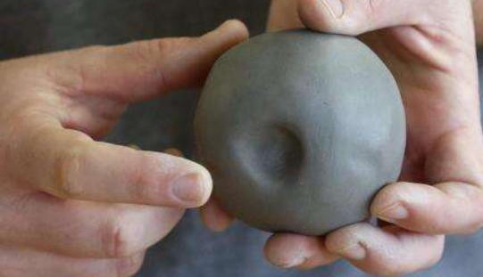

Joining – putting pieces of clay together

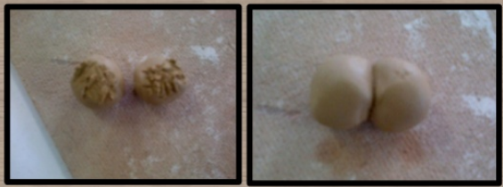

Cutting – using scissors to cut the clay

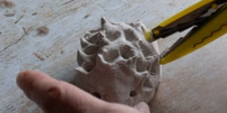

**Key skills**

1. Be able to shape clay using fingers.
2. Be able to cut spikes ensuring they are a similar size and shape using scissors.
3. Carve shapes for the eyes and attach them using joining techniques.
4. Paint using different brushes for different areas.
5. Be able to mix colours correctly.

**Key knowledge**

* To know what a hedgehog looks like e.g. spikes, colour, shape and size.
* To know and explain what shaping, carving, joining and cutting means.
* To know how to use our hands and fingers to shape
* To know how to use tools to carve out holes
* To know how to join pieces of clay together.

Year 1 – form