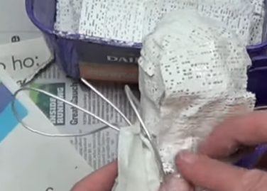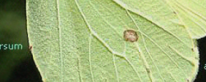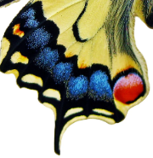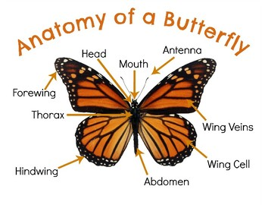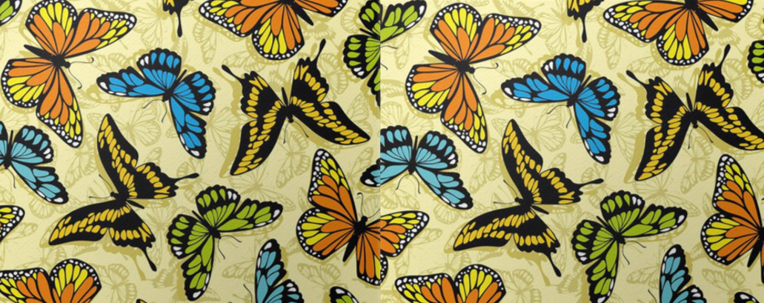

**Key skills**

1. Use joining and smoothing techniques that create texture and pattern within the butterfly
2. Understand how to join items using mod roc
3. Understand how to add material delicately so that the mod roc doesn’t break
4. Paint using correctly mixed colours that are appropriate for camouflage

**Key knowledge**

* Know how to shape (mould) newspaper using hands and tape
* Understand how to attach other pieces e.g. legs to the body
* Know what mod roc is, how it can be used and that less mod roc is better
* Know how to add detail and secure this using mod roc

**Key vocabulary**

Pattern – a repeated design

Detail – The smaller parts of a picture or  
item e.g. the detail on the butterfly’s wing

Shaping – moulding the newspaper into the correct shape for the butterfly’s body and wings

Joining – attaching other pieces of the body using mod roc to secure it

Smoothing – using hands to ensure there are no lumps

Texture – what things are made from. Giving the wings texture for the wing veins

Year 4 – form