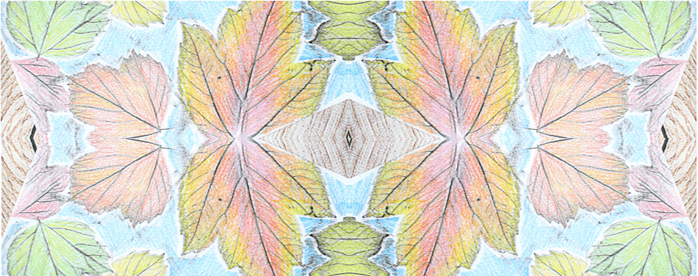

**Key skills**

1. Use different tools to draw  
   with

* Pastels
* Crayons
* Pencils

1. Explore and explain the difference in textures.
2. Explain what a pattern is.
3. Be able to sketch

* Use the pencil lightly
* Draw the outside first
* Add in detail afterwards

1. Take rubbings using different textures and tools

**Key knowledge**

* To know what pattern is and recognise it in nature. For example, on a leaf.
* To recognise how some patterns in nature are repeated.
* To know what a rubbing is and how to create one using a pencil or an oil pastel.
* To be able to create different rubbings using different textures.
* To know and explain what makes a good sketch.

**Key vocabulary**

Landscape – is an area of land.

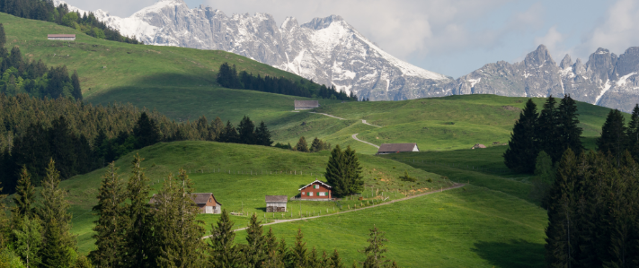

Texture – what things are made from.

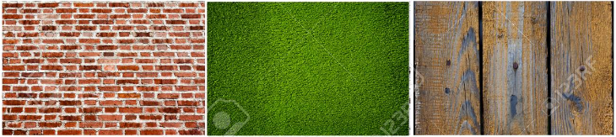

Sketch – a drawing.

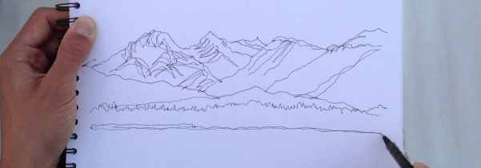

**Key vocabulary**

Pattern – a repeated design.

Symmetry – when something looks the exact same on both sides.



Repeating – the same thing over and over again.



Year 1 – drawing