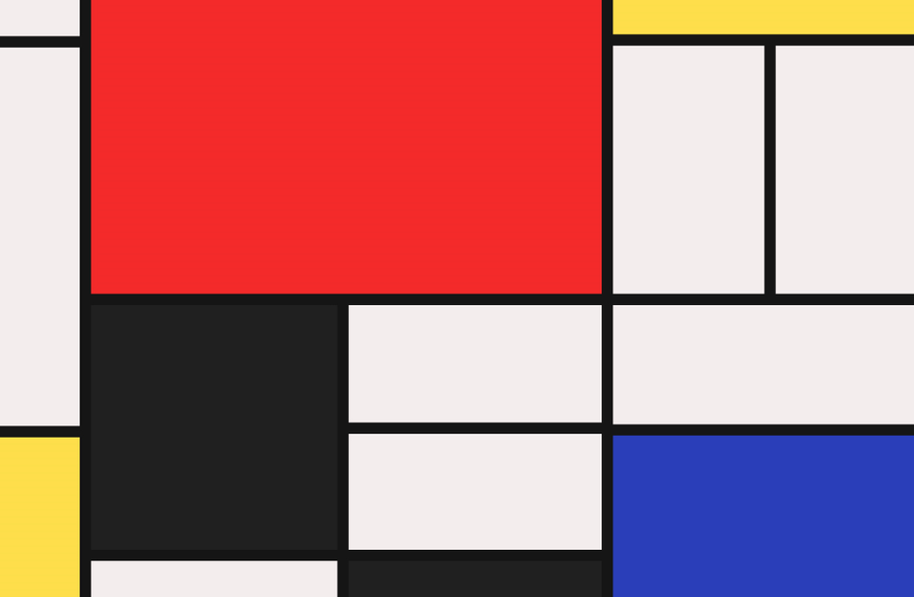

**Key skills**

1. Be able to draw in straight lines
2. Be able to use a ruler to create a right angle.
3. Use shape to create an image.
4. Use primary colours and black or white to create an image.
5. Be able to discuss and evaluate work created by myself and others.

**Piet Mondrian**

Piet was born on 7th March 1872, in Amersfoort. Both his father and uncle were artists.  
Mondrian had ambitions to become a painter but his family wanted him to gain a qualification first. He obtained a teaching qualification but instead of taking up a position in a school, he took painting lessons.

Piet then moved to Amsterdam and his first paintings were exhibited in 1893. Many of Piet’s earliest pieces were landscapes. Around the end of 1911, Piet moved to Paris having seen the work of other cubist artists, such as Pablo Picasso. Mondrian was heavily influenced by their work.

Cubism was a new way of painting using combinations of geometric shapes. He began to experiment with this new style.

Piet developed a style of his own. His work became minimalistic. He painted using simple lines, right angles and blocks of primary colours.

Year 5 – drawing

**Key knowledge**

* Know who Mondrian was and be able to explain what ‘Cubism’ is.
* Be able to explain the term ‘abstract’ and understand how Mondrian used this.
* Understand how Mondrian used shape, line and the primary colours to create his work.
* Make comparisons between feelings and the art work that Mondrian created.

**Key vocabulary**

Landscapes – An area of land

Cubism – To represent their picture/subject through a variety of geometric shapes.

Geometric – These are regular shapes.

Shapes – E.g. Square, rectangle

Abstract - Modern art which does not represent images of our everyday world. It has colour, lines and shapes

Primary colours – Red, blue and yellow

Straight lines – A line without curves.

Right angles – A 90 degree angle

Horizontal

Vertical