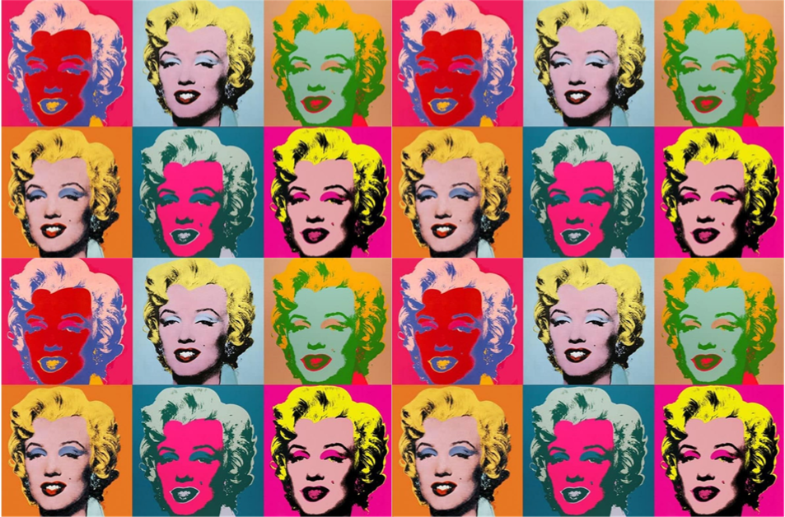

**Key vocabulary**

**Printing** – repeating the same image

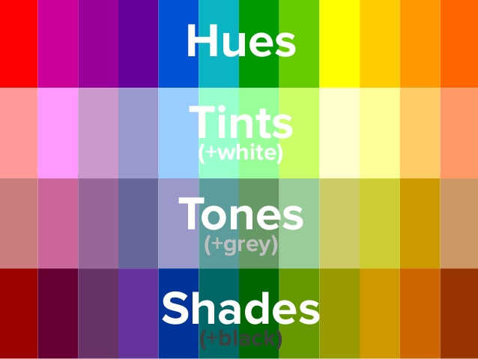

**Mood** – the atmosphere or feeling in a picture.

**Proportion** – how different parts of an image relate to each other

**Perspective** - making an image look 3D

Andy Warhol

Andy Warhol was a popular American print artist. He helped create a style of art called Pop Art. Warhol printed pictures of ordinary objects. He also printed famous people. Warhol did most of his painting during the 1960’s. This was an exciting time in popular culture. New kinds of music, art, books, and movies were being created. This inspired Warhol to look at art in a new way. Warhol’s art showed what was popular in American culture. It was different from anything that had been created before. Many people didn’t take his work seriously.

**This style of art was called Pop Art because the subjects for his work came from popular culture**.

Year 5 – painting, drawing and printing

**Key knowledge**

* I understand hue, tint, tone, shades and mood.
* I know different printing techniques.
* I know what Pop Art is and how I can create my own.
* I know how to use colour for different purposes.
* I know what makes a good sketch

**Key skills**

1. Explore the use of texture  
   in colour.
2. Understand and use colour  
   for purposes
3. Combine printing techniques that  
   I have learnt.
4. Design prints
5. Produce increasingly accurate  
   drawings of people
6. Use the concept of perspective with  
   increasing accuracy.
7. Create a sketch

