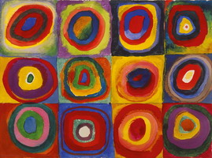

**Key vocabulary**

Primary colours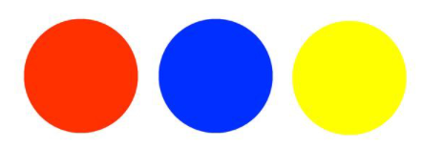

Secondary colours 

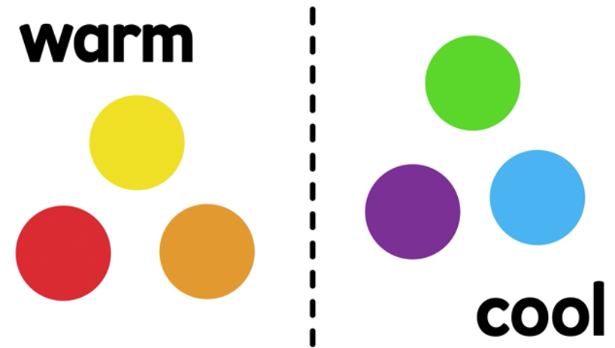

**Key skills**

1. To be able to mix the primary colours to make secondary colours
2. Explore prints
3. Explain what a pattern is.
4. Be able to change the shade   
   of a colour by adding black or white
5. Be able to create a print

**Key knowledge**

* To know what the primary colours are
* To know how to mix the primary colours to make secondary colours
* To know what warm and cold colours are
* To know what adding black or white does to a colour
* To know how to use pattern to create a print

**Key vocabulary**

Pattern – a repeated design.

Printing – moving images onto different places using one object. 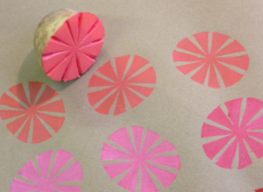

Repeating – the same thing over and over again.



Year 1 – painting/printing