Key Vocabulary
amphibians | A cold blooded vertebrate that spends some time on land but must breed and develop into an adult in water.
characteristics | Special qualities or appearances that make an individual or group of things different to others.
classify | To sort things into different groups.
classification key | A series of questions about the characteristics of living things used to identify a living thing or decide which group it belongs to by answering ‘yes’ or ‘no’ questions.
environment | All physical surrounding on Earth including everything that is living and non-living.
fungus | A simple organism, or living thing, that is neither a plant not an animal.
invertebrates | Animals without a backbone or internal skeleton. Insect, spiders, worms, jellyfish and coral are all types of invertebrates.
mammal | A warm blooded animal with a backbone (vertebrate) that feeds its young with milk produced by its mother.
micro-organism | Living things that are too small to be seen by the naked eye and are therefore usually viewed through a microscope.
organism | Any living thing, from the smallest bacteria to the humungous blue whale.
vertebrates | Animals that have a backbone or spinal column, also called vertebrae. These include fish, birds, mammals, amphibians and reptiles.
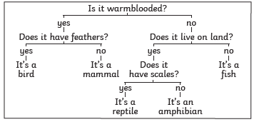
Scientists, called Taxonomists, sort and group living things according to their similarities and differences.
